Community Greenhouse Gas Inventory
2018
Village of Homer, New York

Prepared by: Jennifer Geck, Andrew Goodwin, Kyle Grant, and Marcus Koesterer
Revisions by Amanda Mazzoni, 5/8/20
Contents
Chapter 1: Introduction 4
1.1 Executive Summary 4
1.2 The Greenhouse Gas Effect 4
1.3 Climate Action in New York 5
1.4 The Village of Homer 7
Chapter 2: Methods & Focus Areas 10
2.1 Methods and Scope 10
2.2 Energy - Electricity 10
2.3 Energy - Natural Gas 11
2.4 Transportation 11
2.5 Solid waste 11
Chapter 3: Results 12
3.1 Community GHG Inventory 12
3.2 Residential Sector 14
3.3 Commercial/Industrial Sector 14
3.4 Transportation 15
3.5 Solid Waste 16
3.6 Annual Per Capita GHG Impact 17
Chapter 4: Analysis and Recommendations 18
4.1 Energy - Electricity 18
4.2 Energy - Natural Gas 18
4.3 Transportation 19
4.4 Solid Waste 20
Chapter 5: Conclusion 20
Appendices 21
Appendix A: Energy - Electricity 21
Appendix B: Energy - Natural Gas 22
Appendix C: Transportation 22
Appendix D: Solid Waste 23
Appendix E: Excluded Categories 23
Data Tables 24
Table I: Compiled Data for Electrical Consumption (MWh) 24
Table II: Compiled Data for Natural Gas Consumption (Therms) 25
Table III: Compiled Data for Transportation (AVMT) 25
Table IV : Compiled Solid Waste Data (Tons) 26
Acknowledgements 27
References 28
Images 29

Chapter 1: Introduction

1.1 Executive Summary
This document explores the greenhouse gas emissions emitted from the Village of Homer Community. It will briefly, in the Introduction, discuss the greenhouse gas effect as the greater impetus to engage in emission reduction, as well as Climate Smart Community (CSC) certification. This report is a step in that certification process.
The methods section includes an overview of how data was collected for the included sectors and in the case of wastewater and stationary fuels, what particular emission producers were excluded.
The results section details the emissions stemming from each sector within the inventory report. In addition, the Village of Homer’s GHG emission per capita is established for the year of 2018.
Within analysis and recommendations, the report goes on to recommend taking steps within each sector in order to further reduce emissions. These steps include expansion of a compost program, cooperating with energy auditors to identify potential solutions and promoting the use of bike lanes on village streets.

1.2 The Greenhouse Gas Effect
Greenhouse gases trap solar radiation in our atmosphere causing the planet to warm. The source of almost all increase in greenhouse gases in the atmosphere over the last 150 years is related to human activities. According to the EPA, the largest source of human contributed greenhouse gas emissions comes from the burning of fossil fuels for electricity, heat, and transportation.

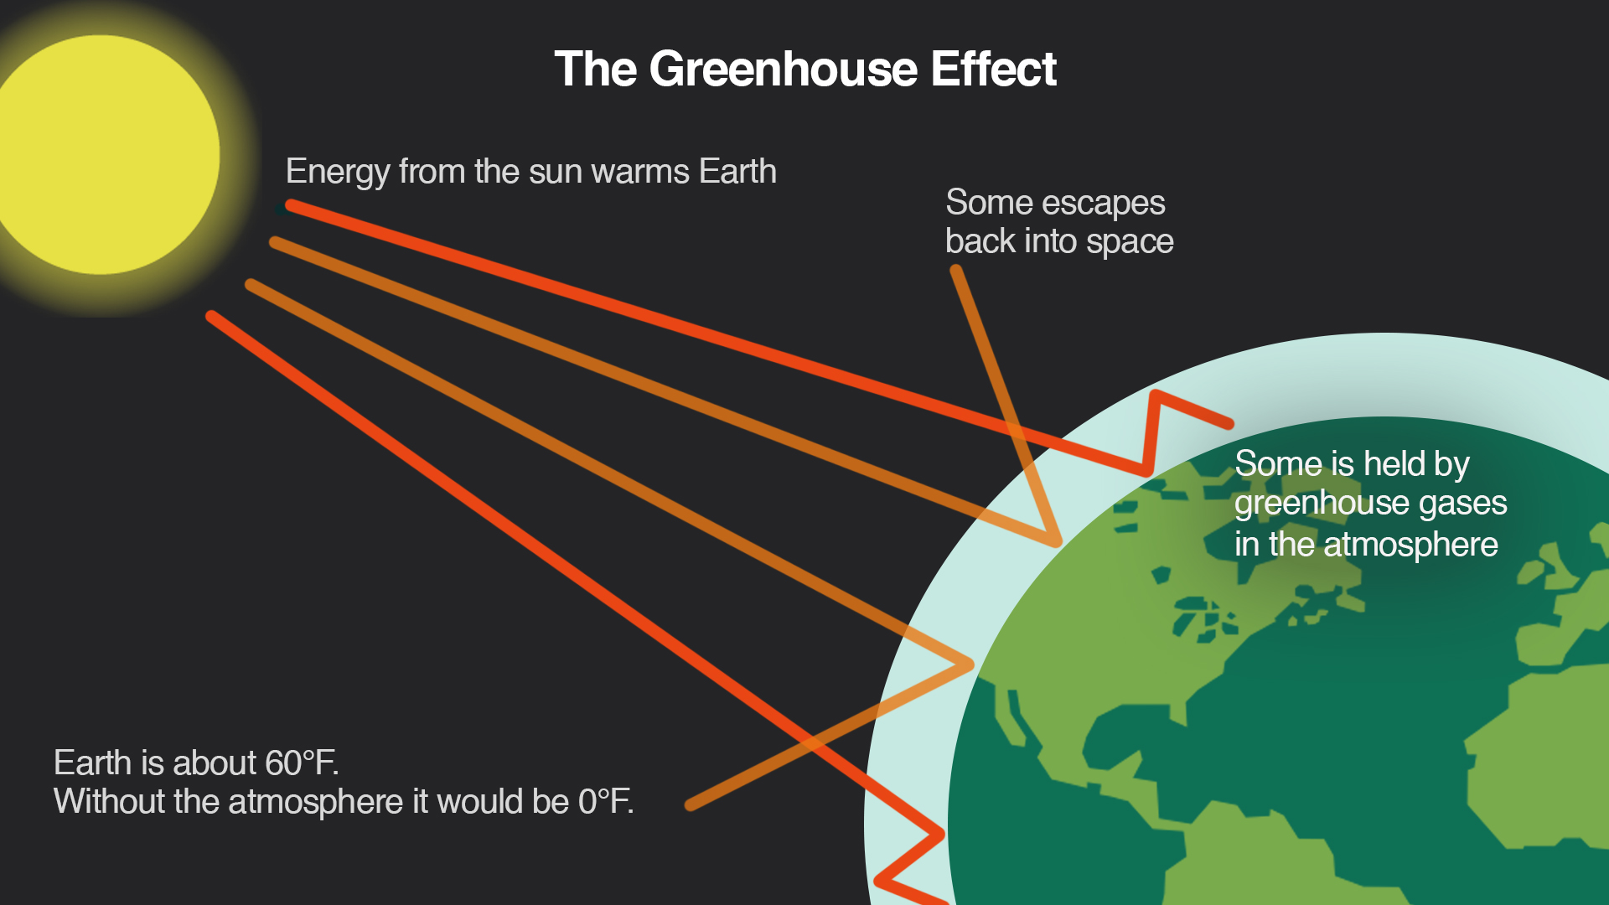

1.3 Climate Action in New York
As the implications of climate change begin to intensify around the world, climate action on a local scale has grown in popularity across the United States. New York State has set ambitious clean energy goals through the Climate Leadership and Community Protection Act which aims to reduce greenhouse gas emissions 40 percent below levels from 1990 by 2030 and 85 percent below 1990 levels by 2050. As part of a plan to lead the way in climate action, New York State has established Climate Smart Communities, a New York State DEC program which consists of a network of communities that aim to reduce greenhouse gas emissions and increase climate resilience (Climate Smart New York 2018).

Climate Smart Community Pledge
- Build a climate-smart community.
- Inventory emissions, set goals, and plan for climate action.
- Decrease energy use.
- Shift to clean, renewable energy.
- Use climate-smart materials management.
- Implement climate-smart land use.
- Enhance community resilience to climate change.
- Support a green innovation economy.
- Inform and inspire the public.
- Engage in an evolving process of climate action.

1.4 The Village of Homer
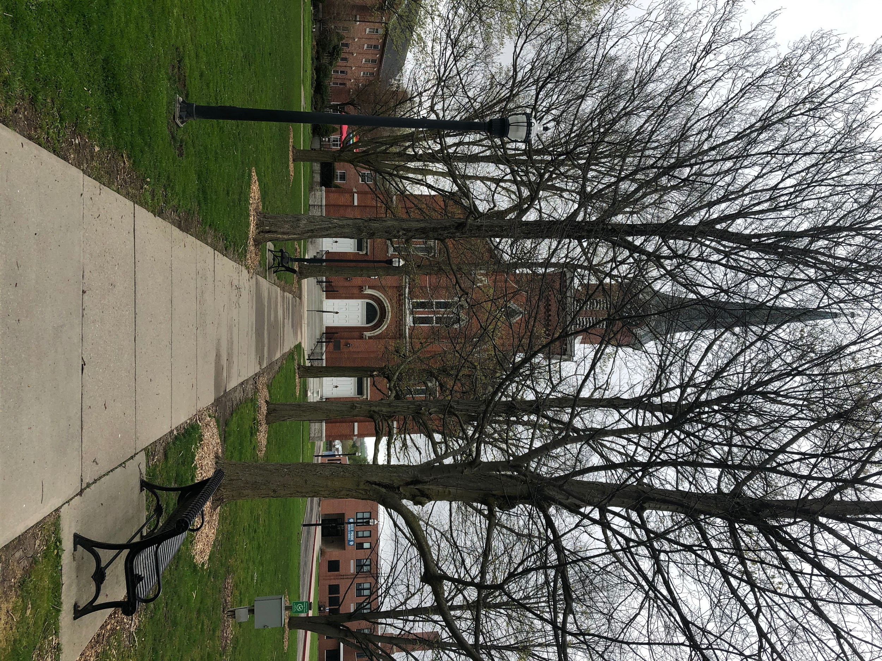
(Photo taken by Andrew Goodwin)
Homer, New York is a village situated in Central New York, with a population of 3,134. They are seeking a bronze certification as a Climate Smart Community. As well as providing environmental benefits, becoming a Climate Smart Community provides additional benefits to any community that becomes certified. Certified Climate Smart Communities receive better scores on grant applications for state funding, such as the Climate Smart Communities Grant Program, state-level recognition, and are provided resources, tools, and guidance in order to achieve their goals. Additionally, by implementing actions required for certification, the communities experience many economic benefits such as cost savings through an increase in energy efficiency (Climate Smart New York, 2018).
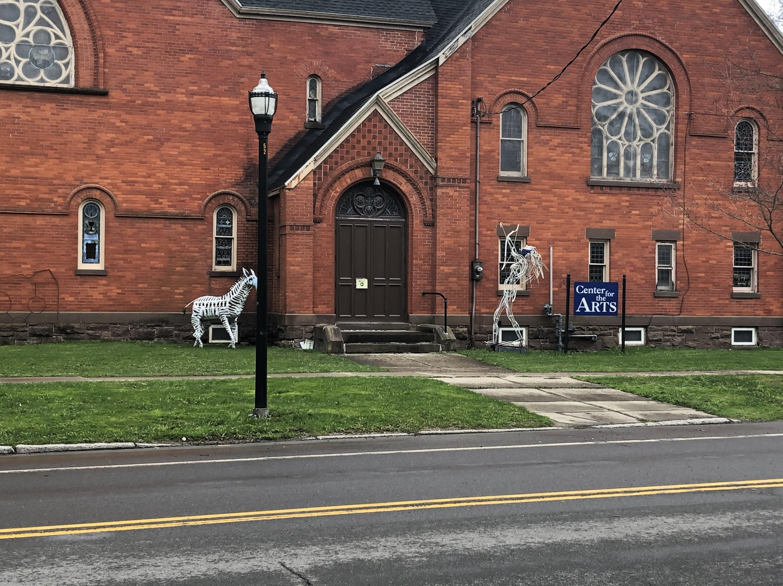
(Photo taken by Andrew Goodwin)
In order to do so, they must undergo a meticulous review process to confirm completion of a variety of actions to ameliorate and adapt to climate change. One of the first steps for reducing greenhouse gas emissions is conducting an inventory of current emissions. In addition to being one of the first steps required to become certified as a Climate Smart Community, a community greenhouse gas (GHG) inventory provides an understanding of the sources of greenhouse gas emissions and provides baseline data that will be utilized as part of the local climate action process (Climate Smart New York, 2018). Broadening a GHG inventory to include the community is essential, as government operations generally account for less than three percent of a community’s emissions. A community GHG inventory provides the data that is required to identify key reduction areas and set realistic goals for future climate action (Climate Smart New York, 2020).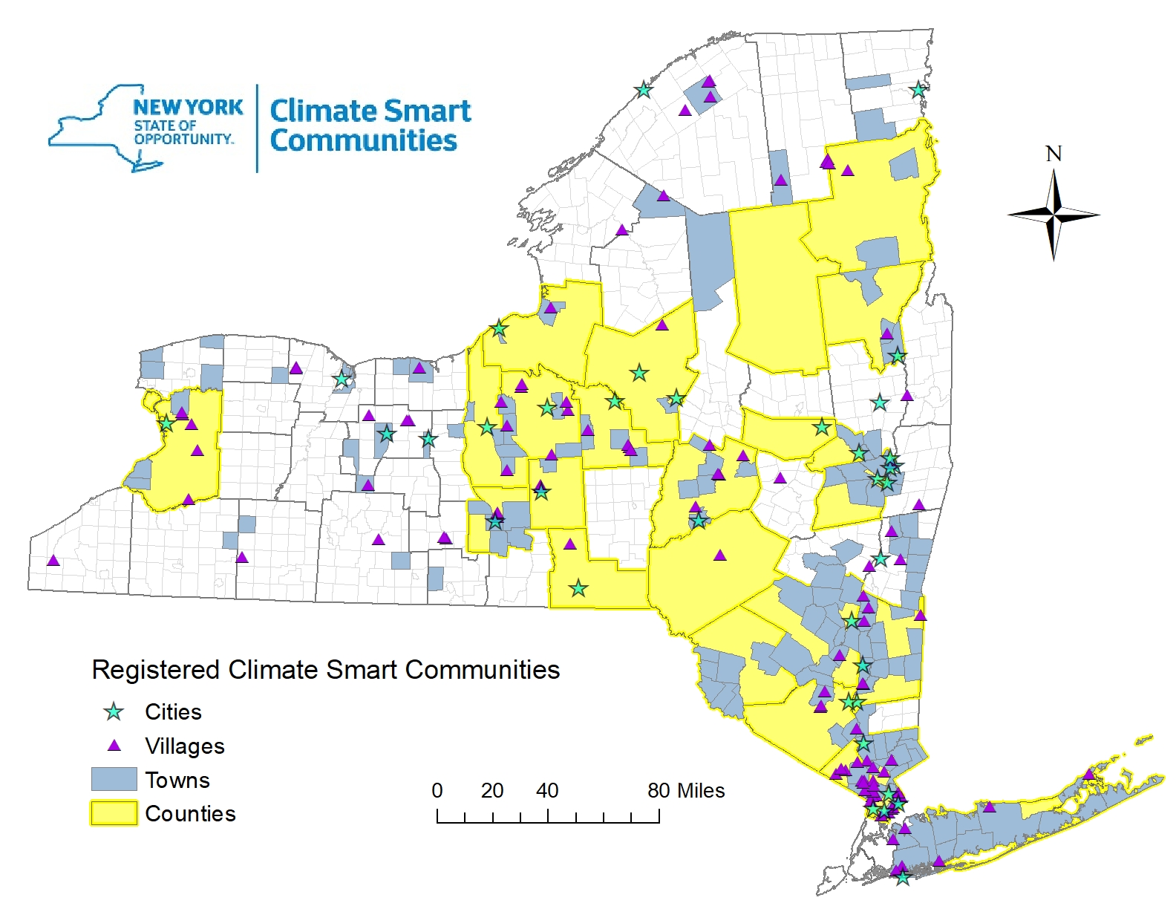

Chapter 2: Methods & Focus Areas

2.1 Methods and Scope
The inventory generated is based on 2018 operations and activities within the Village of Homer municipal boundary. The inventory was conducted according to the ICLEI US Community Protocol for Accounting and Reporting of Greenhouse Gas Emissions as recommended by Climate Smart Communities. Data was collected to meet all possible categories being direct emissions (Scope 1), indirect emissions (Scope 2), and upstream emissions (Scope 3). The focus areas for emissions included electricity, stationary combustion from natural gas, transportation, and solid waste. Emissions calculations were made using the EPA Local Greenhouse Gas Inventory Tool for the Community, available at https://www.epa.gov/statelocalenergy/local-greenhouse-gas-inventory-tool.
Focus areas excluded were wastewater and other stationary combustion fuels. There are no septic systems within the Village of Homer, and analysis of wastewater sent to the treatment plant is outside the scope of this report, therefore wastewater emissions were excluded from this report. The use of other stationary fuels was excluded for several reasons. The Village of Homer residents reported no use of propane, and only very minimal use of coal and fuel oil or kerosene, according to the 2018 American Community Survey. There is no NYS data available to calculate total consumption of coal for residential units. As for kerosene and fuel oil, there is no way to parcel out the use of each fuel, as they are lumped together. Additional elaboration for each of these focus areas can be found in Appendix E.

2.2 Energy - Electricity
This section focuses on the greenhouse gases emitted in association with the consumption of electricity within the Village of Homer, NY. The data was collected through the New York Utility Energy Registry. All months of commercial/industrial consumption data were withheld for the village in 2018, and only two months of commercial/industrial data were available from 2016-2019. Residential electric usage also only had five months of data available for 2018. Therefore, commercial/industrial and residential electric use information from 2016-2019 was substituted as proxy monthly data where available. Where data was not available, it was assumed that total electricity consumption minus residential electricity consumption provided by the UER equaled commercial/industrial consumption. Where data was further not available, average estimates were used based on what information was provided by the UER from 2016-2019. The data was then processed using the EPA Local Greenhouse Gas Inventory Tool using the NYUP eGRID factors. Additional information regarding the processing of this data is available in Appendix A.

2.3 Energy - Natural Gas
This section focuses on the greenhouse gas emissions in association with the consumption of natural gas in the Village of Homer. The data was collected through the New York Utility Energy Registry. The data was processed using the EPA Local Greenhouse Gas Inventory Tool. Additional information regarding the processing of this data is available in Appendix B.

2.4 Transportation
This section focuses on emissions associated with the use of transportation fuels used by on-road passenger and freight motor vehicles within the boundaries of the Village of Homer. In most communities, transportation is generally one of the highest contributors of greenhouse gas emissions. The combustion of fuel in motor vehicles produces CO₂, N₂O, and CH₄ greenhouse gas emissions. Annual Vehicle Miles Traveled (AMVT) was determined using annual daily average traffic data and road miles within the Village of Homer. The data was processed using the EPA Local Greenhouse Gas Inventory Tool. Additional information regarding the processing of this data is available in Appendix C.

2.5 Solid waste
This section focuses on the greenhouse gases associated with the decomposition of solid waste in landfills. Solid waste that is not diverted to recycling, composting, or reuse will produce multiple greenhouse gases through decomposition or incineration. This data was collected from Syracuse Haulers receipts provided by the Village Clerk. The data was then processed using ICLEI-Local Governments for Sustainability’s ClearPath tool online, as the EPA Local Greenhouse Gas Inventory Tool does not provide a method for calculating scope 3 waste process emissions. Additional information regarding the processing of this data is available in Appendix D.

Chapter 3: Results

3.1 Community GHG Inventory
The community greenhouse gas emissions data has been organized into four sectors: residential, commercial/industrial, transportation, and waste, and into five sources: electricity, natural gas, gasoline, diesel, and waste. Only electricity and natural gas use associated with residential and commercial/industrial activities were included as explained previously in section 2.1 and in Appendix E. Other fuel sources were very minimally used within the village and would have a negligible impact on the data within the inventory. The Homer government has varying control over different sectors of the inventory. Separating GHG emissions into sectors and sources allows for the Village of Homer to identify significant areas of GHG emissions. The total emissions generated in the Village of Homer in 2018 was 30,564 Metric Tonnes of CO₂ equivalent. The emissions for both source and sector are seen and presented below.

3.2 Residential Sector
Emissions from the residential sector in 2018 total 8,050 metric tonnes of CO₂ equivalent. Electricity from residential consumption contributes 982 metric tonnes of CO₂ equivalent. As noted previously and in Appendix A, several months of data have been withheld by the Utility Energy Registry. Proxy data and averages were generated for residential emissions estimates. The results shown should be taken as an estimate for the year. The use of natural gas contributes 7,068 metric tonnes of CO₂ equivalent. Natural gas is the primary fuel used for household heating for the Village of Homer which is why it contributes such a large portion of annual residential energy use.

3.3 Commercial/Industrial Sector
Emissions from the commercial/industrial sector total 7,210 metric tonnes of CO₂ equivalent. Emissions from electrical consumption contributes 3,252 metric tonnes of CO₂ equivalent. As noted previously and in Appendix A, commercial/industrial electric use was mostly estimated based on a lack of available data through the UER. While this data is an estimate, it does provide useful insights into approximate electric use and emissions in the Village of Homer in 2018 and can be used as a starting point for a community climate action plan. The use of natural gas contributes 3,958 metric tonnes of CO₂ equivalent.

3.4 Transportation
On-road passenger and freight motor vehicle travel contributed the most significant portion of GHG emissions in the Village of Homer in 2018, emitting 15,081 metric tonnes of CO₂ equivalent which accounts for 49% of total GHG emissions for the Village of Homer. Much of the transportation emissions in the Village of Homer can be attributed to vehicles traveling on I-81 through the village. These emissions have been included because there are on/off ramps within the village, so all travel on I-81 is not pass-through traffic. It is not possible given available information to estimate what percentage of trips in I-81 begin/end within the village boundaries, so all emissions from I-81 travel within the village are included in this inventory.
Gasoline vehicles contributed to 13,321 MTCO2e while diesel vehicles contributed to 1,760 MTCO2e in 2018. Appendix C explains the methodology for calculating emissions from transportation in more detail.

3.5 Solid Waste
Greenhouse gases resulting from the processing of solid waste account for the smallest portion of GHG emissions in Homer at .73%. The waste data was provided as tons of waste collected and was not divided into waste types, so calculations were based on ICLEI’s default mix of waste types. The results calculated show the emissions for total waste collected in the Village of Homer. The total GHG emissions for solid waste in 2018 is 222 metric tonnes of CO₂ equivalent. There is a peak in July of 92.19 tons collected, and a low in March of 38.44 tons collected.

3.6 Annual Per Capita GHG Impact

When examining per capita GHG emissions of metric tonnes of CO₂ equivalent, the Village of Homer is around 50 percent below the national average at 9.8 metric tonnes of CO₂ equivalent per capita, with the national average being 20 metric tonnes of CO₂ equivalent per capita (Massachusetts Institute of Technology, 2008). However, when examined on a global scale, The Village of Homer emits around 2.5 times more than the global average. The Village of Homer’s community emissions are also about 2.5 times greater than another similarly-sized community in Central New York, the Village of Minoa. However, it should be noted that Minoa’s transportation emissions are significantly less than Homer’s, given that no major interstate highway runs through Minoa as I-81 does in Homer. Commercial/Industrial emissions in Minoa are also much less than in Homer, which has more businesses within municipal boundaries.

Chapter 4: Analysis and Recommendations

4.1 Energy - Electricity
Electricity accounts for the third highest source of GHG emissions within the Village of Homer, responsible for 13.85% of total emissions. The use of electricity fluctuates greatly over the course of a year, and it is worthwhile to examine this trend and evaluate how reduction efforts might be implemented. As found in the data tables, energy consumption peaked in January at 4088.56 MWh. This can be potentially explained through a variety of reasons: the increased use of space heaters to provide warmth; the increased use of light sources; or, increased use of kitchen equipment. There is insufficient information to determine which reason may be the cause of this increased use. A recommendation for future community inventories is to develop a survey for the Homer community designed to identify areas of increased electricity use within winter months. The results of this survey could then be used to develop community goals and potentially prepare community resources that would mitigate electricity consumption within winter months.
The month of August exhibits similar energy consumption as January, with 3828.70 MWh. This increased use may be attributed to increased use of air conditioners, fans, or other cooling needs. A survey intended to establish the numerical use of these cooling methods may provide the Village of Homer the impetus to develop mitigation strategies for the future.
As noted above, a considerable portion of electric use data was inaccessible via the Utility Energy Registry, so a recommendation is to encourage the Utility Energy Registry to mandate increased reporting of data to allow inventory reports such as this to better interpret data and set goals for emissions reductions in other communities throughout New York State.

4.2 Energy - Natural Gas
Natural gas accounts for the second largest source contribution of GHG within the Village of Homer, at 36% of emissions. Residential use accounts for most of natural gas consumption when compared to commercial/industrial uses. Consumption of natural gas spikes in the winter months and plummets during the summer months. According to the 2018 American Community Survey, natural gas is the primary source of heating for Homer residences, supplying 86% of homes.
Given the state of natural gas consumption within the Village of Homer, this provides significant opportunity to capitalize on mitigation methods. One recommendation is to develop a program of ongoing assessments of residential households and businesses for efficiency measures. Regular inspection can reduce inefficiencies through identification of structural opportunities such as improving insulation, filling in gaps, and updating windows. If the Village of Homer were to partner with a local contractor, residents could have their utility costs reduced while developing a long-term partnership with a local business.
Through working with NYSERDA, it is possible for the Village of Homer to assist residents in finding rebate programs that allow small businesses and not-for-profits to conduct energy assessments with a cost-share by the state (Energy Assessments, n.d.).

4.3 Transportation
Transportation in the Village of Homer contributed most to overall greenhouse gas emissions, with gasoline emissions accounting for 43.58% of source emissions and diesel accounting for 5.76%. The majority of emissions come from passenger vehicles. While local governments don’t have the ability to implement policy to require certain behaviors, they have the ability to develop infrastructure that encourages alternate forms of transportation such as bicycles. One recommendation for the Village of Homer to reduce vehicle miles traveled is to improve bicycle infrastructure throughout the village. As a small village, approximately 1.9 square miles, Homer has an opportunity to incentivize bicycle travel, reducing greenhouse gas emissions from vehicles. Homer currently has two bike routes, and it is aiming to improve its bicycle infrastructure in the future. This action should be prioritized, as vehicle emissions account for the most significant portion of greenhouse gas emissions for the Village of Homer in 2018.

4.4 Solid Waste
Solid Waste accounted for the least significant portion of overall greenhouse gas emissions for the Village of Homer in 2018, at only 0.73% of emissions. While solid waste was the lowest contributor of greenhouse gas emissions, there is still room for improvement. The Village of Homer has implemented a program for residents to purchase The Earth Machine, which is a machine to allow for home composting. The village purchased these machines in bulk at cost, and allowed residents to buy them for $41.77. The first 100 of these machines sold out, indicating significant interest in home compost. Waste in landfills emits a significant amount of methane, which is one of the strongest greenhouse gasses. Increasing composting throughout the Village of Homer can help reduce the amount of waste taken to landfills, therefore reducing methane emissions. Our recommendation is to expand the home composting program to allow more residents to purchase The Earth Machine. The Village could offer these machines at a reduced or free rate to residents who aren’t able to afford purchasing a machine and are interested in home composting. The village could also add an educational section on their website to inform residents who can’t afford the machines how to compost at home without one.

Chapter 5: Conclusion
The development of a community inventory report is a significant step in the New York State Climate Smart Communities program. As such, developing a robust and persistent method for regular production of a community inventory report is the final recommendation of this report. Serious steps have already been taken by the establishment of a Climate Smart Communities Task Force and the previous production of a government greenhouse gas inventory and climate action plan. The success of the home composting program highlights the potential of community integrated approaches to reducing GHG emissions. Additional opportunities exist with the development and proliferation of educational programs designed to highlight financial savings and community development.
The Village of Homer stands well prepared to approach further engagement with the community and engage with the State of New York to become a certified Climate Smart Community.

Appendices

Appendix A: Energy - Electricity
Electricity consumption for the Village of Homer was retrieved from the Utility Energy Registry, provided publicly by NYSERDA and all investor-owned utilities. The Village of Homer’s electricity provider is National Grid and is classified as Upstate, New York. 2018 data was extracted from two files titled “National Grid - NIMO 2018 Jan-June” and “National Grid - NIMO 2018 Jul-Dec,” and 2016-2017 and 2019 available files were also accessed for proxy data. All months of commercial/industrial consumption data were withheld for the village in 2018, and only two months of commercial/industrial data were available from 2016, 2017, or 2019 to use as proxy data. Residential electric usage only had five months of data available for 2018, and proxy data from 2016, 2017, and 2019 was used for five additional months, where available. For the two months of the year that residential electric consumption was not available, an average of the remaining 10 months of data was applied.
It was assumed that total electricity consumption minus residential electricity consumption provided by the UER equaled commercial/industrial consumption. Total electricity consumption in the village was available for seven months from 2016-2019, so in those cases residential electric consumption could be subtracted from total electric consumption to estimate commercial/industrial electric consumption. For the three months of the year where both total usage and commercial/industrial usage were withheld, an average of the total electric consumption from the other nine months data was applied, and residential electric usage was subtracted from the estimated total to yield commercial/industrial electric use estimates.

Appendix B: Energy - Natural Gas
Natural gas consumption for the Village of Homer was retrieved from the Utility Energy Registry, provided publicly by NYSERDA. The Village of Homer natural gas provider is the New York State Gas & Electric Corporation. The data was extracted from two files titled “NYSEG 2018 Jan-June” and “NYSEG 2018 Jul-Dec.” All data was available so an annual total was computed for natural gas in 2018.

Appendix C: Transportation
Annual Vehicle Miles Traveled (AVMT) for 2018 was calculated by multiplying available Annual Average Daily Traffic (AADT) counts from 2018 and earlier by road lengths within the Village of Homer and multiplying total daily Vehicle Miles Traveled (VMT) by 365 days per year. This data was collected with the assistance of Amanda Mazzoni, Senior Planner at the Central New York Regional Planning and Development Board.
Although there were AADT counts available for 9.905 miles of road within the Village of Homer, there are a total of 15.12 miles of road segments within the Village that do not have traffic counts available. Therefore, some extrapolation was necessary. According to the Minimum Maintenance Standards Regulation 239/02, a set guidelines produced by the Association of Municipalities of Ontario to help local communities estimate traffic volume, while conducting an AADT count, it is possible to estimate the traffic volume for dead-ends and cul-de-sacs to avoid resource intensive counts. This can be done by counting the number of houses on the roadway, and multiplying by a factor of 6 for rural areas and 10 for urban areas.
This method was applied to the Village of Homer for the roads without AADT counts. It was determined that there were 1,330 occupied households in the Village of Homer in 2018, according to the American Community Survey. It was assumed that all homes are on roadways that do not have AADT counts, since most houses are on local/collector roads and almost all local/collector roads in Homer did not have an AADT count. By multiplying the number of occupied homes by 6, a combined AADT count of 7,980 was calculated for 2018 for all 15.12 miles of roads without AADT counts available. In order to calculate VMTs, an average AADT value was needed, and derived by dividing the total AADT by the 15.12 miles of uncounted roadway. This gave an average AADT value of 527.8 for 2018, which was applied to the 15.12 miles of road length that did not have a count.
Vehicle miles traveled information was then attributed to various vehicle types as per ICLEI’s default percentages of vehicle types, including gasoline passenger vehicles at 60.6%, gasoline light duty vehicles at 32.4%, diesel passenger vehicles at 0.3%, diesel light duty vehicles at 1.3%, and diesel heavy duty vehicles at 5.4%. VMT per vehicle type was then divided by average estimated miles per gallon per vehicle type (provided by EPA’s Local Greenhouse Gas Inventory Tool) to yield estimated gallons of fuel use per vehicle type. Gallons of fuel and VMT were then entered into EPA’s Local Greenhouse Gas Inventory Tool and converted to emissions data.

Appendix D: Solid Waste
Solid waste data was gathered from the weight readings of waste collected by Syracuse Haulers. Data was provided as tons per month for 2018. This data was collected with the assistance of the Homer Village Clerk, Dan Egnor. ICLEI’s ClearPath tool was used to process waste data since EPA’s Local Greenhouse Gas Inventory Tool does not provide a method for calculating Scope 3 process waste emissions. Total waste data provided by Syracuse Haulers was entered into ClearPath using a mixed municipal solid waste categorization, since the waste data was not provided by waste type. It was assumed that the methane collection scenario was typical and landfill moisture content was moderate.

Appendix E: Excluded Categories
Stationary combustion of other fuels in the Village of Homer was excluded due to the lack of information available. According to the 2018 American Community Survey, residential data for fuels consumed indicated that six homes in the village of Homer used coal and seventeen homes used fuel oil, kerosene, etc. which accounts for only 1.7 percent of total occupied homes in the Village of Homer. New York State has no residential consumption information for coal in 2018, making it impossible to make the calculation for total consumption based on house count. Also, since the consumption is so low, the impact is minimal to the total GHG impact. As for fuel oil and kerosene, there is no breakdown to make separate calculations for the fuels, and their use is so low that including them would have a negligible impact on overall residential emissions. In addition, the EPA Calculator does not provide input categories for fuel oil or kerosene for potential residential emissions. Due to this, accurate calculations could not be generated.
Wastewater was not included because there are no septic systems within the Village to Homer according to the Village Clerk, Dan Egnor. Analysis of wastewater sent to the treatment plant is outside the scope of this report, since the wastewater treatment facility is located outside of village boundaries.

Data Tables

Table I: Compiled Data for Electrical Consumption (MWh)

Month | Total | Residential | C&I | Notes
Jan | 4,088.56 | 709.98 | 3,378.58 | Res avg used
Feb | 2,731.12 | 900.28 | 1,830.83
Mar | 3,146.10 | 806.54 | 2,339.56
April | 1,535.56 | 847.45 | 688.11
May | 3,060.88 | 698.45 | 2,362.43 | Total avg used
June | 3,465.86 | 636.86 | 2,829.00
July | 3,060.88 | 749.44 | 2,311.44 | Total avg used
Aug | 3,828.70 | 709.98 | 3,118.72 | Res avg used
Sept | 3,245.35 | 660.77 | 2,584.58
Oct | 3,633.60 | 693.39 | 2,940.21
Nov | 3,060.88 | 210.87 | 2,850.01 | Total avg used
Dec | 1,873.06 | 895.77 | 977.29
 |  | 709.98 |  | Res avg estimated
 | 3,060.88 |  |  | Total avg estimated

Table II: Compiled Data for Natural Gas Consumption (Therms)

Month | Total | Residential | Business (C&I)
January | 405,327.00 | 270,361.00 | 134,966.00
February | 343,092.00 | 203,801.00 | 139,291.00
March | 250,716.00 | 153,893.00 | 96,823.00
April | 302,205.00 | 187,419.00 | 114,786.00
May | 113,818.00 | 54,302.00 | 59,516.00
June | 50,384.00 | 33,743.00 | 16,641.00
July | 30,197.00 | 20,567.00 | 9,630.00
August | 30,590.00 | 22,418.00 | 8,172.00
September | 27,276.00 | 19,783.00 | 7,493.00
October | 84,452.00 | 65,294.00 | 19,158.00
November | 175,544.00 | 124,536.00 | 51,008.00
December | 282,096.00 | 187,304.00 | 94,792.00
Total Therms Used | 2,095,697.00 | 1,343,421.00 | 752,276.00

Table III: Compiled Data for Transportation (AVMT)

Total Annual Vehicle Miles Traveled (AVMT) 2018: | 35,565,080
Annual VMT with AADT | 32,652,380.50
Annual VMT for manually calculated AADT | 2,912,700
Total length of road segments in Village of Homer with AADT: | 9.905
Total length of road segments in Village of Homer without AADT: | 15.12

Table IV : Compiled Solid Waste Data (Tons)

Month | Solid Waste (Tons)
January | 71.89
February | 61.98
March | 38.44
April | 66.96
May | 76.03
June | 75.34
July | 92.19
August | 73.23
September | 74.39
October | 72.38
November | 84.42
December | 66.49
Annual Total | 853.74
Annual Per Capita | 0.02121569879

Acknowledgements
  - Amanda Mazzoni, Senior Planner at the Central New York Regional Planning and Development Board
  - The Village of Homer Board of Trustees
  - Dan Egnor, Village of Homer Clerk
  - Dr. Josh Cousins, Assistant Professor at ESF
  - Village of Homer Green Team
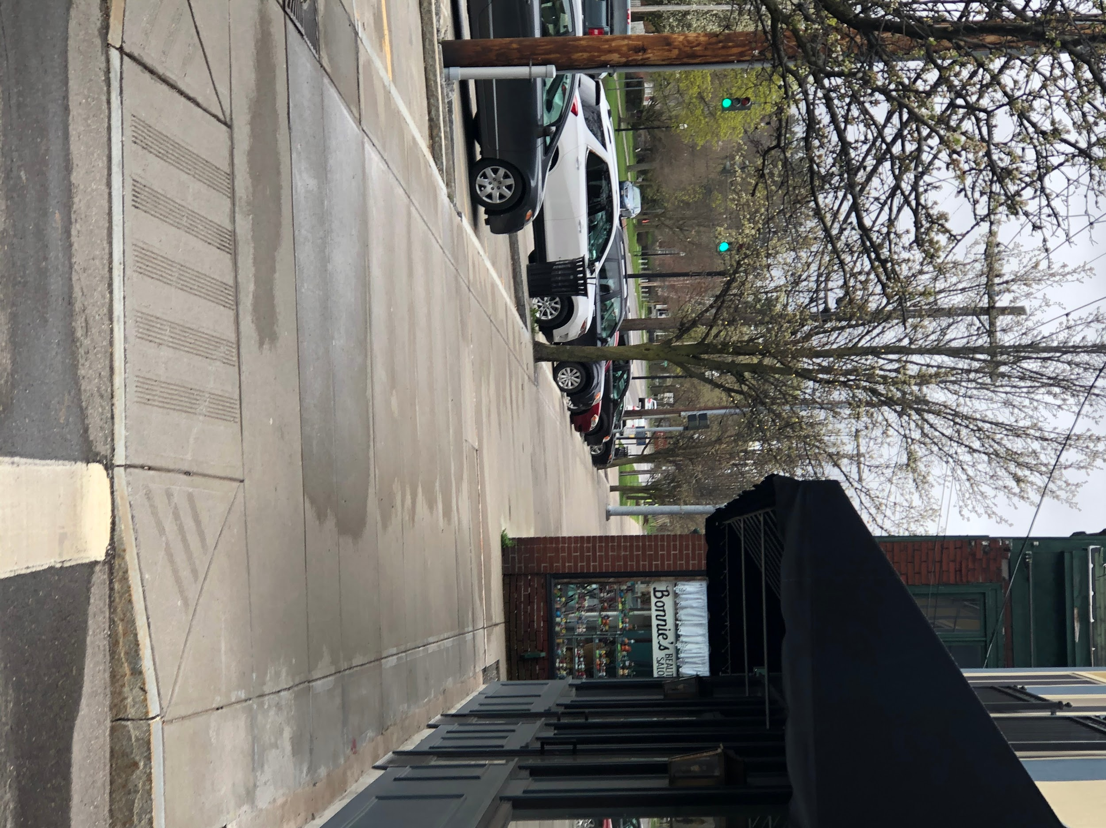
(Photo taken by Andrew Goodwin)

References

Climate Smart New York. (2018, April 19). Retrieved April 1, 2020, from https://climatesmart.ny.gov/actions-certification/why-become-certified

Climate Smart New York. (2020, January 3). Retrieved April 6, 2020, from https://climatesmart.ny.gov/actions-certification/actions/#open/action/7

Energy Studies for Small Commercial and Not-For-Profit Entities. (n.d.). Retrieved from https://www.nyserda.ny.gov/All-Programs/Programs/Small-Commercial-Energy-Assessments

Massachusetts Institute of Technology. (2008, April 29). Carbon Footprint Of Best Conserving Americans Is Still Double Global Average. ScienceDaily. Retrieved April 23, 2020 from www.sciencedaily.com/releases/2008/04/080428120658.htm

“Sources of Greenhouse Gas Emissions.” EPA, Environmental Protection Agency, 11 Apr. 2020, www.epa.gov/ghgemissions/sources-greenhouse-gas-emissions.

Images

“Greenhouse Gas Effect.” Climate Central, 16 Apr. 2014, https://medialibrary.climatecentral.org/resources/the-greenhouse-effect.

“Map of Climate Smart Communities” (n.d.). Retrieved from https://www.dec.ny.gov/images/administration_images/climatesmtmap12302019.jpg

“Village of Homer Logo.” (n.d.). Retrieved from https://www.homerny.org/wp-content/uploads/2017/12/village-seal-300x298.png

