Village of Tully, New York

Community Greenhouse Gas Inventory and Municipal Forecast
Compiled by the Central New York
Regional Planning and Development Board

May 17, 2022

Village of Tully

PO Box 1028

Tully, NY 13159

This GHG inventory was compiled by the Central New York Regional Planning and Development Board (CNY RPDB) in support of the village’s Climate Smart Communities and Clean Energy Communities efforts. Contributors include:

- Principal Author: Amanda Mazzoni, Principal Planner; CNY RPDB,
- Chris Carrick, Energy Program Manager; CNY RPDB,
- Kathy Vernay, Trustee; Village of Tully,
- Eli Yewdall, Senior Program Officer; ICLEI USA.
Table of Contents
I. Introduction 4
Background 4
Climate Change and Greenhouse Gases 5
New York State GHG Emissions and Climate Goals 6
The Purpose of a Greenhouse Gas Inventory 8
Village Profile 9
II. Data Collection and Analysis 9
Reporting 9
III. Community Emissions Inventory 10
Overall Results 10
Residential Sector 12
Methods and inputs 12
Results 13
Commercial/Industrial Sector 14
Methods and inputs 14
Results 15
Transportation Sector 16
Methods and inputs 16
Results 18
Waste Sector 20
Methods and inputs 20
Results 20
Wastewater Sector 21
Methods and inputs 21
Results 21
IV. Municipal Operations Emissions Forecast 21
Methods and inputs 21
Results 22
Discussion 22
V. Community Emissions Forecast 23
Methods and inputs 23
Results 24
Discussion 24
VI. Discussion: 2010 vs 2019 Inventory 26
Community Comparison 27
VII. Conclusion 29
VIII. Bibliography 29

I. Introduction

Background
The Climate Smart Communities Program represents a partnership between New York State and local governments to reduce energy use and GHG emissions while working to adapt to a changing climate. The required ten elements of the Climate Smart Communities Pledge are:

- Build a climate-smart community.
- Inventory emissions, set goals, and plan for climate action.
- Decrease energy use.
- Shift to clean, renewable energy.
- Use climate-smart materials management.
- Implement climate-smart land use.
- Enhance community resilience to climate change.
- Support a green innovation economy.
- Inform and inspire the public.
- Engage in an evolving process of climate action.

The Village of Tully adopted the ten-element Climate Smart Communities Pledge as a commitment to greenhouse gas (GHG) emission reduction and climate change adaptation in October 2019, and it is working towards becoming a Bronze Certified Climate Smart Community. The Climate Smart Communities Certification program recognizes communities that have gone beyond the ten pledge elements by completing and documenting mitigation and adaptation actions at the local level. Certified communities are the foremost leaders in the state in terms of climate action. Communities can achieve certification at the Bronze, Silver, or Gold (currently in development) level.

As part of the village’s efforts to become a Certified Climate Smart Community, the village decided to compile a community and municipal GHG inventory. ESF students compiled the municipal operations inventory while the CNY RPDB compiled the community operations inventory. The village decided to use the 2019 for the community GHG inventory due to data availability issues, while the municipal inventory uses 2021 as a baseline. A GHG emissions inventory is an audit of activities that contribute to the release of emissions and acts as a baseline for a Climate Action Plan.

It is important to note that the information provided in this inventory is not meant to be exhaustive, but rather to provide an estimate of community and municipal emissions data at one snapshot in time. The inventory information will inform climate action planning efforts in the village moving forward. This inventory will act as a baseline for tracking and understanding trends associated with future GHG mitigation efforts.

For this community GHG inventory, residential energy use, commercial/industrial energy use, transportation, waste generation, and wastewater treatment information was gathered for the 2019 year, and methods of calculation explained in the U.S. Community Operations Protocol were utilized to generate emissions figures. Data was entered into the ClearPath tool, outputs were aggregated into metric tons of CO₂ equivalent, and emissions were delineated by sector and source.

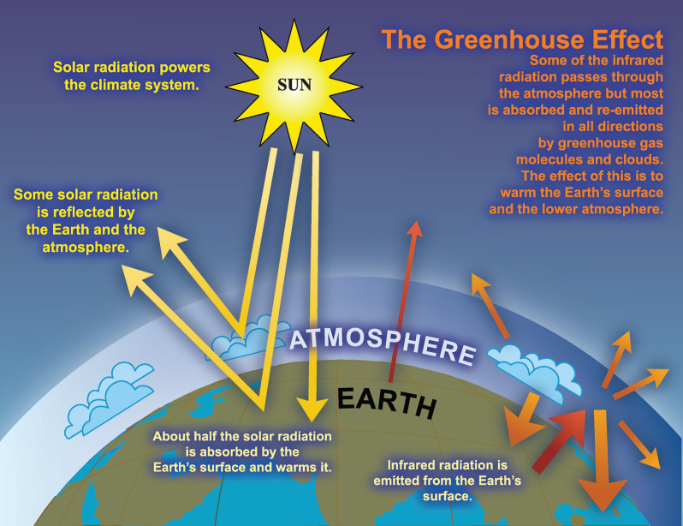

Climate Change and Greenhouse Gases
Climate change is recognized as a global concern. Scientists have documented changes to the Earth’s climate including the rise in global average temperatures, as well as sea levels, during the last century. An international panel of leading climate scientists, the Intergovernmental Panel on Climate Change (IPCC), was formed in 1988 by the World Meteorological Organization and the United Nations Environment Program to provide objective and up-to-date information regarding the changing climate. In its 2014 Fifth Assessment Report, the IPCC states that there is a greater than 95 percent chance that rising global average temperatures, observed since the mid-20th century, are primarily due to human activities. Evidence of observed changes in extremes such as heatwaves, heavy precipitation, droughts, and tropical cyclones, and, in particular, their attribution to human influence, has strengthened since the Fifth Assessment Report, as noted in the Sixth Assessment Report AR6 Climate Change: The Physical Science Basis study published in August 2021.
Figure 1: The Greenhouse Effect

The rising trend of human-generated GHG emissions is a global threat. The increased presence of these gases affects the warming of the planet by contributing to the natural greenhouse effect, which warms the atmosphere and makes the earth habitable for humans and other species (see Figure 1). Mitigation of GHGs is occurring in all sectors as a means of reducing the impacts of this warming trend. However, scientific models predict that some effects of climate change are inevitable no matter how much mitigative action is taken now. Therefore, climate mitigation actions must be paired with adaptation measures in order to continue efforts to curb emissions contributions to global warming, while adapting communities so that they are able to withstand climate change impacts and maintain social, economic, and environmental resilience in the face of uncertainty. Climate adaptation can take shape through infrastructure assessments and emergency planning, as well as through educational efforts to raise public awareness about potential climate change impacts.

New York State outlined projected climate impacts and vulnerabilities during the 2011 ClimAid assessment and 2014 supplement (ClimAid Report). The ClimAid Report projects changes to ecosystems (e.g., increased presence of invasive species and shifts in tree composition), while water quality and quantity may also be impacted due to changes in precipitation. Potential beneficial economic impacts were also identified, such as a longer recreation season in the summer, and a longer growing season for the agricultural sector due to rising temperatures. Scientific evidence suggests that the impacts of global climate change will be different in various regions, and will include temperature shifts, more extreme heat events, sea level rise and coastal flooding, more frequent intense precipitation events, and human health risks.

We have already experienced the effects of a changing climate in New York State and abroad, the need for climate action and adaptation is imperative. The goal of building community resilience in order to protect the health and livelihood of residents and natural systems serves as a motivating factor in the assessment of greenhouse gas contributions and effective sustainability planning.

New York State GHG Emissions and Climate Goals
According to the July 2019 New York State Greenhouse Gas Inventory: 1990-2016 report prepared by the New York State Energy Research and Development Authority (NYSERDA), 2016 state emissions were equal to 206 million metric tons of carbon dioxide equivalent (MMTCO₂e), the majority of which came from energy-related sources (173 MMTCO₂e) compared to non-energy sources (33 MMTCO₂e). Of the energy-related emissions sources, 36% were from transportation, 30% from on-site fuel combustion from buildings, 15% from electricity generation, and 3% from other sources such as fugitive emissions from fossil fuel infrastructure and incineration of municipal waste (see Figure 2).

In July 2019, Governor Cuomo signed the Climate Leadership and Community Protection Act (CLCPA) into law. The CLCPA is New York State’s ambitious emissions reduction plan with the goal of making electricity 70% renewable by 2030 and 100% carbon neutral by 2040, reducing GHG emissions 40% below 1990 levels by 2030 and 85% below 1990 levels by 2050, implementing 6,000 MW of solar by 2025, 3,000 MW of energy storage by 2030, and 9,000 MW of offshore wind by 2035 (see Figure 3).

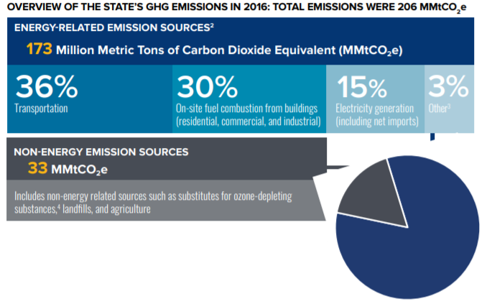
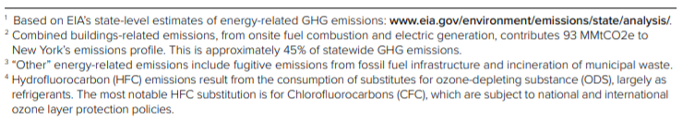
Figure 2: Overview of the State’s GHG Emissions in 2016

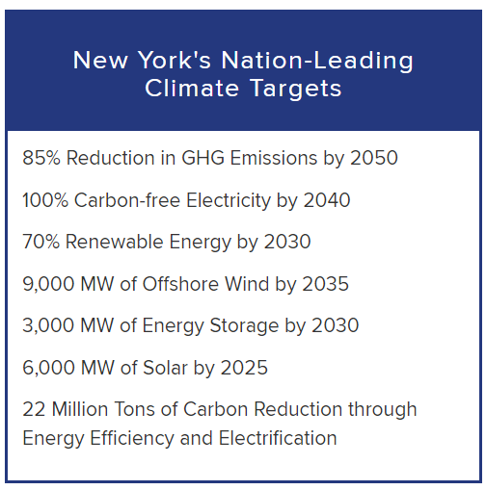
Figure 3: Overview of the CLCPA targets

The Purpose of a Greenhouse Gas Inventory
Many local governments have decided to gain a detailed understanding of how their emissions and their community’s emissions are related to climate change and have committed to reducing GHG emissions at the local level. Local governments exercise direct control over their own operations and can lead by example by reducing energy usage in municipal facilities, using alternative fuels for their fleets, and investing in renewable energy sources. Local governments can also influence community-wide activities that contribute to climate change by improving building codes and standards, providing cleaner transportation options, and educating members of the community about their choices as consumers. Each local government is unique with its own set of opportunities, challenges, and solutions, and therefore climate action needs to be tailored to each community at the local level.

Because local governments typically contribute less than ten percent of the total greenhouse gas emissions generated in a given community, it is recommended that local governments develop both local government operations and community-wide greenhouse gas emissions inventories and reduction strategies. Before concerted management and reduction of greenhouse gas emissions can occur within our local governments and communities, local governments must undertake measurement and analysis of all GHG sources. As mentioned previously, SUNY ESF students compiled a municipal operations GHG inventory for the village operations on a parallel track to this community inventory being developed. The community inventory includes energy use and emissions data for the 2019 year while the municipal operations inventory includes energy use and emissions data for the 2021 year.

It is important to note that this inventory represents an estimate of emissions for the Village of Tully community for the 2019 year, and that the purpose of this inventory is to gain a general baseline of emissions upon which the village can work from for climate action planning purposes. This inventory includes a number of assumptions and estimations, and the methods used to establish this baseline will not necessarily be the same methods used to measure progress.

There are several major benefits to compiling emissions inventories:

- Fiscal benefits: Developing climate and energy strategies can help reduce energy costs and save taxpayer dollars. Conducting a GHG emissions inventory will explain exactly how energy is being used and identify opportunities to become more efficient.

- Climate leadership: By taking action now to address climate change, local governments and elected officials can be recognized for their leadership on climate and energy issues.

- Community benefits: Measures to reduce GHG emissions and energy consumption typically have many co-benefits. They can improve air quality and public health, stimulate the local economy, create green jobs, and make communities more livable and walkable.

- Regulatory preparedness: Taking action now will help your jurisdiction prepare for any future legislative requirements and position your local government for successful compliance.

Village Profile
The Village of Tully is located in southern Onondaga County. The village covers an area of approximately 0.6 square miles and is located within the Town of Tully. According to the 2019 American Community Survey, the village has a population of about 951 residents, with 428 occupied housing units.

II. Data Collection and Analysis
Information related to residential, commercial/industrial, transportation, waste, and wastewater, were collected for the Village of Tully community for the 2019 year following the U.S. Community Protocol. Specific data collection methods for each sector are explained within each section of this report.

The ICLEI ClearPath tool was utilized to convert the information into emissions data measured in metric tons of carbon dioxide equivalent (MTCO₂e). The online tool streamlines the process of converting different sources, units, and varieties of emissions into comparable energy use and emissions figures.

Reporting
The three most prevalent greenhouse gases, and therefore the focus of this analysis, are carbon dioxide (CO₂), methane (CH₄) and nitrous oxide (N₂O). The unit used to discuss these gases in aggregate is carbon dioxide equivalent (CO₂e), which is a conversion based on each gas’s Global Warming Potential (GWP), or the impact of 1 unit of each gas in the atmosphere compared to 1 unit of CO₂ (see Table 1). This inventory uses the 20-year GWP values published by the IPCC’s 5th Assessment Report. A discussion of emissions using the IPCC’s 2nd Assessment Report is also included later in this report since these were the GWPs used in the 2010 regional greenhouse gas inventory effort.

Greenhouse Gas (GHG) | Global Warming Potential (GWP)
Carbon Dioxide (CO₂) | 1
Methane (CH₄) | 85
Nitrous Oxide (N₂O) | 264

Table 1: IPCC 5th Assessment 20-year Global Warming Potential Values

Emissions are reported by sector and source in this inventory. Sectors are included or excluded in the boundaries of GHG inventories based on availability of data, relevance to emissions totals, and scale to which they can be changed. This inventory includes emissions for the residential, commercial/industrial, transportation, waste, and wastewater sectors. Commercial and industrial sectors are combined due to availability of data from the Utility Energy Registry (UER), which combines commercial/industrial electricity and natural gas use into what it refers to as the “business” sector. Emissions data is also reported by source, including electricity, natural gas, and fuel oil as sources of emissions within the residential or commercial/industrial sectors, while gasoline and diesel are included as sources of emissions within the transportation sector.

III. Community Emissions Inventory

Overall Results
In 2019, the Village of Tully’s community emissions totaled 5,073 MTCO₂e. The residential energy use sector contributed to the largest percentage of emissions, accounting for 2,119 MTCO₂e, or 42% of the community’s total emissions. Transportation was the next highest emitting sector, producing 1,425 MTCO₂e, or 28% of total community emissions, followed by the commercial/industrial energy use sector, which produced 1,249 MTCO₂e, or 24% of total emissions. The waste sector emitted 272 MTCO₂e, or 5% of emissions, followed by the wastewater sector which contributed 8 MTCO₂e, or 0% of emissions.

Figure 4: 2019 Community Emissions by Sector

The largest source of community emissions in the Village of Tully in 2019 was natural gas, accounting for 2,450 MTCO₂e, or 48% of all community emissions. Gasoline was also a large emitting source, producing 1,007 MTCO₂e (20%).

Figure 5: 2019 Community Emissions by Source

Residential Sector

Methods and inputs
Residential electricity and natural gas usage for 2019 was collected using the Utility Energy Registry (UER), which was developed pursuant to the Order Adopting the Utility Energy Registry, issued by the New York State Public Service Commission on April 20, 2018. The UER “standardizes and crowdsources data directly from utilities,” and “was developed by NYSERDA to provide local communities data they need to develop greenhouse gas (GHG) inventories and to track progress towards climate goals.” A few months of data were withheld for both electricity and natural gas, so usage in those months was estimated using the average of the months with data available.

Residential fuel oil use was compiled using the 2019 American Community Survey 5-Year Estimates tables for Selected Housing Characteristics which indicates house heating fuels within the Village of Tully. This information was compared to New York State data for household heating fuel, also from the 2019 American Community Survey 5-Year Estimates tables, and amount/type of fuel consumed within the state (according to the US Energy Information Administration (EIA)’s 2019 Residential Energy Consumption Estimates) to calculate estimated heating fuel use within Village of Tully homes.

Residential energy uses were entered into ClearPath using standard emissions factors for natural gas and fuel oil. The Environmental Protection Agency (EPA)’s Emissions & Generation Resource Integrated Database (eGRID) factors for NPCC Upstate NY from 2019 were used for electricity emissions calculations (see Table 2 below).

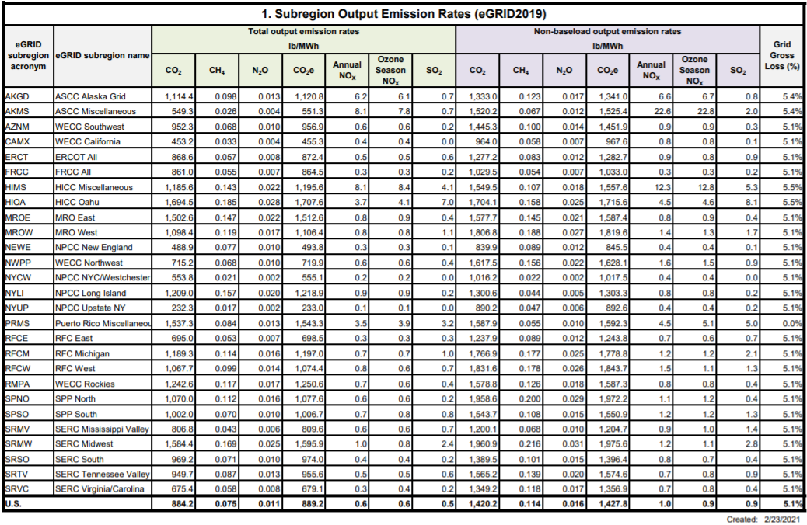
Table 2: eGRID2019 Summary Table: Subregion Emissions

Results
Residential electricity consumption in 2019 was 3,618,872 kWh; residential natural gas consumption was 310,558 therms; and residential fuel oil consumption was estimated at 972 MMBtu. Residential emissions from electricity in 2019 were 385 MTCO₂e; emissions from residential natural gas were 1,661 MTCO₂e; and emissions from fuel oil were 73 MTCO₂e. Overall residential emissions in 2019 were 2,119 MTCO₂e.

Figure 6: 2019 Residential Emissions by Source

Commercial/Industrial Sector

Methods and inputs
Commercial/industrial electricity and natural gas usage for 2019 were gathered from the National Grid UER data for 2019, under the Business field (which includes non-residential customers). A few months of data were withheld for both electricity and natural gas, so usage in those months was estimated using the average of the months with data available.

Commercial/industrial propane and fuel oil use were estimated by assuming the proportion of residential homes using propane and fuel oil within the Village of Tully is equal to the proportion of commercial square footage within the Village of Tully using propane and fuel oil. Since no homes in Tully use propane for heating, it was assumed that no businesses do either.

The proportion of residential homes using fuel oil was determined from the 2019 American Community Survey 5-Year Estimates tables for Selected Housing Characteristics, which indicate house heating fuels within the Village of Tully, compared to total occupied housing units within the village. These ratios were multiplied by the estimated commercial square footage within the Village of Tully to come up with the estimated commercial/industrial space within the village that uses fuel oil.

Commercial/industrial square footage in the Village of Tully was estimated using commercial floor space per worker from the US EIA’s Commercial Buildings Energy Consumption Survey (CBECS) information for 2012 (this was the most recent year with data available), multiplied by the total number of nonfarm workers in the Village of Tully according to the American Community Survey 2019 5-year tables for Occupation by Sex for the Civilian Employed Population 16 Years and Over (including all employed minus natural resources, construction, and maintenance occupations).

Commercial square footage in the Village of Tully using fuel oil were then compared to commercial square footage using fuel oil within New York State. Total commercial floor space within New York was calculated using EIA’s Commercial Buildings Energy Consumption Survey (CBECS) for 2012 (this was the most recent year with data available), multiplied by the total number of nonfarm workers as per the American Community Survey 2019 5-year tables for Occupation by Sex for the Civilian Employed Population 16 Years and Over (including all employed minus natural resources, construction, and maintenance occupations) for New York State. Tully commercial/industrial space using fuel oil were then compared to the statewide proportion of households using fuel oil from the statewide American Community Survey. That ratio was then multiplied by the total fuel use within New York State (from the EIA’s State Energy Data System (SEDS) 2019 report) to come up with the total commercial/industrial fuel oil use within the Village of Tully. These calculations are explained in detail within the CNY RPDB’s data collection and analysis workbooks for this inventory.

Commercial energy uses were entered into ClearPath using the default emissions factors for natural gas and fuel oil. Similar to the residential electric analysis, the EPA’s eGRID factors from 2019 was used for electricity emissions calculations for the commercial/industrial sector.

Results
Commercial/industrial electricity consumption in 2019 was 4,078,917 kWh; commercial/industrial natural gas consumption was 147,470 therms; and commercial/industrial fuel oil consumption was 361 MMBtu. Commercial/industrial emissions from electricity in 2019 were 433 MTCO₂e; emissions from commercial/industrial natural gas were 789 MTCO₂e; and emissions from fuel oil were 27 MTCO₂e. Total emissions from the commercial/industrial sector in 2019 were 1,249 MTCO₂e.

Figure 7: 2019 Commercial/Industrial Emissions by Source

Transportation Sector

Methods and inputs
Transportation emissions were estimated using estimated annual vehicle miles traveled (AVMT), 2019 U.S. National Default emissions factors (updated 2021 – see Table 3 below), and estimates for percentage of vehicle types. Transportation emissions were broken down for diesel and gasoline, assuming a standard 10% ethanol blend in gasoline.

AVMT for 2019 was calculated by multiplying available Annual Average Daily Traffic (AADT) counts from 2019 by road lengths within the Village of Tully and multiplying total daily VMT by 365 days per year.

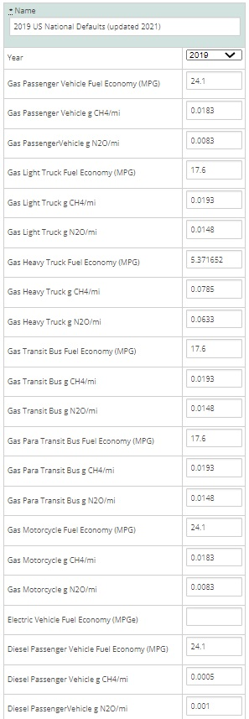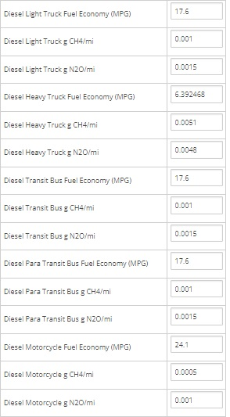
Table 3: 2019 US National Default Transportation Emissions

AADT counts were primarily only available for main arteries; therefore, additional calculations for AADT were needed to estimate AVMT for local/collector roads, as well as some main arteries that do not have AADTs available. The total length of roads in Tully with traffic counts is 2.342 miles, while 2.527 miles of roads do not have AADT counts available.

According to the Minimum Maintenance Standards Regulation 239/02, a set of guidelines produced by the Association of Municipalities of Ontario to help local communities estimate traffic volume, while conducting an AADT count, it is possible to estimate the traffic volume for dead-ends and cul-de-sacs to avoid resource intensive counts. This is done by multiplying the number of houses on the roadway by a factor of 6 for rural areas.

This method was applied to the Village of Tully for the roads without AADT counts since most of these roads were local/collector roads. It was determined that there were 428 occupied households in the Village of Tully in 2019, according to the American Community Survey. It was assumed that all homes are on roadways that do not have a count, since most houses are on local/collector roads. By multiplying the number of occupied homes by 6, a combined AADT count of 2,568 was calculated for all 2.527 miles of roads without AADT counts available. In order to calculate VMTs, an average AADT value was needed, and derived by dividing the total AADT by the 2.527 miles of uncounted roadway. This gave an average AADT value of 1,016.3 for 2019, which was applied to all roadways that did not have a count.

Results
AVMT for roads with AADT counts available in 2019 totaled 2,011,411.63, while AVMT for roads without AADT counts available in 2019 totaled 937,320. Total AVMT in 2019 was 2,948,762.

BeginDescr | EndDescrip | RoadwayNam | Calculatio | AADT | Length_Mi | VMT
CLINTON ST | DOUGLAS ST | LINCOLN AVE | 2019 | 346 | 0.170000 | 58.82
GROVE ST | LINCOLN AVE | DOUGLAS ST | 2019 | 422 | 0.048007 | 20.26
START 11/80 OLAP TULLY | APULIA RD |  | 2019 | 3430 | 0.409413 | 1404.29
LAKE ST TULLY S VILLAGE LN | START 11/80 OLAP TULLY |  | 2019 | 1534 | 0.470000 | 720.98
START 11/80 OLAP TULLY | RT 281 START 11/80 OLAP |  | 2019 | 5475 | 0.248482 | 1360.44
START 11/80 OLAP TULLY | RT 281 START 11/80 OLAP |  | 2019 | 5475 | 0.243250 | 1331.79
Cort/Onon Co Line | LAKE ST TULLY S VILLAGE LN |  | 2019 | 968 | 0.002624 | 2.54
STATE ST | DOUGLAS ST | ONONDAGA ST | 2019 | 1209 | 0.248150 | 300.01
SKADDAN TERR | MELINDA LA | VILLAGE VIEW DR | 2019 | 60 | 0.170016 | 10.20
CORTLAND CO LN | DOUGLAS ST | TRUXTON HILL RD | 2019 | 909 | 0.331646 | 301.47
 |  |  |  |  | Daily VMT total | 5,510.80
 |  |  |  |  | 365 days | 365.00
 |  |  |  |  | Annual VMT | 2,011,441.63

Table 4: 2019 Village of Tully Traffic Data for Road Segments with Available AADT

# occupied housing units: | 428
Total AADT for roads not accounted for above: | 2,568
Days per year: | 365
Average AADT for roads not accounted for above: | 1016.3
Total Annual VMT for manually calculated roads: | 937,320

Table 5: 2019 Village of Tully Traffic Data for Road Segments without Available AADT

Emissions from transportation in the Village of Tully in 2019 totaled 1,425 MTCO₂e, with 1,007 MTCO₂e from gasoline (10% ethanol) and 418 MTCO₂e from diesel.

Figure 8: 2019 Transportation Emissions by Source

Waste Sector

Methods and inputs
Waste emissions from the Village of Tully were calculated using total tons of waste from Onondaga County disposed of at the Onondaga County Resource and Recovery Agency (OCRRA)’s Waste to Energy facility and scaling down to the village based on population. There were 6,008 tons of waste disposed of from the Village of Tully in 2019.

County Population | Village of Tully population | Total tons waste from Onondaga County (not including recycling) | Disposal method | Tons of waste disposed per person | Tons of waste disposed from Village of Tully
462,872 | 951 | 362,653 | Waste-to-energy | 0.78 | 745.09

Table 6: 2019 Community Waste Estimation

All waste disposed of at the Waste to Energy Facility was entered into the “Combustion of Solid Waste Generated by the Community” calculator and calculated using ICLEI’s SW.2.2a methodology.

Results
Waste emissions for the Village of Tully in 2019 totaled 272 MTCO₂e.

Wastewater Sector

Methods and inputs
It is illegal to have a private septic tank/system within the Village. Therefore, all residents in the Village of Tully are using the Village’s wastewater treatment facility, which is located within the Village’s boundary.

Process emissions from the Village’s wastewater treatment facility were calculated using the Process N2O Emissions from Wastewater Treatment and the Process N2O From Effluent Discharge to Rivers and Estuaries calculators in ClearPath. The total population served by the facility in 2019 was 951, and the Industrial Commercial Discharge Multiplier of 1.25 from ICLEI protocols was used in the calculations.

Results
Overall wastewater emissions are estimated to be 8 MTCO₂e.

IV. Municipal Operations Emissions Forecast

Methods and inputs
A municipal operations emissions forecast is included here to provide a sense of what emissions might look like in 2030 for municipal operations under a business-as-usual scenario. The forecast was compiled using ICLEI’s protocol for forecasting and entering data into the ClearPath tool online. Data from the 2021 municipal inventory, under separate cover, was used as a baseline for this forecast. Compound Average Growth Rates were used to forecast emissions in all sectors using the inputs noted below.

To forecast emissions from the municipal buildings and facilities sector, population growth rates from 2010 to 2019 as well as mandates of the Climate Leadership and Community Protection Act (i.e. 70% electricity from renewables by 2030) were used. It is assumed that as population of the village increases, energy used by municipal operations at facilities increases in a proportional manner.

To forecast emissions from municipal streetlights, mandates of the Climate Leadership and Community Protection Act (i.e. 70% electricity from renewables by 2030) were used. It is assumed that as population of the village increases, energy used by streetlights will increases in a proportional manner.

To forecast emissions from the municipal vehicle fleet, population growth rates as well as Federal rules on vehicle fuel mileage standards were used. It is assumed that as population of the village increases, energy used by the municipal vehicle fleet increases in a proportional manner.

To forecast emissions from water and wastewater facilities, population growth rates as well as mandates of the Climate Leadership and Community Protection Act (i.e. 70% electricity from renewables by 2030) were used. It is assumed that as population of the village increases, energy used by municipal operations at water and wastewater facilities increases in a proportional manner, along with process emissions from wastewater treatment.

Results
Assuming a business-as-usual scenario, emissions in the Village of Tully in 2030 are expected to decrease from 128 MTCO₂e in 2019 to 82 MTCO₂e in 2030, a decrease of about 36%. Each sector’s forecast is explained further below.

Figure 9: Village of Tully Municipal Operations 2030 Emissions Forecast

Discussion
Electric, natural gas, and diesel used at municipal buildings and facilities are expected to increase slightly in accordance with the village population growth trend (which has increased since 2010). However, since the Climate Leadership and Community Protection Act (CLCPA) requires the state to achieve 70% renewable electricity by 2030, emissions from municipal operation buildings and facilities are expected to remain constant at 5 MTCO₂e from 2021 to 2030.

Emissions from the municipal vehicle are expected to decrease, because even though vehicle miles traveled are expected to increase in accordance with the village’s population growth trend, there are expected to be decreases in the carbon intensity of the vehicle miles traveled as federal transportation policies require vehicle fuel mileage standards to improve over time. Emissions from municipal vehicle fleet at therefore expected to decrease from 33 MTCO₂e in 2021 to 18 MTCO₂e by 2030.

Emissions from streetlights are expected to decrease from 1 MTCO₂e to 0 MTCO₂e in accordance with CLCPA goals of achieving 70% renewable electricity by 2030.

Finally, emissions from water and sewer facilities are expected to decrease from 89 MTCO₂e in 2021 to 59 MTCO₂e by 2030 because even though electric and natural gas energy use and process emissions are expected to increase slightly based on the population growth rate, the emissions from electricity are expected to decrease significantly, from 51 MTCO₂e to 17 MTCO₂e, mostly in accordance with the CLCPA goals of achieving 70% renewable electricity by 2030.

V. Community Emissions Forecast

Methods and inputs
A community emissions forecast is included here to provide a sense of what emissions might look like in 2030 under a business-as-usual scenario. The forecast was compiled using ClearPath guidance. Compound Average Growth Rates were used to forecast emissions in all sectors, using the inputs noted below.

To forecast emissions from the residential and commercial/industrial sectors, State energy use trends as described in the 2015 New York State Energy Plan and mandates of the Climate Leadership and Community Protection Act (i.e. 70% electricity from renewables by 2030) were used.

To forecast emissions from the transportation sector, State energy use trends as described in the 2015 New York State Energy Plan and Federal rules on vehicle fuel mileage standards were used.

To forecast emissions from the waste sector, population growth rates for the Village of Tully from the American Community Survey from 2010 vs. 2019 were used, assuming population would continue to decrease at a similar rate through 2030 and waste production would decrease proportionally to the population growth rate.

To forecast emissions from the wastewater sector, population growth rates for the Village of Tully from the American Community Survey from 2010 vs. 2019 were used, assuming population would continue to decrease at a similar rate through 2030 and wastewater emissions would decrease proportionally to the population growth rate.

Results

Assuming a business-as-usual scenario, emissions in the Village of Tully in 2030 are expected to decrease from 5,073 MTCO₂e in 2019 to 3,713 MTCO₂e in 2030, a decrease of about 27%. Emissions are expected to decrease in all sectors. Each sector’s forecast is explained further below.

Figure 10: Village of Tully Community 2030 Emissions Forecast

Discussion

Emissions from the residential sector are expected to decrease from 2,119 MTCO₂e in 2019 to 1,844 MTCO₂e by 2030.

Figure 11: Forecasted Residential Emissions in the Village of Tully for 2030

Since the Climate Leadership and Community Protection Act has set a goal of 70% electricity coming from renewables by 2030, emissions from residential electricity use are expected to drop significantly. Residential fuel oil use is projected to decrease as well, with natural gas use staying about the same, according to the 2015 New York State Energy Plan.

Emissions from the commercial/industrial sector are expected to decrease overall, from 1,249 MTCO₂e in 2019 to 996 MTCO₂e by 2030.

Figure 12: Forecasted Commercial/Industrial Emissions in the Village of Tully for 2030

Since the Climate Leadership and Community Protection Act has set a goal of 70% electricity coming from renewables by 2030, emissions from commercial/industrial electricity use are expected to drop significantly. Commercial/industrial fuel oil use is projected to remain about the same, and natural gas use is expected to increase slightly over time, according to the 2015 New York State Energy Plan.

Emissions from the transportation sector are expected to decrease overall as well, from 1,425 MTCO₂e in 2019 to 555 MTCO₂e by 2030.

Figure 13: Forecasted Transportation Emissions in the Village of Tully for 2030

According to the 2015 New York State Energy Plan, gasoline and vehicle miles traveled are expected to decrease over time, with diesel use and vehicle miles traveled increasing. However, the carbon intensity of the vehicle miles traveled for all fuel types is expected to decrease as federal transportation policies require vehicle fuel mileage standards to improve over time, so emissions from all fuel sources are expected to decrease.

Emissions from the waste sector are expected to increase slightly, from 272 MTCO₂e in 2019 to 309 MTCO₂e by 2030. This forecast is directly related to estimated population growth rate in the village.

Emissions from the wastewater sector are expected to increase slightly as well, from 8 MTCO₂e in 2019 to 9 MTCO₂e in 2030. This forecast is directly related to estimated population growth rate in the village.

VI. Discussion: 2010 vs 2019 Inventory

As part of the regional greenhouse gas inventory effort which was prepared by ICF International with a baseline year of 2010, community inventories were also provided for Central NY municipalities. Below is a discussion comparing emissions for the community in 2010 vs 2019.

It should be noted that the 2010 inventory was compiled using the current standards at the time, which meant using Global Warming Potentials (GWPs) from the IPCC’s 2nd Assessment Report compared to the current standard of using the 20-year GWPs in IPCC’s 5th Assessment Report. Therefore, Figure 17 below shows what emissions totals would be for 2019 using the same GWPs as were used to calculate 2010 emissions (noted as “2019 IPCC 2nd”).

The IPCC 2nd assessment report assumes a GWP of 21 for methane over a 100-year period, meaning that the impact of 1 unit of methane in the atmosphere creates 21 times more warming potential than 1 unit of CO₂ over a 100-year time period. However, methane typically remains in the atmosphere for closer to 12 years as opposed to CO₂ which can remain in the atmosphere for over 100 years, meaning that methane’s impact while it remains in the atmosphere is much stronger than that of CO₂. Therefore, the IPCC 5th assessment report includes both a 100 year and 20-year GWP for methane of 28 and 84, respectively. The IPCC 5th assessment report’s 20-year GWP for nitrous oxide is 264 as compared to 310 from the IPCC 2nd assessment report, 100-year GWP.

As illustrated in Figure 17, there is not a large difference between the two GWP scenarios for most sectors, but there is a more noticeable increase in emissions for waste using the IPCC 5th assessment 20-year GWPs. Therefore, it is important to consider the methodology used in creating this and future inventory updates, as well as when comparing data from this inventory to inventories from other communities.

Community Comparison
In 2010, emissions from the Village of Tully community totaled 9,771 MTCO₂e, compared to 5,073 MTCO₂e in 2019. It should be noted that the 2010 baseline was able to separate out Commercial and Industrial emissions due to availability of data at the time, but the two sectors are included in the Commercial/Industrial Use sector in Figure 17 below.

It should also be noted that Wastewater emissions were not included in the 2010 inventory, and industrial processes and energy supply sectors were not included in this 2019 inventory due to lack of data, hence the missing information in Figure 18 below.

Finally, it should be noted that the two inventories used similar methodologies for calculating emissions from residential energy use and commercial energy use . However, the inventories differed fairly significantly in process and methodology for calculating waste and transportation.

Figure 17: Village of Tully 2011 vs 2019 Community Emissions

As illustrated in Figure 17, emissions in the commercial/industrial and transportation sectors appear to have decreased significantly. This could be a result of:
- a decrease in energy used in the sectors,
- a decrease in emissions factors for electricity and transportation as a result of less polluting source energy and a cleaner electricity grid and improved vehicle emissions standards, and/or
- a difference in methodology in calculating emissions (e.g. 2010 emissions for transportation include off-road transportation emissions, whereas 2019 emissions for transportation only include on-road emissions).

Emissions from the residential and waste sectors appear to have increased, which could be a result of:
- increased energy use in the residential sector and increased waste production, and/or
- a difference in methodology in calculating emissions (e.g. residential electric and gas data is now based off of utility-provided usage figures from the Utility Energy Registry as opposed to statewide energy use figures; 2010 emissions for waste do not include emissions from the waste to energy facility, whereas 2019 emissions for waste are specific to emissions generated at the waste to energy facility).

VII. Conclusion
This greenhouse gas inventory can help inform a community-wide Climate Action Plan, which can help the village chart a course for reducing emissions.

The results of this study indicate that the largest percentage of community emissions came from the residential energy use for 2019, with 67% of emissions from residential and commercial/industrial energy use combined. Emissions from buildings should therefore be targeted in the village’s future Climate Action Plan so that energy use from these sectors can be reduced, therefore lowering both energy costs and GHG emissions. Efforts could be directed towards cleaner sources of heating and cooling, including implementing local community campaigns for clean heating and cooling and energy efficiency, which could be completed in coordination with HeatSmart CNY and with the assistance of the CNY RPDB.

It is recommended that the village continue to participate in the Clean Energy Communities program and other state and utility incentive programs to help achieve additional energy and emissions savings. The CNY RPDB is available to provide technical assistance to implement projects and to secure grants and other financial support for projects.

As a Climate Smart Community, the Village of Tully has partnered with state and local agencies to combat climate change and pledge to reduce greenhouse gas emissions. Conducting an emissions inventory is an important step in climate action planning, mitigation, and adaptation. This inventory will provide a benchmark for planning purposes and can serve as a baseline for a future Climate Action Plan.

VIII. Bibliography

Center for Climate and Energy Solutions. (2020). Federal Vehicle Standards. Retrieved from https://www.c2es.org/content/regulating-transportation-sector-carbon-emissions/.

ICLEI. (2020). ClearPath. Retrieved from https://clearpath.icleiusa.org/.

IPCC. (2014). Fifth Assessment Report. Retrieved from https://www.ipcc.ch/report/ar5/syr/.

IPCC Working Group I. (2007). The Physical Science Basis. Retrieved from https://wg1.ipcc.ch/publications/wg1-ar4/faq/wg1_faq-1.3.html.

Level of Service Policy for Municipal Highways in the United Townships of Head, Clara & Maria. (2008). Retrieved from http://www.townshipsofheadclaramaria.ca/download.php?dl=YToyOntzOjI6ImlkIjtzOjI6 Ijg1IjtzOjM6ImtleSI7aTo0O30=.

NYSERDA. (2014). Climate Change in New York State: Updating the 2011 ClimAID Climate Risk Information. Retrieved from https://www.nyserda.ny.gov/About/Publications/Research%20and%20Development%20 Technical%20Reports/Environmental%20Research%20and%20Development%20Techni cal%20Reports/Response%20to%20Climate%20Change%20in%20New%20York.

NYSERDA. (2019). New York Greenhouse Gas Inventory Fact Sheet. Retrieved from https://www.nyserda.ny.gov/About/Publications/EA-Reports-and-Studies/Energy- Statistics.

NYSERDA. (2021). Utility Energy Registry. Retrieved from
https://utilityregistry.org/app/#/datagrid.

US EIA. (2021). State Energy Data System (SEDS): 1960-2019. Retrieved from https://www.eia.gov/state/seds/seds-data-complete.php#Consumption.

US EIA. (2016). Commercial Buildings Energy Consumption Survey (CBECS). Retrieved from https://www.eia.gov/consumption/commercial/data/2012/#b1-b2.

US EPA. (2021). eGRID 2019 Summary Tables. Retrieved from https://www.epa.gov/egrid/egrid-2019-summary-tables.

The U.S. Community Operations Protocol was developed by ICLEI-Local Governments for Sustainability in order to provide “detailed, cutting-edge guidance on completing a GHG emissions inventory at the community scale in the United States — including emissions from businesses, residents, and transportation,” according to ICLEI’s website.
ClearPath is a proprietary tool developed by ICLEI-Local Governments for Sustainability to assist local governments with conducting greenhouse gas emissions inventories and with the development of local climate action plans.
IPCC. 2014. Fifth Assessment Report. https://www.ipcc.ch/report/ar5/syr/
IPCC. 2021. Sixth Assessment Report Headline Statements from the Summary for Policymakers. https://www.ipcc.ch/report/ar6/wg1/downloads/report/IPCC_AR6_WGI_Headline_Statements.pdf
IPCC Working Group. https://wg1.ipcc.ch/publications/wg1-ar4/faq/wg1_faq-1.3.html
NYSERDA. 2014. Climate Change in New York State: Updating the 2011 ClimAID Climate Risk Information. https://www.nyserda.ny.gov/About/Publications/Research%20and%20Development%20Technical%20Reports/Environmental%20Research%20and%20Development%20Technical%20Reports/Response%20to%20Climate%20Change%20in%20New%20York
NYSERDA. 2014. Climate Change in New York State: Updating the 2011 ClimAID Climate Risk Information. https://www.nyserda.ny.gov/About/Publications/Research%20and%20Development%20Technical%20Reports/Environmental%20Research%20and%20Development%20Technical%20Reports/Response%20to%20Climate%20Change%20in%20New%20York; and National Climate Assessment. 2014. Climate Change Impacts in the United States. https://nca2014.globalchange.gov/.
NYSERDA. Greenhouse Gas Inventory Fact Sheet. https://www.nyserda.ny.gov/About/Publications/EA-Reports-and-Studies/Energy-Statistics.
ICLEI. 2012. U.S. Community Protocol for Accounting and Reporting of Greenhouse Gas Emissions.
NYSERDA. Utility Energy Registry. https://utilityregistry.org/app/#/
US EIA. State Energy Data System (SEDS): 1960-2019. https://www.eia.gov/state/seds/seds-data-complete.php#Consumption
The ClearPath tool provides standard emissions factors that were developed by ICLEI and are described in the Local Government Operations Protocol, Appendix G.
US EPA. Emissions & Generation Resource Integrated Database (eGRID). https://www.epa.gov/egrid/summary-data.
US EIA. Commercial Buildings Energy Consumption Survey (CBECS). https://www.eia.gov/consumption/commercial/data/2012/#b1-b2
US EIA. Commercial Buildings Energy Consumption Survey (CBECS). https://www.eia.gov/consumption/commercial/data/2012/#b1-b2
US EIA. State Energy Data System (SEDS): 1960-2019. https://www.eia.gov/state/seds/seds-data-complete.php#Consumption.
The ClearPath tool provides standard emissions factors that were developed by ICLEI and are described in the Local Government Operations Protocol, Appendix G.
US EPA. Emissions & Generation Resource Integrated Database (eGRID). https://www.epa.gov/energy/emissions-generation-resource-integrated-database-egrid.
As per Eli Yewdall at ICLEI, “The default vehicle factor sets are derived from EIA data for fuel economy, and EPA emissions factors for CH4 and N2O. Because EPA publishes factors by model year, we had to convert those to represent the average mix of new and old vehicles on the road in a particular year; we did this using data from the US National GHG inventory.”
As provided by Eli Yewdall at ICLEI: Gasoline passenger vehicles: 68.6% Deisel passenger vehicles: 0.3% Gasoline light trucks: 19.7% Deisel light trucks: 0.8% Gasoline heavy trucks: 1.4% Deisel heavy trucks: 8.5%
The gasoline entry in ClearPath was entered as ethanol with 10% biofuel to account for the typical 10% ethanol blend.
AADT and road segment length GIS data provided by the NYSDOT Highway Data Services Bureau. These traffic counts include all traffic within the village, including pass-through traffic where the origin and destination of trips occur outside of the village’s boundaries. These trips will be more difficult to address in climate action planning than the trips that begin and/or end within the village.
http://www.townshipsofheadclaramaria.ca/download.php?dl=YToyOntzOjI6ImlkIjtzOjI6Ijg1IjtzOjM6ImtleSI7aTo0O30=
As per instructions from Eli Yewdall of ICLEI.
According to the 2019 American Community Survey 5-Year Estimates tables
This forecast uses the March 2020 Safer Affordable Fuel Efficient (SAFE) Vehicles Rule, which projects combined passenger and light duty vehicle fuel efficiency to be 40.4 mpg by 2026, according to https://www.c2es.org/content/regulating-transportation-sector-carbon-emissions/ accessed 10/19/21.
Since ClearPath requires VMT inputs for municipal vehicle fleet forecasts, National Default Vehicle Fuel Efficiencies provided by ICLEI at https://docs.google.com/spreadsheets/d/1KXmtHoxI-mPXz0ujidtj76woUcK-RN9ITMRy-gMoUls/edit#gid=1929834944 were utilized to calculate estimated VMT for the village’s fleet, using average light trucks for gasoline and heavy duty trucks for diesel.
This forecast uses the national greenhouse gas (GHG) emissions standards for passenger cars and light trucks for Model Years 2023- 2026, finalized in December 2021, as per https://www.epa.gov/regulations-emissions-vehicles-and-engines/regulations-greenhouse-gas-emissions-passenger-cars-and, accessed 2/18/22.
IPCC. Climate Change 2014 Synthesis Report. https://ar5-syr.ipcc.ch/ipcc/ipcc/resources/pdf/IPCC_SynthesisReport.pdf
Though we now have the Utility Energy Registry which was not previously available for electricity and natural gas usage information.
Though we now have the Utility Energy Registry which was not previously available for electricity and natural gas usage information.
The 2010 inventory includes waste emissions generated at OCRRA’s Waste to Energy Facility in the Electricity Generation sector instead of the waste sector since this facility generates energy.
The 2010 inventory uses a “journey-to-work factor” and includes off-road transportation emissions for the community at large (e.g. recreational, logging, mining equipment). This 2019 inventory uses the methodology explained above as per ICLEI’s protocols and does not include off-road transportation emissions due to difficulty of obtaining of data.

