Village of Aurora, New York: 2022 Municipal Greenhouse Gas Inventory
Conducted Spring of 2023 by:
Eden Gardner, Lily John, Mackinzee Macho, Ethan McDevitt, Eldon Montague, Jade Nguyen
SUNY College of Environmental Science and Forestry
EST 427: Environmental Energy and Auditing
Dr. Joshua Cousins

Executive Summary
The contents of this document include the methods, results, analysis, and recommendations for the Municipal Greenhouse Gas Inventory for the Village of Aurora. This report was made possible by our professor, Dr. Joshua Cousins, our connections with Michael Bocuzzi and Amanda Mazzoni at the Central New York Regional Planning and Development Board, and the willingness of the Village of Aurora to take these next steps towards sustainability. We also extend our gratitude to Jim Yienger at Climate Action Associates for creating the useful GHG inventory tool.
After inputting the municipal energy, fuel, and cost data in the inventory tool, our results pointed to two sources that release the most greenhouse gasses and cost the most for the Village: the firehouse and wastewater treatment plant. The firehouse costs over $13,000 for heating oil in 2022, releasing 37.2 MTCO2e. The wastewater treatment plant takes 308,000 KWH of electricity to operate, costing the Village of Aurora almost $25,000 and releasing 32.8 MTCO2e.
The recommendations include Climate Smart Communities (CSC) compliance and specific emissions reductions strategies. If the Village of Aurora wants to take advantage of all that CSC has to offer, they are required to create a CSC Task Force and Coordinator to create priorities for the Village’s emissions reductions. The Village may submit a Government Operations Greenhouse Gas Inventory to CSC that uses the data and analysis contained in this report. A Government Operations Climate Action is a great next step after the inventory submission as it lays out initiatives to reduce the municipality’s emissions and costs. If the Village wants to take their climate action a step further, they may collect community energy and fuel use data to see a comprehensive picture of the whole Village’s climate change impacts. Lastly, the Village of Aurora may choose to input municipal GHG and energy data from preceding years into the ‘Jim” tool to understand their emissions and energy consumption trends.
As the wastewater treatment plant and firehouse are the most climate and financially costly buildings, it is recommended to shift away from fossil fuels and towards sustainable energies. The firehouse may turn to heat pumps or geothermal heat pumps to heat the building. This not only would reduce emissions but also costs tremendously for the Village. The wastewater treatment plant may be audited to find where the Village can increase efficiency and reduce costs. Although municipal vehicles make up a smaller portion of the Village’s GHG emissions, Climate Smart Communities offers rebates for municipalities purchasing full electric, hybrid, or hydrogen-powered vehicles- or Zero Emission Vehicles (ZEVs) if the Village is interested. Lastly, there is opportunity for collaboration with Wells College in reducing the whole community’s emissions.
The Village of Aurora is commendable for their interest in reducing emissions and doing their part to combat climate change. There are many areas for improvement and the Climate Smart Communities programs offers aid that is integral for communities mitigating and adapting to climate change. The Village of Aurora is becoming a leader in combating climate change for New York State and their community.

Table of Contents
Executive Summary 2
Acknowledgments 4
Introduction 5
Methods 6
Emissions Results and Discussion by Sector 8
Vehicle Fleet 8
Streetlights 8
Buildings and Facilities 9
Wastewater 9
Tank fuels (propane/fuel oil) 9
Cumulative Emissions Results and Discussion 9
Recommendations 13
Conclusion 16

Acknowledgments
It is essential that we express our gratitude for all parties that have guided us through this auditing process. We are very appreciative to be part of this endeavor and hope to empower the Village’s decision-making powers toward becoming a Climate Smart Community.
We would first like to thank our professor, Dr. Joshua Cousins, for providing us with this opportunity to collaborate on this project. This experience has been very enriching and valuable; we have thoroughly enjoyed applying the teachings of the course into the application of this project.
We would next like to express gratitude to the Central New York Regional Planning and Development Board and specifically Michael Boccuzzi and Amanda Mazzoni for their willingness to collaborate and share data with us.
Moreover, we want to thank the Village of Aurora for their desire to have a Greenhouse Gas Inventory conducted and entrusting us with this valuable project. Their endeavor to become a Climate Smart Community is an impressive mission to accomplish, and we are fortunate to be able to aid in that transition!

Introduction
As New York strives towards a more sustainable and environmentally just future, municipalities across the state are incorporating green infrastructure and technologies into their communities to meet government-sanctioned climate goals. One such program is the 'Climate Smart Communities' (CSC) initiative, which provides participating communities with tools, funding, rebates, and technical assistance to achieve their sustainability goals. The Village of Aurora has registered with the CSC program as part of their Comprehensive Plan and has pledged to take action, demonstrating strong initiative and support for a more sustainable municipality.
The Climate Smart Communities Certification Program was developed for New York State, and premiered in 2009 with the goal of encouraging local governments to formally commit to implementing strategies to mitigate climate change. New York State sponsorships include the Department of Environmental Conservation (DEC), the Energy Research and Development Authority (NYSERDA), and others. The program evolved to provide specific guidelines on how to implement these changes, and gain an official CSC certification. Now, the CSC platform has over 100 climate actions that communities can choose from in order to work towards a certification. Certifications are obtained by completing these actions and accumulating points, which contribute to the locality’s level of certification as bronze, silver, or gold. The goals of the program include reducing greenhouse gas emissions, building resilience to the impacts of climate change, saving taxpayer dollars, increasing energy security and reliability, and improving community public health and safety.
Many communities are seeking ways to mitigate and adapt to climate change as it poses threats to their residents’ wellbeing. In the Village of Aurora’s Comprehensive Plan, the main priority is building resiliency against flooding caused by more frequent stormwater runoff. Complementary to this effort, the Village seeks to implement sound stormwater management, increase sustainable energy usage, protect Cayuga Lake, and participate in the New York State smart growth communities.
The Village of Aurora took the Climate Smart Communities pledge and joined the Clean Energy Communities program as part of the NYS smart growth communities, but needs help in establishing a greenhouse gas emissions inventory. Greenhouse Gas (GHG) Emissions Inventories are one way for a community to measure its sustainability and identify areas where emissions can be most effectively reduced. These inventories allow for the analysis of different sources of emissions and how they can be mitigated. Such inventories pave the way for future economic benefits, with tax incentives and rebates. This is integral to the Climate Smart Communities pledge so that they may set goals and plan for climate action based on these baselines. When the Village of Aurora is ready to begin reducing emissions, they can receive technical assistance and government funding for their efforts. CSCs track their progress by fulfilling certification actions, like reducing GHGs from government vehicles or enacting a climate action plan. The more actions they perform, the more points they accrue to move from bronze to silver status.

Methods
A municipal GHG inventory is an easy first step to becoming a CSC. In keeping with CSC guidelines, emissions are classified by scope:

Scope 1: Direct GHG emissions from village-owned equipment
Scope 2: Indirect GHG emissions via purchasing electricity from utilities
Scope 3: Other indirect emissions (transport of goods, life-cycle assessments)

This inventory focuses on scope 1 and scope 2 emissions coming solely from municipal operations. All data was obtained from the CNYRPDB in conjunction with the Village of Aurora. The inventory was carried out through the CSC/CAA Excel Workbook, colloquially known as the ‘Jim Tool’ after its creator, Jim Yienger, at Climate Action Associates.

The first step in creating the GHG inventory is creating a facility master list, seen in Figure 1. By creating this master list, account data will automatically link to its associated building and use. This is the most important step in ensuring data will auto populate in the deliverables, or ‘GHG Inventory’ tab.
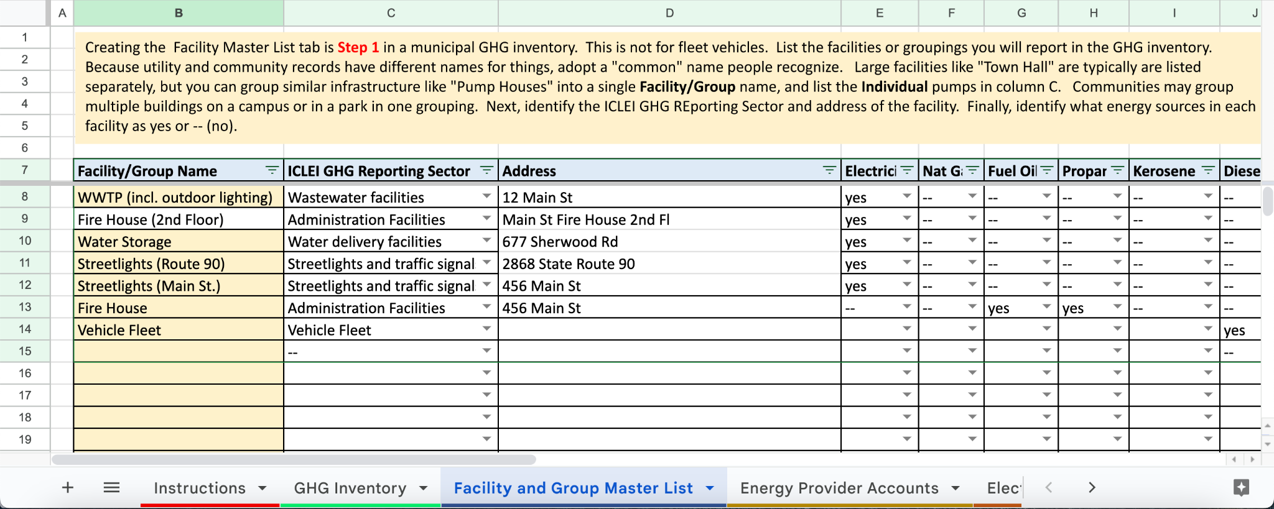
Figure 1. Aurora’s Facility Master List

After this, the next step is linking energy provider accounts, seen in Figure 2. This step allows the data obtained from energy bills to be assigned to the correct facility.

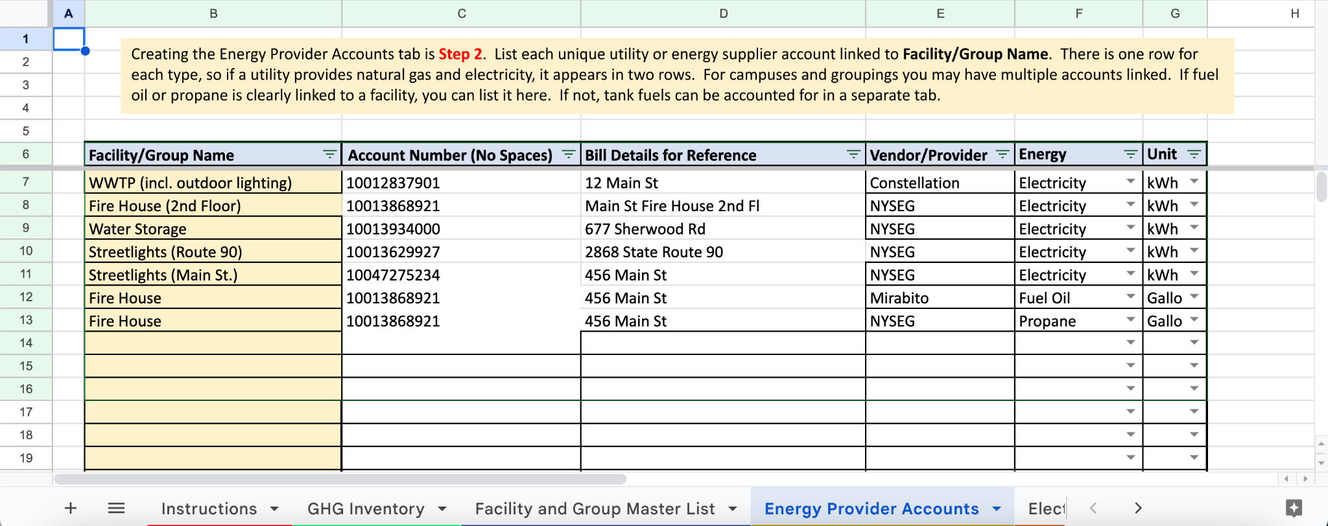
Figure 2. Energy Provider Accounts

From here, data obtained from the village is entered into four relevant categories:
- Electric bills (monthly & annual)
  - Electricity provided to WWTP, firehouse, and streetlights
- Tank Fuels
  - Propane and diesel provided to firehouse
- Vehicle Fleet Fuel
  - Fuels required to operate municipal vehicles
- Wastewater Treatment
  - Emissions from N₂O load

Once compiled, this data auto populates into deliverable information including annual costs, metric tons of CO₂ released, and energy consumed into the ‘GHG Inventory’ tab, seen in Figure 3. With this tab, total municipal emissions for Aurora are separated by year, sector, building, and more. The deliverables tab also comes with premade graphs that auto populate based on available data. Using these graphs, opportunities to reduce costs and emissions were identified, and factored into this report’s final recommendations.
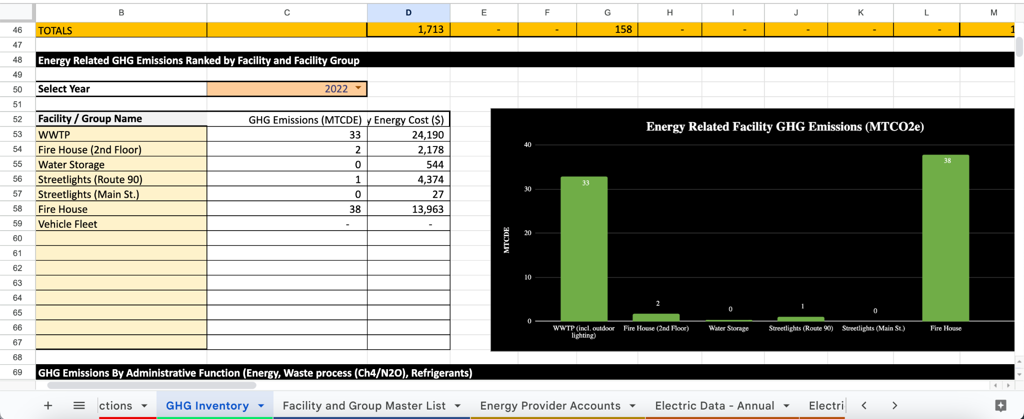
Figure 3. ‘GHG Inventory’ Tab showing some of the final data and deliverables

Emissions Results and Discussion by Sector

Vehicle Fleet
The Village’s vehicle fleet is composed of vehicles that fulfill the purposes of street sweeping, snow-blowing, and transporting between municipal facilities. The vehicle fleet used 1,713 gallons of gasoline, with an equivalent of $5,518.04 in financial costs. Diesel consumption was 157.5 gallons with a cost equivalent of $830.22.

Streetlights
The Village’s street lights light up State Route 90 as well as Main Street. For the street lights on both of these roads, 9,383 KWH were used, costing $4,401.23.

Buildings and Facilities
The Village’s municipal buildings and facilities consist of only the firehouse. The firehouse used 15,960 KWH of electricity for a price of $2,177.63. The firehouse also consumes 117 gallons of propane for a cost of $338.43 and 3648.7 gallons of fuel oil for a price of $13,624.91.

Wastewater
The Village’s wastewater treatment plant uses 311,250 KWH of electricity to process wastewater for the 2022 year. This sums up to $24,733.82. Propane is also used in the firehouse, totalling 117 gallons, or $338.43 worth of propane.

Tank fuels (propane/fuel oil)
Fuel oil is used in the Village to heat the firehouse. As iterated in the buildings and facilities section, the 2022 year showed that 3648.7 gallons of fuel oil were used for municipal heating at a price of $13,624.91.

Cumulative Emissions Results and Discussion
- Greenhouse Gas Emissions (in metric tons of carbon dioxide equivalent) by Sector Pie Chart
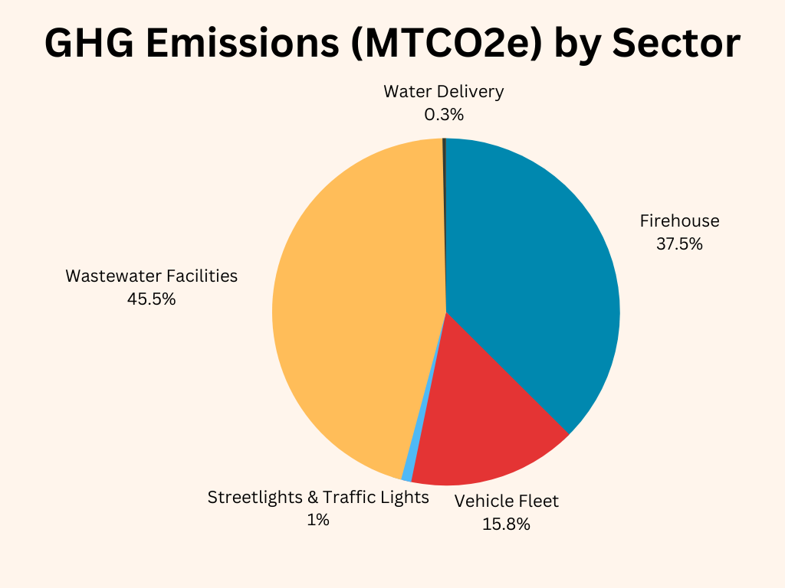

This graph serves as an excellent visualization of the proportional distribution of greenhouse gas emissions by sector. This graph became crucial to the understanding, breakdown, and recommendations as it altered prior assumptions around the costliest sector. It was presumed that the recommendations would be centered around electrifying the vehicle fleet, but from this graph it was determined to be a valuable recommendation, but not top priority. The wastewater facilities were expected to produce the greatest amount of emissions on behalf of how much energy is required to process wastewater. Hence, the proportion of emissions coming from the firehouse was proportionally alarming.

- Greenhouse Gas Emissions (in metric tons of carbon dioxide equivalent) by Sector Bar Graph
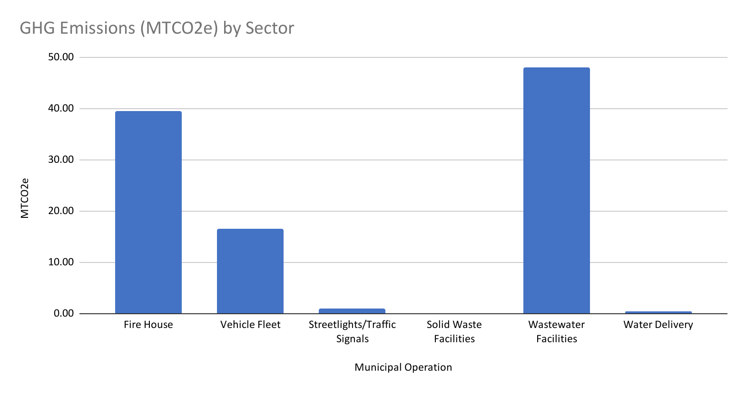
This bar graph is the equivalent to the pie chart, but instead highlights the emissions by value rather than in percentage in relation to each sector. This is another way to visualize the data by sector.

- Greenhouse Gas Emissions by Energy Type (in metric tons of carbon dioxide equivalent)
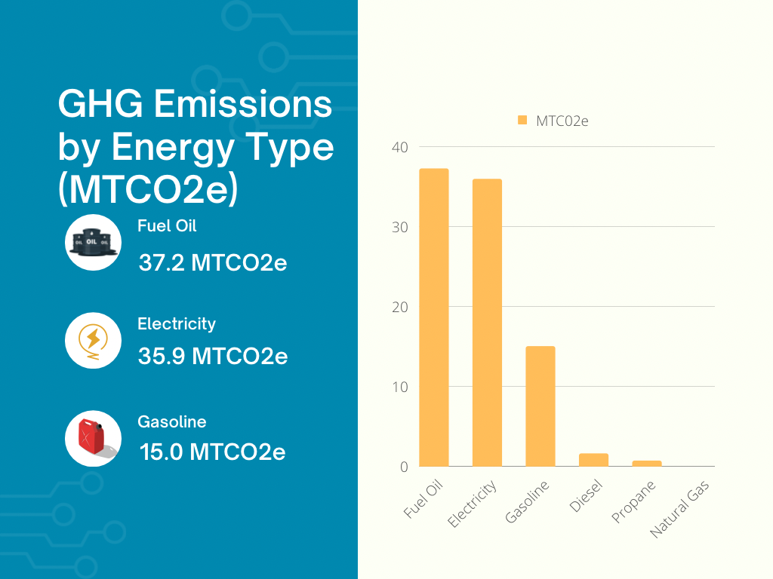

This graph was very important to the analysis as it indicated the significant amount of emissions by fuel oil. This influenced the recommendations further as it served as motivation to find ways to reduce or even eliminate fuel oil usage. With the knowledge that the fuel oil is used to heat the firehouse, an implementation of heat pumps is highly recommended to curb emissions and save money as the return on investment could be as soon as a few years.

- Annual Energy Use by Facility

This pie chart serves as an indicator of energy consumption by facility. The message here is to emphasize the vast energy use difference from the wastewater treatment plant and every other facility. The treatment plant uses the most energy by a landslide. However, it is important to still consider ways to reduce costs and emissions for the other sectors, as they are more manageable sectors to transform.

- Energy Cost by Fuel Type
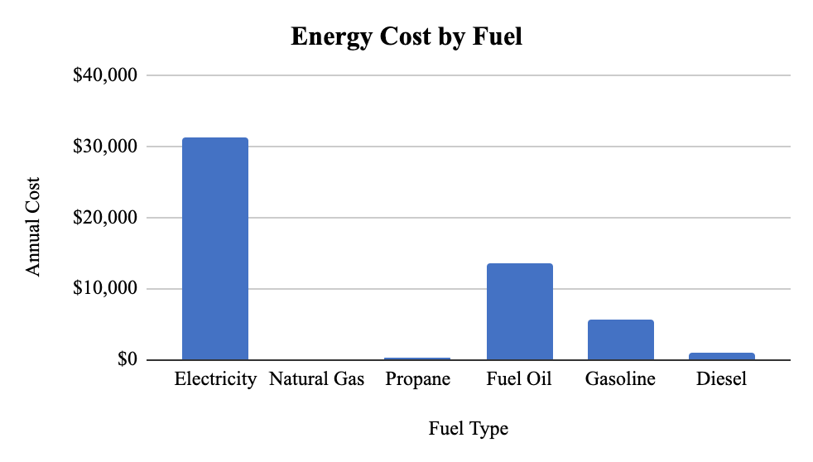
This bar graph provides an energy cost breakdown by each fuel type. Here, it is critical to note the cost of fuel oil being $13,624.91 for the 2022 year. This is the cost to heat the firehouse for one year, which is very expensive. Through combining information from the “Greenhouse Gas Emissions by Energy Type” bar graph (figure 3), and this graph, it can be confidently determined that fuel oil is both costly for the Village and environment. Investing in an alternate system such as heat pumps or geothermal systems will likely turn around return on investment within a few years given these tremendous annual fuel costs.

- Emissions by Scope
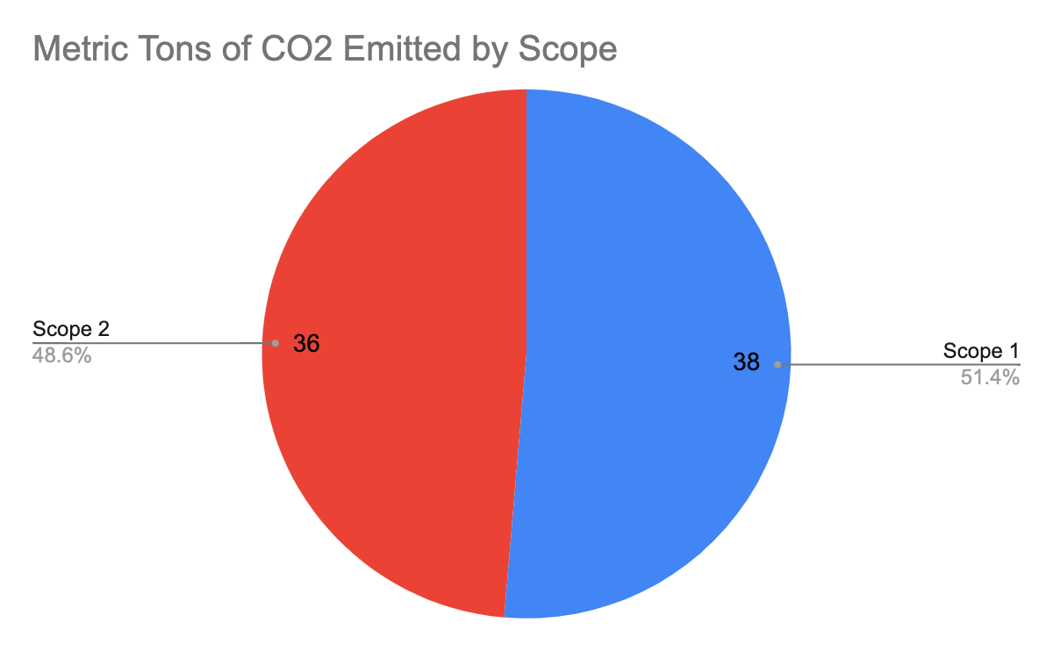
This pie chart shows a breakdown of Aurora’s emissions by scope. The Village produces more scope 1 emissions than scope 2, meaning in-house municipal emissions from Aurora are greater than emissions produced by the local electric plant in providing the municipality’s annual 336.6 megawatts/hour. 100% of scope 1 emissions are due to fuel oil used in the firehouse, underscoring how much carbon and money goes into maintaining that system.

Recommendations
The following recommendations were made to reduce costs, emissions, and energy and fuel consumption for the Village of Aurora based on the GHG Inventory results. The recommendations are divided between Climate Smart Communities compliance and specific reductions strategies.
First, it is highly recommended that the Village form a Climate Smart Communities Task Force to help identify further actions the Village can take to earn points towards CSC Certification. This can be an advisory board or steering committee that advises and collaborates with the Village to accomplish plans, programs, and activities that are part of the CSC Certification program. The Task Force can be a mix of community members and municipal representatives.
The Village of Aurora may submit the data contained in this report for the Government Operations GHG Inventory action. The Village will gain 16 points towards their Climate Smart Communities certification. The inventory we have prepared includes the necessary requirements for this action, like Scope 1 and Scope 2 emissions. Scope 1 emissions are the direct emission from the municipality like government-owned vehicles, onsite fuel combustion (e.g., natural gas, propane, or fuel oil), and wastewater treatment facilities. Scope 2 emissions are indirect emissions such as purchased electricity.
Next, the Village can develop a Government Operations Climate Action Plan, which includes this data, GHG reduction targets, and initiatives to reduce those emissions. A municipal climate action plan is a time-consuming and expensive endeavor, but CSC offers technical assistance and funding for this action. A climate action plan includes the specific initiatives that the municipality will take to reduce their greenhouse gas emissions. New York State’s climate act requires a reduction in GHG emissions of 40 percent by 2030 and 85 percent by 2050 (below 1990 levels). Climate Smart Communities encourage municipalities to align their targets with state goals.
The Village of Aurora may choose to conduct a Community GHG Emissions Inventory. This is not required for certification, but as CSC notes, “Government operations typically account for less than three percent of a community’s emissions.” It’s important to understand how the industries, businesses, schools, homes, and vehicles in the entire Village are contributing to climate change. Both the government operations GHG inventory and community GHG emissions inventory will show a more comprehensive picture of where reductions can be made in emissions and costs.
Lastly, we would recommend inputting GHG and energy data from preceding years into the JIM tool, if time allows. This step is not required for CSC compliance, but this would allow the Village to better understand their GHG emissions and energy consumption trends.
The following are specific Greenhouse Gas Reductions that the Village could implement. As seen in the data, the wastewater treatment plant and the firehouse are the most expensive buildings with the highest emissions by sector. In 2022, the wastewater treatment plant required 308,000 kilowatt hours of electricity to operate, costing the Village of Aurora over $24,000. It is recommended that the Village perform a detailed audit on their wastewater treatment plant to determine areas where it would be possible to increase efficiency and reduce costs. The first step in this process is to conduct an evaluation of the plant using the Water Resource Foundation’s self-assessment. Next, it would be advisable to evaluate the existing technology and ensure that it is functioning properly. If possible, older technology should be replaced, as it has the potential to reduce water waste and energy consumption. If the plant currently uses constant speed pumps, they should be retrofitted with variable frequency drives, which can reduce energy use by up to 50%. One example of smart technology that could be used to monitor water usage is Automated Meter Reading (AMR), which collects data from the water meter more efficiently for faster interpretation; this is used in conjunction with Advanced Metering Infrastructure (AMI) to gather comprehensive data. Another strategy to decrease energy use of WWTP is the conversion of biogas products into electricity and heat with fuel cell generators. If the Village could connect the WWTP to nearby community wind or solar farms, they could reduce their dependence on fossil fuel electricity generation.
The firehouse also produces a large portion of the Village’s Greenhouse Gas emissions from burning heating oil, which is also very costly. It would be advisable to move away from this form of fossil fuel, and install heat pumps or geothermal heat pumps if feasible. This could be paired with solar panel installations on the firehouse to run the heat pumps.
Although municipal vehicles make up a smaller portion of GHG emissions, Climate Smart Communities offers rebates for municipalities purchasing full electric, hybrid, or hydrogen-powered vehicles- or Zero Emission Vehicles (zevs). These rebates do not cover the full cost of the vehicles, but these rebates help municipalities afford these vehicles to further their emissions reductions goals. By getting CSC certified, the Village is placing itself in a better position when applying for the DEC Zero-Emission Vehicle (ZEV) grants.
Finally, we would recommend partnering with Wells College for GHG emissions reduction strategies. They currently have their own climate action plan and greenhouse gas emission inventory which could provide promising information about savings on costs and emissions.

Conclusion
The team would once again like to thank the Village of Aurora, Joshua Cousins, Michael Boccuzzi, Amanda Mazzoni, and the SUNY College of Environmental Science and Forestry for their help in seeing this project to fruition. The aforementioned groups have been integral in providing data, advice, and guidance in this project, and our gratitude for their continued support cannot be understated.
The analysis has shown that the Wastewater Treatment Plant (WWTP), and firehouse are the two most costly facilities for fuel and energy consumption, and the resultant recommendations are tailored as such: to improve efficiency, upgrade technologies, and transition to renewable energy. Comprising 45.5% and 37.5% of annual GHG emissions respectively, the WWTP and firehouse are, and will continue to be vital locations to improve sustainability in the coming years. With the vehicle fleet comprising 15.8% of GHG emissions, we also recommend pursuing Zero Emission Vehicle (ZEV) rebates, and the creation of a specific and actionable Climate Action Plan to achieve these goals.
The group wishes the best of luck to the Village of Aurora in establishing themselves as a Climate Smart Community and continuing to optimize their community in a way that will yield benefits in the form of fiscal savings, ecosystem services, and time-saving efficiency. The Village has already taken great initiative to begin working towards CSC status and it is exciting to see where the Village of Aurora goes with their sustainability initiatives.

“About the Climate Smart Communities Program”, Climate Smart Communities, accessed May 3, 2023, https://climatesmart.ny.gov/about/
LaBella Associates, “The Village of Aurora Comprehensive Plan”, December 15, 2021, https://auroranewyork.us/wp-content/uploads/2021/12/Aurora-CP-Final-211215.pdf
Calculations for CO₂ emitted were performed under the assumption of an AR5- 20 year global warming potential and in the NPCC Upstate NY emission factor region. California Air Resources Board et al., “Local Government Operations Protocol,” May 2010, chrome-extension://efaidnbmnnnibpcajpcglclefindmkaj/https://ww2.arb.ca.gov/sites/default/files/classic/cc/protocols/lgo_protocol_v1_1_2010-05-03.pdf.
“PE1 Action: CSC Task Force”, Climate Smart Communities, accessed May 2, 2023, https://climatesmart.ny.gov/actions-certification/actions/?type=1336777436&tx_sjcert_action%5BactionObject%5D=2&tx_sjcert_action%5Baction%5D=getPDF&tx_sjcert_action%5Bcontroller%5D=Action&cHash=62f5ea18215d56fddaabe3966c9753dc
“PE2 Action: Government Operations GHG Inventory”, Climate Smart Communities, accessed May 2, 2023, https://climatesmart.ny.gov/actions-certification/actions/?type=1336777436&tx_sjcert_action%5BactionObject%5D=6&tx_sjcert_action%5Baction%5D=getPDF&tx_sjcert_action%5Bcontroller%5D=Action&cHash=8bc667611ae79325884ae20cc72df16c
Ibid.
“PE2 Action: Government Operations Climate Action Plan”, Climate Smart Communities, accessed May 2, 2023, https://climatesmart.ny.gov/actions-certification/actions/?type=1336777436&tx_sjcert_action%5BactionObject%5D=10&tx_sjcert_action%5Baction%5D=getPDF&tx_sjcert_action%5Bcontroller%5D=Action&cHash=e88c3cc9a4fd13bcec4f3a5a25699b62
“PE2 Action: Community Climate Action Plan”, Climate Smart Communities, accessed May 2, 2023, https://climatesmart.ny.gov/actions-certification/actions/?type=1336777436&tx_sjcert_action%5BactionObject%5D=11&tx_sjcert_action%5Baction%5D=getPDF&tx_sjcert_action%5Bcontroller%5D=Action&cHash=a9105ba573a674bbcac183a9d6e25010
“Self-Assessment for Wastewater Treatment Plant Optimization,” American Water Works Association, 2017, https://www.awwa.org/Portals/0/AWWA/Partnerships/PCW/20828_SelfAssessmentforWWTPOpt.pdf
“5 ways to improve water treatment plant efficiency,” World Pumps, 2017, August 3 worldpumps.com/content/features/5-ways-to-improve-water-treatment-plant-efficiency/
Ibid.
“Advanced Metering Infrastructure,” Ameresco, accessed May 2, 2023, https://www.ameresco.com/advanced-metering-infrastucture/#:~:text=Advanced%20Metering%20Infrastructure%20(AMI)%20and,and%20gas%20utility%20distribution%20systems.

