Town of Richland, New York

Municipal Operations and Community Greenhouse Gas Inventory Update
Compiled by the Central New York
Regional Planning and Development Board

November 5, 2021

Town of Richland

1 Bridge St.

Pulaski, NY 13142

This GHG inventory update was compiled by the Central New York Regional Planning and Development Board (CNY RPDB) in support of the town’s Climate Smart Communities and Clean Energy Communities efforts. Contributors include:

- Principal Author: Amanda Mazzoni, Principal Planner; CNY RPDB,
- Chris Carrick, Energy Program Manager; CNY RPDB,
- Julie Peterson, Deputy Clerk; Town of Richland,
- Carl Schmidt, Solid Waste Operations Manager; Oswego County Department of Solid Waste
- Eli Yewdall, Senior Program Officer; ICLEI USA.
Table of Contents
I. Introduction 4
Background 4
Climate Change and Greenhouse Gases 5
New York State GHG Emissions and Climate Goals 6
The Purpose of a Greenhouse Gas Inventory 8
Town Profile 9
II. Data Collection and Analysis 9
Reporting 9
III. Municipal Operations Emissions Inventory 10
Overall Results 10
Buildings and Facilities 12
Methods and inputs 12
Results 13
Streetlights and Traffic Signals 13
Methods and inputs 13
Results 13
Water Delivery Facilities 13
Methods and inputs 13
Results 14
Vehicle Fleet 14
Methods and inputs 14
Results 14
IV. Community Emissions Inventory 14
Overall Results 14
Residential Sector 16
Methods and inputs 16
Results 16
Commercial/Industrial Sector 17
Methods and inputs 17
Results 18
Transportation Sector 19
Methods and inputs 19
Results 21
Waste Sector 24
Methods and inputs 24
Results 24
Wastewater Sector 25
Methods and inputs 25
Results 25
V. Municipal Operations Emissions Forecast 25
Methods and inputs 25
Results 26
Discussion 26
VI. Community Emissions Forecast 27
Methods and inputs 27
Results 28
Discussion 28
VII. Discussion: 2011 vs 2019 Inventory 31
Municipal Comparison 31
Community Comparison 33
VIII. Conclusion 34
IX. Bibliography 35

I. Introduction

Background
The Climate Smart Communities Program represents a partnership between New York State and local governments to reduce energy use and GHG emissions while working to adapt to a changing climate. The required ten elements of the Climate Smart Communities Pledge are:

- Build a climate-smart community.
- Inventory emissions, set goals, and plan for climate action.
- Decrease energy use.
- Shift to clean, renewable energy.
- Use climate-smart materials management.
- Implement climate-smart land use.
- Enhance community resilience to climate change.
- Support a green innovation economy.
- Inform and inspire the public.
- Engage in an evolving process of climate action.

The Town of Richland adopted the ten-element Climate Smart Communities Pledge as a commitment to greenhouse gas (GHG) emission reduction and climate change adaptation in February 2015, and it is working towards becoming a Bronze Certified Climate Smart Community. The Climate Smart Communities Certification program recognizes communities that have gone beyond the ten pledge elements by completing and documenting mitigation and adaptation actions at the local level. Certified communities are the foremost leaders in the state in terms of climate action. Communities can achieve certification at the Bronze, Silver, or Gold (currently in development) level.

As part of the town’s efforts to become a Certified Climate Smart Community, the town decided to compile a community and municipal GHG inventory update using a baseline of 2019. A GHG emissions inventory is an audit of activities that contribute to the release of emissions and acts as a baseline for a Climate Action Plan, and the town is considering an update to their Climate Action Plan as well. The original GHG inventory was completed for the town in September 2015 with a baseline of 2011, and their Climate Action Plan was completed in combination with the Village of Pulaski in April 2016.

It is important to note that the information provided in this inventory is not meant to be exhaustive, but rather to provide an estimate of community and municipal emissions data at one snapshot in time, 2019. The inventory information will inform climate action planning efforts in the town moving forward. This inventory will act as a baseline for tracking and understanding trends associated with future GHG mitigation efforts.

For the municipal operations GHG inventory, energy used by buildings and facilities, streetlights, water delivery facilities, and the vehicle fleet were gathered for the 2019 year, and for the community GHG inventory, residential energy use, commercial/industrial energy use, transportation, waste generation, and wastewater treatment information were gathered for the 2019 year. Methods of calculation explained in the U.S. Community Operations Protocol were utilized to generate emissions figures. Data was entered into the ClearPath tool, outputs were aggregated into metric tons of CO₂ equivalent, and emissions were delineated by sector, source, and scope (for municipal emissions).

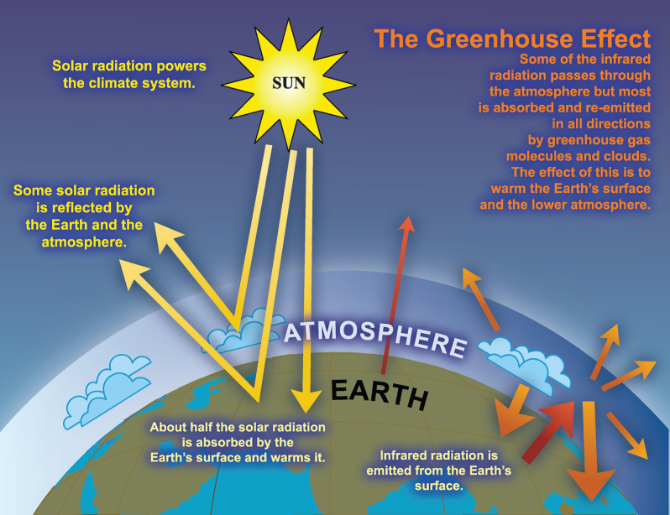

Climate Change and Greenhouse Gases
Climate change is recognized as a global concern. Scientists have documented changes to the Earth’s climate including the rise in global average temperatures, as well as sea levels, during the last century. An international panel of leading climate scientists, the Intergovernmental Panel on Climate Change (IPCC), was formed in 1988 by the World Meteorological Organization and the United Nations Environment Program to provide objective and up-to-date information regarding the changing climate. In its 2014 Fifth Assessment Report, the IPCC states that there is a greater than 95 percent chance that rising global average temperatures, observed since the mid-20th century, are primarily due to human activities. Evidence of observed changes in extremes such as heatwaves, heavy precipitation, droughts, and tropical cyclones, and, in particular, their attribution to human influence, has strengthened since the Fifth Assessment Report, as noted in the Sixth Assessment Report AR6 Climate Change: The Physical Science Basis study published in August 2021.
Figure 1: The Greenhouse Effect

The rising trend of human-generated GHG emissions is a global threat. The increased presence of these gases affects the warming of the planet by contributing to the natural greenhouse effect, which warms the atmosphere and makes the earth habitable for humans and other species (see Figure 1). Mitigation of GHGs is occurring in all sectors as a means of reducing the impacts of this warming trend. However, scientific models predict that some effects of climate change are inevitable no matter how much mitigative action is taken now. Therefore, climate mitigation actions must be paired with adaptation measures in order to continue efforts to curb emissions contributions to global warming, while adapting communities so that they are able to withstand climate change impacts and maintain social, economic, and environmental resilience in the face of uncertainty. Climate adaptation can take shape through infrastructure assessments and emergency planning, as well as through educational efforts to raise public awareness about potential climate change impacts.

New York State outlined projected climate impacts and vulnerabilities during the 2011 ClimAid assessment and 2014 supplement (ClimAid Report). The ClimAid Report projects changes to ecosystems (e.g., increased presence of invasive species and shifts in tree composition), while water quality and quantity may also be impacted due to changes in precipitation. Potential beneficial economic impacts were also identified, such as a longer recreation season in the summer, and a longer growing season for the agricultural sector due to rising temperatures. Scientific evidence suggests that the impacts of global climate change will be different in various regions, and will include temperature shifts, more extreme heat events, sea level rise and coastal flooding, more frequent intense precipitation events, and human health risks.

We have already experienced the effects of a changing climate in New York State and abroad, the need for climate action and adaptation is imperative. The goal of building community resilience in order to protect the health and livelihood of residents and natural systems serves as a motivating factor in the assessment of greenhouse gas contributions and effective sustainability planning.

New York State GHG Emissions and Climate Goals
According to the July 2019 New York State Greenhouse Gas Inventory: 1990-2016 report prepared by the New York State Energy Research and Development Authority (NYSERDA), 2016 state emissions were equal to 206 million metric tons of carbon dioxide equivalent (MMTCO₂e), the majority of which came from energy-related sources (173 MMTCO₂e) compared to non-energy sources (33 MMTCO₂e). Of the energy-related emissions sources, 36% were from transportation, 30% from on-site fuel combustion from buildings, 15% from electricity generation, and 3% from other sources such as fugitive emissions from fossil fuel infrastructure and incineration of municipal waste (see Figure 2).

In July 2019, Governor Cuomo signed the Climate Leadership and Community Protection Act (CLCPA) into law. The CLCPA is New York State’s ambitious emissions reduction plan with the goal of making electricity 70% renewable by 2030 and 100% carbon neutral by 2040, reducing GHG emissions 40% below 1990 levels by 2030 and 85% below 1990 levels by 2050, implementing 6,000 MW of solar by 2025, 3,000 MW of energy storage by 2030, and 9,000 MW of offshore wind by 2035 (see Figure 3).

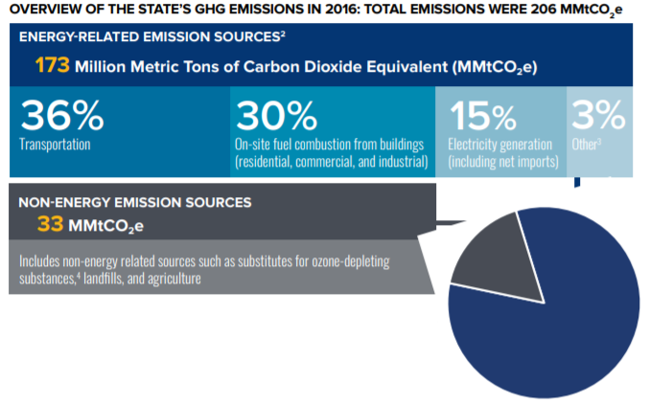
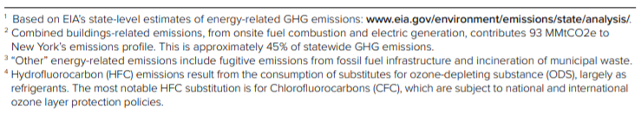
Figure 2: Overview of the State’s GHG Emissions in 2016

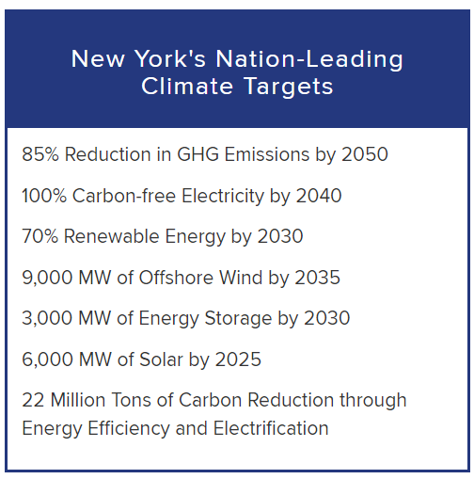
Figure 3: Overview of the CLCPA targets

The Purpose of a Greenhouse Gas Inventory
Many local governments have decided to gain a detailed understanding of how their emissions and their community’s emissions are related to climate change and have committed to reducing GHG emissions at the local level. Local governments exercise direct control over their own operations and can lead by example by reducing energy usage in municipal facilities, using alternative fuels for their fleets, and investing in renewable energy sources. Local governments can also influence community-wide activities that contribute to climate change by improving building codes and standards, providing cleaner transportation options, and educating members of the community about their choices as consumers. Each local government is unique with its own set of opportunities, challenges, and solutions, and therefore climate action needs to be tailored to each community at the local level.

Because local governments typically contribute less than ten percent of the total greenhouse gas emissions generated in a given community, it is recommended that local governments develop both local government operations and community-wide greenhouse gas emissions inventories and reduction strategies. Before concerted management and reduction of greenhouse gas emissions can occur within our local governments and communities, local governments must undertake measurement and analysis of all GHG sources. This report includes a GHG inventory update for both municipal operations and the community-at-large for the 2019 year.

It is important to note that this inventory represents an estimate of emissions for the Town of Richland for the 2019 year, and that the purpose of this inventory is to gain a general baseline of emissions upon which the town can work from for climate action planning purposes. This inventory includes a number of assumptions and estimations, and the methods used to establish this baseline will not necessarily be the same methods used to measure progress.

There are several major benefits to compiling emissions inventories:

- Fiscal benefits: Developing climate and energy strategies can help reduce energy costs and save taxpayer dollars. Conducting a GHG emissions inventory will explain exactly how energy is being used and identify opportunities to become more efficient.

- Climate leadership: By taking action now to address climate change, local governments and elected officials can be recognized for their leadership on climate and energy issues.

- Community benefits: Measures to reduce GHG emissions and energy consumption typically have many co-benefits. They can improve air quality and public health, stimulate the local economy, create green jobs, and make communities more livable and walkable.

- Regulatory preparedness: Taking action now will help your jurisdiction prepare for any future legislative requirements and position your local government for successful compliance.

Town Profile
The Town of Richland is located in northern Oswego County. The town covers an area of approximately 54.6 square miles and encompasses the Village of Pulaski. According to the 2019 American Community Survey, the town has a population of about 3,528 residents outside of the village, with 1,247 occupied housing units.

II. Data Collection and Analysis
For the municipal inventory update, information related to building and facilities, streetlights, water delivery facilities, and vehicle fleet were collected for the Richland municipal operations for the 2019 year following the Local Government Operations Protocol. Specific data collection methods for each sector are explained within each section of this report.

For the community inventory update, information related to residential, commercial/industrial, transportation, waste, and wastewater were collected for the Richland community for the 2019 year following the U.S. Community Protocol. Specific data collection methods for each sector are explained within each section of this report.

The ICLEI ClearPath tool was utilized to convert the information into emissions data measured in metric tons of carbon dioxide equivalent (MTCO₂e). The online tool streamlines the process of converting different sources, units, and varieties of emissions into comparable energy use and emissions figures.

Reporting
The three most prevalent greenhouse gases, and therefore the focus of this analysis, are carbon dioxide (CO₂), methane (CH₄) and nitrous oxide (N₂O). The unit used to discuss these gases in aggregate is carbon dioxide equivalent (CO₂e), which is a conversion based on each gas’s Global Warming Potential (GWP), or the impact of 1 unit of each gas in the atmosphere compared to 1 unit of CO₂ (see Table 1). This inventory uses the 20-year GWP values published by the IPCC’s 5th Assessment Report. A discussion of emissions using the IPCC’s 4th Assessment Report is also included later in this report since these were the GWPs used in the 2015 inventory report.

Greenhouse Gas (GHG) | Global Warming Potential (GWP)
Carbon Dioxide (CO₂) | 1
Methane (CH₄) | 85
Nitrous Oxide (N₂O) | 264

Table 1: IPCC 5th Assessment 20-year Global Warming Potential Values

Emissions are reported by sector and source in the community inventory update and also by scope for the municipal update. Sectors are included or excluded in the boundaries of GHG inventories based on availability of data, relevance to emissions totals, and scale to which they can be changed. The municipal inventory update includes emissions for the buildings and facilities, streetlights, water delivery facilities, and vehicle fleet sector. The community inventory update includes emissions for the residential, commercial/industrial, transportation, waste, and wastewater sectors. Commercial and industrial sectors are combined due to availability of data from the Utility Energy Registry (UER), which combines commercial/industrial electricity and natural gas use into what it refers to as the “business” sector. Emissions data is also reported by source, including electricity, natural gas, fuel oil, propane, gasoline, and diesel.

III. Municipal Operations Emissions Inventory

Overall Results
In 2019, the Town of Richland’s municipal emissions totaled 355 MTCO₂e. The vehicle fleet sector contributed to the largest percentage of emissions, accounting for 283 MTCO₂e, or 80% of the government’s total emissions. Buildings and facilities was the second largest emitting sector, producing 44 MTCO₂e, or 12% of total municipal emissions, followed by the water delivery facilities sector, which produced 27 MTCO₂e, or 8% of total emissions, and the streetlights and traffic signals sector, which produced 1 MTCO₂e, or 0% of total emissions.

Figure 4: 2019 Municipal Emissions by Sector

The largest source of municipal emissions in the Town of Richland in 2019 was gasoline, accounting for 206 MTCO₂e, or 58% of all community emissions. Diesel and natural gas were also large emitting sources, producing 77 MTCO₂e (22%) and 40 MTCO₂e (11%), respectively.

Figure 5: 2019 Municipal Emissions by Source

The majority (93%) of municipal emissions were scope 1 emissions. Scope 1 emissions are those that are directly emitted by the government onsite, including stationary combustion and vehicle fleet emissions. Scope 2 emissions are those that are indirectly emitted by the government through energy created elsewhere, such as electricity. Scope 3 emissions are other indirect emissions not included in scope 2, such as emissions from wastewater, solid waste processes, or employee commute. Scope 3 emissions were not included in this inventory update primarily due to lack of data.

Figure 6: 2019 Municipal Emissions by Scope

Buildings and Facilities

Methods and inputs
Building and facility electricity and natural gas usage for 2019 was collected using National Grid bills. This sector includes all municipal accounts that are not streetlights or related to water delivery facilities. There was no propane or fuel oil used in this sector in 2019.

Building and facility energy uses were entered into ClearPath using standard emissions factors for natural gas, and the Environmental Protection Agency (EPA)’s Emissions & Generation Resource Integrated Database (eGRID) factors for NPCC Upstate NY from 2019 were used for electricity emissions calculations (see Table 2 below).

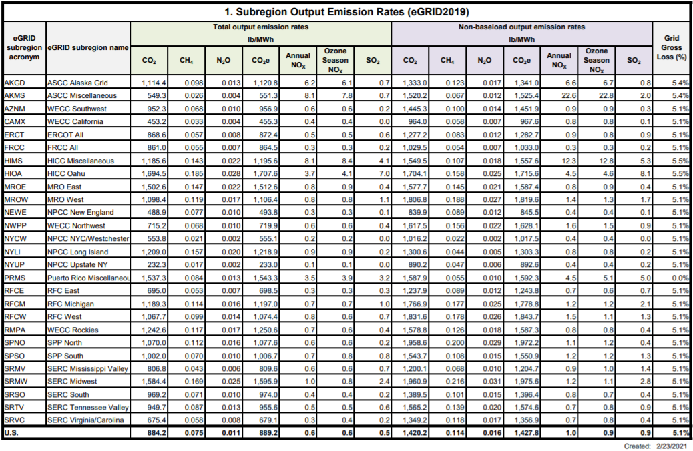
Table 2: eGRID2019 Summary Table: Subregion Emissions

Results
Building and facilities electricity consumption in 2019 was 37,651 kWh and natural gas consumption was 7,516 therms. Building and facilities emissions from electricity in 2019 were 4 MTCO₂e; emissions from natural gas were 40 MTCO₂e. Overall building and facilities emissions in 2019 were 44 MTCO₂e.

Streetlights and Traffic Signals

Methods and inputs
Streetlights and Traffic Signals electricity for 2019 was collected using National Grid bills. Streetlight energy use was entered into ClearPath using eGRID 2019 factors.

Results
Streetlights and Traffic Signals electricity consumption in 2019 was 13,028 kWh, a total of 1 MTCO₂e.

Water Delivery Facilities

Methods and inputs
Water Delivery Facilities electricity and propane usage for 2019 was collected using National Grid bills and propane use totals provided by the Town of Richland. This sector includes all municipal accounts that are related to water delivery facilities, including pump stations, control valves, the Central Water Works, and the wellsite on Richland Orwell Road.

Water Delivery Facilities energy uses were entered into ClearPath using standard emissions factors for propane, and the eGRID 2019 factors.

Results
Water Delivery Facilities electricity consumption in 2019 was 183,580 kWh (20 MTCO₂e), and propane use totaled 1,257 gallons (7 MTCO₂e). Water Delivery Facilities emissions totaled 27 MTCO₂e.

Vehicle Fleet

Methods and inputs
Gasoline and diesel fuel use for 2019 was collected from the Town of Richland and entered into ClearPath using standard emissions factors for diesel. Gasoline was entered into ClearPath assuming a standard 10% ethanol blend.

Results
Vehicle fleet gasoline consumption in 2019 was 26,086 gallons (206 MTCO₂e), and diesel use totaled 7,527 gallons (77 MTCO₂e). Vehicle Fleet emissions totaled 283 MTCO₂e in 2019.

IV. Community Emissions Inventory

Overall Results
In 2019, the Town of Richland’s community emissions totaled 49,869 MTCO₂e. The transportation sector contributed to the largest percentage of emissions, accounting for 38,684 MTCO₂e, or 77% of the community’s total emissions. Residential energy use was the next highest emitting sector, producing 5,863 MTCO₂e, or 12% of total community emissions, followed by the commercial/industrial energy use sector, which produced 2,169 MTCO₂e, or 4% of total emissions. The waste sector emitted 1,852 MTCO₂e, or 4% of emissions, followed by the wastewater sector which contributed 1,212 MTCO₂e, or 3% of emissions.

Figure 7: 2019 Community Emissions by Sector

The largest source of community emissions in the Town of Richland in 2019 was gasoline, accounting for 27,336 MTCO₂e, or 55% of all community emissions. Diesel was also a large emitting source, producing 11,348 MTCO₂e (23%).

Figure 8: 2019 Community Emissions by Source

Residential Sector

Methods and inputs
Residential electricity and natural gas usage for 2019 was collected using the Utility Energy Registry (UER), which was developed pursuant to the Order Adopting the Utility Energy Registry, issued by the New York State Public Service Commission on April 20, 2018. The UER “standardizes and crowdsources data directly from utilities,” and “was developed by NYSERDA to provide local communities data they need to develop greenhouse gas (GHG) inventories and to track progress towards climate goals.” Most of the Town of Richland’s data has been withheld for 2019 due to privacy screens built into the UER, however, so data from neighboring communities was used to estimate both electricity and natural gas usage within the town.

Residential propane and fuel oil use were compiled using the 2019 American Community Survey 5-Year Estimates tables for Selected Housing Characteristics which indicate house heating fuels within the Town of Richland. This information was compared to New York State data for household heating fuel, also from the 2019 American Community Survey 5-Year Estimates tables, and amount/type of fuel consumed within the state (according to the US Energy Information Administration (EIA)’s 2019 Residential Energy Consumption Estimates) to calculate estimated heating fuel use within Town of Richland homes.

Residential energy uses were entered into ClearPath using standard emissions factors for natural gas, propane, and fuel oil. eGRID factors for NPCC Upstate NY from 2019 were used for electricity emissions calculations (as explained above).

Results
Residential electricity consumption in 2019 was estimated at 12,860,799 kWh; residential natural gas consumption was estimated at 69,165 therms; residential propane consumption was estimated at 36,370 MMBtu; and residential fuel oil consumption was estimated at 24,589 MMBtu. Residential emissions from electricity in 2019 were 1,367 MTCO₂e; emissions from residential natural gas were 370 MTCO₂e; emissions from propane were 2,280 MTCO₂e; and emissions from fuel oil were 1,846 MTCO₂e. Overall residential emissions in 2019 were 5,863 MTCO₂e.

Figure 9: 2019 Residential Emissions by Source

Commercial/Industrial Sector

Methods and inputs
Commercial/industrial electricity and natural gas usage for 2019 were gathered from the National Grid UER data for 2019, under the Business field (which includes non-residential customers). Most of the Town of Richland’s data has been withheld for 2019 due to privacy screens built into the UER, however, so data from neighboring communities was used to estimate both commercial/industrial electricity and natural gas usage within the town.

Commercial/industrial propane and fuel oil use were estimated by assuming the proportion of residential homes using propane and fuel oil within the Town of Richland is equal to the proportion of commercial square footage within the Town of Richland using propane and fuel oil.

The proportion of residential homes using propane and fuel oil was determined from the 2019 American Community Survey 5-Year Estimates tables for Selected Housing Characteristics, which indicate house heating fuels within the Town of Richland, compared to total occupied housing units within the town. These ratios were multiplied by the estimated commercial square footage within the Town of Richland to come up with the estimated commercial/industrial space within the town that uses fuel oil and propane.

Commercial/industrial square footage in the Town of Richland was estimated using commercial floor space per worker from the US EIA’s Commercial Buildings Energy Consumption Survey (CBECS) information for 2012 (this was the most recent year with data available), multiplied by the total number of nonfarm workers in the Town of Richland according to the American Community Survey 2019 5-year tables for Occupation by Sex for the Civilian Employed Population 16 Years and Over (including all employed minus natural resources, construction, and maintenance occupations).

Commercial square footage in the Town of Richland using fuel oil and propane were then compared to commercial square footage using fuel oil and propane within New York State. Total commercial floor space within New York was calculated using EIA’s Commercial Buildings Energy Consumption Survey (CBECS) for 2012 (this was the most recent year with data available), multiplied by the total number of nonfarm workers as per the American Community Survey 2019 5-year tables for Occupation by Sex for the Civilian Employed Population 16 Years and Over (including all employed minus natural resources, construction, and maintenance occupations) for New York State. Richland commercial/industrial space using fuel oil and propane were then compared to the statewide proportion of households using fuel oil and propane from the statewide American Community Survey. That ratio was then multiplied by the total fuel use within New York State (from the EIA’s State Energy Data System (SEDS) 2019 report) to come up with the total commercial/industrial fuel oil and propane use within the Town of Richland. These calculations are explained in detail within the CNY RPDB’s data collection and analysis workbooks for this inventory.

Commercial energy uses were entered into ClearPath using the default emissions factors for natural gas, propane, and fuel oil. Similar to the residential electric analysis, the EPA’s eGRID factors from 2019 was used for electricity emissions calculations for the commercial/industrial sector.

Results
Commercial/industrial electricity consumption in 2019 was estimated at 5,379,424 kWh; commercial/industrial natural gas consumption was estimated at 62,805 therms; commercial/industrial propane consumption was estimated at 8,963 million British Thermal Units (MMBtu); and commercial/industrial fuel oil consumption was 9,309 MMBtu. Commercial/industrial emissions from electricity in 2019 were 572 MTCO₂e; emissions from commercial/industrial natural gas were 336 MTCO₂e; emissions from propane were 562 MTCO₂e; and emissions from fuel oil were 699 MTCO₂e. Total emissions from the commercial/industrial sector in 2019 were 2,169 MTCO₂e.

Figure 10: 2019 Commercial/Industrial Emissions by Source

Transportation Sector

Methods and inputs
Transportation emissions were estimated using estimated annual vehicle miles traveled (AVMT), 2019 U.S. National Default emissions factors (updated 2021 – see Table 3 below), and estimates for percentage of vehicle types. Transportation emissions were broken down for diesel and gasoline, assuming a standard 10% ethanol blend in gasoline.

AVMT for 2019 was calculated by multiplying available Annual Average Daily Traffic (AADT) counts from 2019 by road lengths within the Town of Richland and multiplying total daily VMT by 365 days per year.

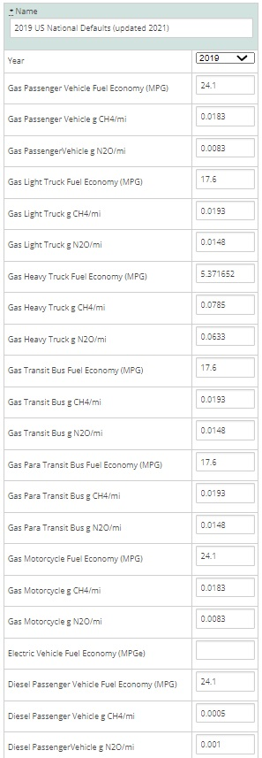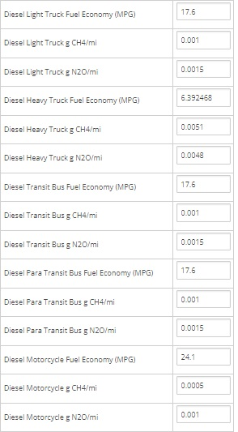
Table 3: 2019 US National Default Transportation Emissions

AADT counts were primarily only available for main arteries; therefore, additional calculations for AADT were needed to estimate AVMT for local/collector roads, as well as some main arteries that do not have AADTs available. The total length of roads in Richland with traffic counts is 55.496 miles, while 85.757 miles of roads do not have AADT counts available.

According to the Minimum Maintenance Standards Regulation 239/02, a set of guidelines produced by the Association of Municipalities of Ontario to help local communities estimate traffic volume, while conducting an AADT count, it is possible to estimate the traffic volume for dead-ends and cul-de-sacs to avoid resource intensive counts. This is done by multiplying the number of houses on the roadway by a factor of 6 for rural areas.

This method was applied to the Town of Richland for the roads without AADT counts since most of these roads were local/collector roads. It was determined that there were 1,247 occupied households in the Town of Richland in 2019 (not inclusive of the village), according to the American Community Survey. It was assumed that all homes are on roadways that do not have a count, since most houses are on local/collector roads. By multiplying the number of occupied homes by 6, a combined AADT count of 7,482 was calculated for all 85.757 miles of roads without AADT counts available. In order to calculate VMTs, an average AADT value was needed, and derived by dividing the total AADT by the 85.747 miles of uncounted roadway. This gave an average AADT value of 87.2 for 2019, which was applied to all roadways that did not have a count.

Results
AVMT for roads with AADT counts available in 2019 totaled 77,285,392.54, while AVMT for roads without AADT counts available in 2019 totaled 2,730,930. Total AVMT in 2019 was 80,016,323.

BeginDescr | EndDescrip | RoadwayNam | Calculatio | AADT | RCSTAYearD | Length_Mi | VMT
US 11 | ALBION TL | FRANK LACY RD | 2019 | 131 | 346005, 2019, CT | 1.229990 | 161.128690
JCT CR 2 RICHLAND RD | JCT LAKE ST CR 15 LACONA | Interstate 81 | 2019 | 19064 | 340580, 2019, CT | 1.156170 | 22041.224880
JCT CR 28 TINKER TAVERN RD | JCT RT 13 | Interstate 81 | 2019 | 20618 | 340557, 2019, CT | 3.109460 | 64110.846280
JCT RT 104 | JCT CR 28 TINKER TAVERN RD | Interstate 81 | 2019 | 21137 | 340556, 2019, CT | 2.720900 | 57511.663300
NY 13 (OFF) | I-81 SB (ON) | EXIT 36 I81 AT | 2019 | 1986 | 343018, 2019, CT | 0.149878 | 297.657708
NY 3 | SALISBURY RD | ATKINSON RD | 2019 | 151 | 342206, 2019, CT | 1.470000 | 221.970000
I-81 NB (OFF) | NY 13(ON) | EXIT 36 I81 AT | 2019 | 1927 | 343017, 2019, CT | 0.034254 | 66.006495
CR 28 (OFF) | I-81 SB (ON) | EXIT 35 I81 AT | 2019 | 702 | 343016, 2019, CT | 0.405170 | 284.429340
I-81 SB (OFF) | CR 28 (OFF) | EXIT 35 I81 AT | 2019 | 369 | 343015, 2019, CT | 0.280000 | 103.320000
LEHIGH RD | I-81 NB (ON) | EXIT 35 I81 AT | 2019 | 362 | 343014, 2019, CT | 0.376457 | 136.277434
CR 48 PINEVILLE | ACC RT 81I |  | 2019 | 2961 | 340269, 2019, CT | 1.420080 | 4204.856880
RT 11 | RT 3 END RT 13 |  | 2019 | 2249 | 340268, 2019, CT | 2.165580 | 4870.389420
RT 13 PORT ONTARIO | CR 15 CENTER CHURCH |  | 2019 | 2237 | 340267, 2019, CT | 3.050610 | 6824.214570
RT 104B | RT 13 PORT ONTARIO |  | 2019 | 4363 | 340265, 2019, CT | 3.463260 | 15110.203380
I-81 NB (OFF) | CR 28 (ON) | EXIT 35 I81 AT | 2019 | 733 | 343013, 2019, CT | 0.320000 | 234.560000
RT 104 MAPLE VIEW | CR 41A |  | 2019 | 1573 | 340252, 2019, CT | 1.432460 | 2253.259580
CR 41A | CR 41 AND WOOD RD |  | 2019 | 1831 | 340251, 2019, CT | 3.990000 | 7305.690000
CR 41 AND WOOD RD | RT 13 | SALINA ST | 2019 | 3960 | 340250, 2019, CT | 0.086541 | 342.702756
CR 5 PULASKI | CR 15 SANDY CREEK |  | 2019 | 2126 | 340245, 2019, CT | 1.137270 | 2417.836020
US 11 | SPRINGBROOK RD | CANNING FACTORY | 2019 | 458 | 346007, 2019, CT | 1.389990 | 636.615420
SPRINGBROOK RD | CR 48 | CANNING FACTORY | 2019 | 230 | 347068, 2019, CT | 2.090000 | 480.700000
CR 2 | LACONA VL | CR 48 | 2019 | 437 | 347066, 2019, CT | 1.964920 | 858.670040
CENTERVILLE RD | CR 2 | PECK RD | 2019 | 1430 | 347064, 2019, CT | 1.670010 | 2388.114300
CR 41 | US 11 | CR 41A | 2019 | 338 | 347058, 2019, CT | 2.090390 | 706.551820
NY 3 | HINMAN RD | CLARK RD | 2019 | 219 | 346141, 2019, CT | 2.219970 | 486.173430
NYS 13 | E VIL LINE | CR 2A | 2019 | 3159 | 346139, 2019, CT | 1.567970 | 4953.217230
MEXICO TL | US 11 | CR 41 | 2019 | 797 | 346137, 2019, CT | 5.599960 | 4463.168120
E VILLAGE LINE | MEXICO TL | CR 41 | 2019 | 646 | 346135, 2019, CT | 0.001355 | 0.875640
PULASKI VL | RICHLAND TL | RICHLAND RD | 2019 | 1469 | 346126, 2019, CT | 4.313190 | 6336.076110
NYS 3 | US 11 | TINKER TAVERN R | 2019 | 421 | 346125, 2019, CT | 4.590030 | 1932.402630
 |  |  |  |  |  | Daily VMT total | 211,740.80
 |  |  |  |  |  | 365 days | 365.00
 |  |  |  |  |  | Annual VMT | 77,285,392.54

Table 4: 2019 Town of Richland Traffic Data for Road Segments with Available AADT

# occupied housing units: | 1,247
Total AADT for roads not accounted for above: | 7,482
Days per year: | 365
Average AADT for roads not accounted for above: | 87.2
Total Annual VMT for manually calculated roads: | 2,730,930

Table 5: 2019 Town of Richland Traffic Data for Road Segments without Available AADT

Emissions from transportation in the Town of Richland in 2019 totaled 38,684 MTCO₂e, with 27,336 MTCO₂e from gasoline (10% ethanol) and 11,348 MTCO₂e from diesel.

Figure 11: 2019 Transportation Emissions by Source

Waste Sector

Methods and inputs
Waste emissions from the Town of Richland were calculated using total tons of waste from Oswego County disposed of at the Oswego County Landfill and Energy Recovery Facility and scaling down to the town based on population. The landfill is located outside the Town of Richland and has methane collection at a rate of about 37%. Total waste figures and methane collection information were obtained from Carl Schmidt, Solid Waste Operations Manager at Oswego County Department of Solid Waste.

County Population | Town of Richland population | Total tons waste from Oswego County | Type of waste | Disposal method | Tons of waste disposed per person | Tons of waste disposed from Town of Richland
118,339 | 3,528 | 45,598 | MSW | incinerated | 0.39 | 1,359.40
118,339 | 3,528 | 15,870 | MSW | landfilled | 0.13 | 473.13
118,339 | 3,528 | 6,042 | C&D | incinerated | 0.05 | 180.13
118,339 | 3,528 | 14,643 | C&D | landfilled | 0.12 | 436.55
118,339 | 3,528 | 3,936 | Biosolids | landfilled | 0.03 | 117.34
118,339 | 3,528 | 6,447 | C&I | landfilled | 0.05 | 192.20
118,339 | 3,528 | 923 | C&I | incinerated | 0.01 | 27.52

Table 6: 2019 Community Waste Composition and Disposal Location

Based on guidance from Eli Yewdall, Senior Program Officer at ICLEI, waste data for C&D waste and biosolids (sludge/manure) was then put into ICLEI’s ClearPath software using the “Waste Generation - California” calculator at 37% landfill gas capture and keeping the 10% oxidation percentage default. Waste data for mixed Municipal Solid Waste (MSW) was entered into ICLEI’s ClearPath software using the “Waste Generation” calculator, assuming a typical methane collection scenario and moderate moisture content. Commercial and Industrial Waste sent to landfill was not included in this inventory, as industrial waste includes items that do not typically break down to produce methane in a landfill. The “Waste Generation – California” calculator does not use a factor set, but has waste composition entered into the calculator itself, whereas a 100% mixed MSW factor set was used with the “Waste Generation” calculator.

All waste disposed of at the Energy Recovery Facility was entered into the “Combustion of Solid Waste Generated by the Community” calculator and calculated using ICLEI’s SW.2.2a methodology.

Results
Waste emissions for the Town of Richland in 2019 totaled 1,852 MTCO₂e.

Wastewater Sector

Methods and inputs
According to Julie Peterson, Deputy Town Clerk, all town residents use septic systems with no use of public water treatment. Therefore, only emissions from septic systems are included in the Town of Richland’s community inventory.

Fugitive emissions from septic systems within the Town of Richland were calculated using the Population Based method in ClearPath and assuming the whole residential population of the town was using septic systems (3,528 people).

Results
Fugitive emissions from septic systems in the Town of Richland totaled 1,301 MTCO₂e in 2019.

V. Municipal Operations Emissions Forecast

Methods and inputs
A municipal operations emissions forecast is included here to provide a sense of what emissions might look like in 2030 for municipal operations under a business-as-usual scenario. The forecast was compiled using ICLEI’s protocol for forecasting and entering data into the ClearPath tool online. Data from the 2019 municipal inventory above was used as a baseline for this forecast. Compound Average Growth Rates were used to forecast emissions in all sectors using the inputs noted below.

To forecast emissions from the municipal buildings and facilities sector, population growth rates from 2010 to 2019 as well as mandates of the Climate Leadership and Community Protection Act (i.e. 70% electricity from renewables by 2030) were used. It is assumed that as population of the town increases, energy used by municipal operations at facilities increases in a proportional manner.

To forecast emissions from municipal streetlights, mandates of the Climate Leadership and Community Protection Act (i.e. 70% electricity from renewables by 2030) were used. It is assumed that as population of the town increases, energy used by municipal operations increases in a proportional manner.

To forecast emissions from the municipal vehicle fleet, population growth rates as well as Federal rules on vehicle fuel mileage standards were used. It is assumed that as population of the town increases, energy used by the municipal vehicle fleet increases in a proportional manner.
To forecast emissions from water delivery facilities, population growth rates as well as mandates of the Climate Leadership and Community Protection Act (i.e. 70% electricity from renewables by 2030) were used. It is assumed that as population of the town increases, energy used by municipal operations at water delivery facilities increases in a proportional manner.

Results
Assuming a business-as-usual scenario, emissions in the Town of Richland in 2030 are expected to decrease from 355 MTCO₂e in 2019 to 307 MTCO₂e in 2030, a decrease of about 14%. Each sector’s forecast is explained further below.

Figure 12: Town of Richland Municipal Operations 2030 Emissions Forecast

Discussion
Electric and natural gas used at municipal buildings and facilities is expected to remain relatively constant in accordance with the town population growth trend (which has increased only very slightly since 2010), but since the Climate Leadership and Community Protection Act requires the state to achieve 70% renewable electricity by 2030, emissions from municipal operations electricity use are expected to drop from 4 MTCO₂e to 1 MTCO₂e. Overall emissions from municipal buildings and facilities are therefore expected to increase from 44 MTCO₂e in 2019 to 45 MTCO₂e by 2030.

Emissions from the municipal vehicle are expected to decrease, because despite an estimated slightly higher amount of vehicle miles traveled in accordance with the town’s population growth trend, the carbon intensity of the vehicle miles traveled is expected to decrease as federal transportation policies require vehicle fuel mileage standards to improve over time. Emissions from municipal vehicle fleet at therefore expected to decrease from 283 MTCO₂e in 2019 to 248 MTCO₂e by 2030.

Emissions from streetlights are expected to decrease from 1 MTCO₂e to 0 MTCO₂e in accordance with CLCPA goals of achieving 70% renewable electricity by 2030.

Finally, emissions from water delivery facilities are expected to decrease from 27 MTCO₂e to 14 MTCO₂e by 2030 because even though electric and propane energy use are expected to increase slightly based on the population growth rate, emissions from electricity are expected to decrease significantly, from 20 MTCO₂e to 6 MTCO₂e, in accordance with the CLCPA goals of achieving 70% renewable electricity by 2030.

VI. Community Emissions Forecast

Methods and inputs
A community emissions forecast is included here to provide a sense of what emissions might look like in 2030 under a business-as-usual scenario. The forecast was compiled using ClearPath guidance. Compound Average Growth Rates were used to forecast emissions in all sectors, using the inputs noted below.

To forecast emissions from the residential and commercial/industrial sectors, State energy use trends as described in the 2015 New York State Energy Plan and mandates of the Climate Leadership and Community Protection Act (i.e. 70% electricity from renewables by 2030) were used.

To forecast emissions from the transportation sector, State energy use trends as described in the 2015 New York State Energy Plan and Federal rules on vehicle fuel mileage standards were used.

To forecast emissions from the waste sector, population growth rates for the Town of Richland from the American Community Survey from 2010 vs. 2019 were used, assuming population would continue to grow at a similar rate through 2030 and waste production would increase proportionally to population growth.

To forecast emissions from the wastewater sector, population growth rates for the Town of Richland from the American Community Survey from 2010 vs. 2019 were used, assuming population would continue to grow at a similar rate through 2030 and wastewater emissions would increase proportionally to population growth.

Results

Assuming a business-as-usual scenario, emissions in the Town of Richland in 2030 are expected to decrease from 49,869 MTCO₂e in 2019 to 39,765 MTCO₂e in 2030, a decrease of about 20%. Emissions are expected to decrease in the residential, commercial/industrial, and transportation sectors, and increase in the waste and wastewater sectors. Each sector’s forecast is explained further below.

Figure 13: Town of Richland Community 2030 Emissions Forecast

Discussion

Emissions from the residential sector are expected to decrease from 5,863 MTCO₂e in 2019 to 4,447 MTCO₂e by 2030.

Figure 14: Forecasted Residential Emissions in the Town of Richland for 2030

Since the Climate Leadership and Community Protection Act has set a goal of 70% electricity coming from renewables by 2030, emissions from residential electricity use are expected to drop significantly. Residential propane and fuel oil use are projected to decrease as well, with natural gas use staying about the same, according to the 2015 New York State Energy Plan.

Emissions from the commercial/industrial sector are expected to decrease overall, from 2,169 MTCO₂e in 2019 to 1,795 MTCO₂e by 2030.

Figure 15: Forecasted Commercial/Industrial Emissions in the Town of Richland for 2030
Since the Climate Leadership and Community Protection Act has set a goal of 70% electricity coming from renewables by 2030, emissions from commercial/industrial electricity use are expected to drop significantly. Commercial/industrial fuel oil use is projected to decrease as well, with propane use staying about the same and natural gas use increasing slightly over time, according to the 2015 New York State Energy Plan.

Emissions from the transportation sector are expected to decrease overall as well, from 38,684 MTCO₂e in 2019 to 30,088 MTCO₂e by 2030.

Figure 16: Forecasted Transportation Emissions in the Town of Richland for 2030

According to the 2015 New York State Energy Plan, gasoline and vehicle miles traveled are expected to decrease over time, with diesel use and vehicle miles traveled increasing. However, the carbon intensity of the vehicle miles traveled for all fuel types is expected to decrease as federal transportation policies require vehicle fuel mileage standards to improve over time, so emissions from all fuel sources are expected to decrease.

Emissions from the waste sector are expected to increase slightly, from 1,852 MTCO₂e in 2019 to 2,018 MTCO₂e by 2030. This forecast is directly related to estimated population growth rate in the town.

Emissions from the wastewater sector are expected to increase, from 1,301 MTCO₂e in 2019 to 1,417 MTCO₂e in 2030. This forecast is directly related to estimated population growth rate in the town.

VII. Discussion: 2011 vs 2019 Inventory

As noted above, the Town of Richland compiled a greenhouse gas inventory in 2015 with a baseline year of 2011. Below is a discussion comparing emissions for both the municipal operations and the community as reported in 2011 vs this report.

It should be noted that the 2011 inventory was compiled using the current standards at the time, which meant using Global Warming Potentials (GWPs) from the IPCC’s 4th Assessment Report compared to the current standard of using the 20-year GWPs in IPCC’s 5th Assessment Report. Therefore, Figures 17 and 18 below shows what emissions totals would be for 2019 using the same GWPs as were used to calculate 2011 emissions (noted as “2019 IPCC 4th”).

The IPCC 4th assessment report assumes a GWP of 25 for methane over a 100-year period, meaning that the impact of 1 unit of methane in the atmosphere creates 25 times more warming potential than 1 unit of CO₂ over a 100-year time period. However, methane typically remains in the atmosphere for closer to 12 years as opposed to CO₂ which can remain in the atmosphere for over 100 years, meaning that methane’s impact while it remains in the atmosphere is much stronger than that of CO₂. Therefore, the IPCC 5th assessment report includes both a 100 year and 20-year GWP for methane of 28 and 84, respectively. The IPCC 5th assessment report’s 20-year GWP for nitrous oxide is 264 as compared to 298 from the IPCC 4th assessment report, 100-year GWP.

As illustrated in Figures 17 and 18, there is not much difference between the two GWP scenarios for most sectors, but there is a more noticeable increase in emissions for waste and wastewater using the IPCC 5th assessment 20-year GWPs. Therefore, it is important to consider the methodology used in creating this and future inventory updates, as well as when comparing data from this inventory to inventories from other communities.

Municipal Comparison

Table 7 below compares municipal energy use in 2011 to municipal energy use in 2019.

Municipal Energy Use | Source | 2011 | 2019 | Difference
Buildings and Facilities | Electricity (kWh) | 216,299 | 37,651 | -178,648 | -83%
 | Natural gas (therms) | 4,910 | 7,516 | 2,606 | 53%
Streetlights and Traffic Signals | Electricity (kWh) | 33,660 | 13,028 | -20,632 | -61%
Vehicle Fleet | Gasoline (gallons) | 2,693 | 26,086 | 23,394 | 869%
 | Diesel (gallons) | 8,154 | 7,527 | -627 | -8%
Water Delivery Facilities | Electricity (kWh) | 116,273 | 183,580 | 67,307 | 58%
 | Propane (gallons) | 424 | 1,257 | 834 | 197%

Table 7: Town of Richland Municipal Energy Use 2011 v 2019
As indicated in Table 7, each sector’s energy use information is quite different from 2011 to 2019. This is likely attributed to data gathering methodology and accuracy/availability of data, although some differences could be caused by behavior changes and/or energy efficiency projects as well. Other reasons for significant changes are discussed below.

In 2011, emissions from the Town of Richland municipal operations totaled 216 MTCO₂e, compared to 355 MTCO₂e in 2019.

Figure 17: Town of Richland 2011 vs 2019 Municipal Emissions

As illustrated in Figure 17, the largest difference in emissions and energy use from 2011 to 2019 is in the vehicle fleet sector. This could be due to accuracy of data used for the 2011 inventory compared to this report, as the information used for the 2011 inventory was mostly based on assumptions from the Highway Superintendent at the time, compared to the information used for this report which includes actual gallons of gasoline and diesel fuel used by the municipal fleet in 2019. Otherwise, an increase in emissions could be explained by additional vehicles, or additional vehicle miles traveled by the fleet.

Emissions and energy use from Buildings and Facilities also decreased relatively significantly between 2011 and 2019. Between 2011 and 2019, the Salmon River Ice Hockey Association took over the bills for the Hockey Rink and Ballfields at 16 Maple Avenue Extension, which were two of the larger electric accounts for the town in 2011 (178,040 kWh of electricity used between the two accounts in 2011). Therefore, these accounts are not included in the 2019 inventory, contributing to a significant decrease in energy use and emissions from the Town of Richland’s municipal Buildings and Facilities. Decreases in emissions factors for electricity as a result of less carbon-intensive sources of electricity supplied by the state’s utilities could have also impacted the decrease in emissions over time.

Emissions from Streetlights decreased between 2011 and 2019 as the energy use also decreased, since the town converted all streetlights to LEDs during that time period.

Emissions from Water Delivery Facilities stayed almost constant between 2011 and 2019, because although electric and propane use increased during that time, electric emissions factors decreased over that same time period due to a cleaner Upstate NY electric grid. It should be noted that the Central Water Works facility was not in service the entire 2011 year, which helps account for the lower propane usage in 2011 compared to 2019.

Community Comparison

Table 8 below compares community energy use in 2011 to community energy use in 2019.

Community Energy Use | Source | 2011 | 2019 | Difference
Residential Energy Use | Electricity (kWh) | 14,631,193 | 12,860,799 | -1,770,394 | -12%
 | Natural gas (therms) | 47,120 | 69,165 | 22,045 | 47%
 | Propane (MMBtu) | 1,812 | 36,370 | 34,558 | 1907%
 | Fuel oil (MMBtu) | 19,179 | 24,589 | 5,409 | 28%
Commercial/Industrial Energy Use | Electricity (kWh) | 11,370,566 | 5,379,424 | -5,991,142 | -53%
 | Natural gas (therms) | 298,283 | 62,805 | -235,478 | -79%
 | Propane (MMBtu) | 4,107 | 8,963 | 4,856 | 118%
 | Fuel oil (MMBtu) | 31,620 | 9,309 | -22,311 | -71%
Transportation | Vehicle Miles Traveled | 93,124,086 | 80,016,323 | -13,107,763 | -14%
Waste | Total tons | 825 | 2,786 | 1,961 | 238%

Table 8: Town of Richland Community Energy Use 2011 v 2019

As indicated in Table 8, each sector’s energy use information is quite different from 2011 to 2019. This is likely attributed to data gathering methodology and accuracy/availability of data (this is likely the case for residential propane use estimates, for example), although some differences could be caused by behavior changes, energy efficiency, and/or renewable energy projects as well.

In 2011, emissions from the Town of Richland community totaled 57,366 MTCO₂e, compared to 49,869 MTCO₂e in 2019. It should be noted that the 2015 report was able to separate out Commercial and Industrial emissions due to availability of data at the time, but the two sectors are included in the Commercial/Industrial Use sector in Figure 18 below. It should also be noted that Wastewater emissions were not included in the 2011 baseline inventory, hence the missing information in Figure 18 below.

Figure 18: Town of Richland 2011 vs 2019 Community Emissions

As illustrated in Figure 18, emissions in the Residential and Waste sectors were relatively similar in 2011 and 2019, whereas emissions for Commercial/Industrial and Transportation sectors appear to have decreased. This could be due to a difference in methodology, as Commercial/Industrial energy use for all sources had to be estimated in 2019 and Industrial energy use was not available separately. It could also be due to a decrease in emissions factors for electricity (as a result of less carbon-intensive sources of electricity supplied by utilities) as the as well as for vehicle miles traveled (as vehicles have become more efficient per mile traveled over time). Vehicle miles traveled do appear to have decreased between 2011 and 2019, which also could help attribute to the decrease in emissions from the transportation sector.

VIII. Conclusion
This greenhouse gas inventory update can help inform a Climate Action Plan update, which can help the town to better understand energy use and emissions from both municipal operations and the community-at-large.

The results of this study indicate that the largest percentage of municipal emissions came from the vehicle fleet and the largest percentage of community emissions came from the transportation sector for 2019. Vehicle fleet/transportation emissions should be targeted in the town’s future Climate Action Plan Update so that energy use from this sector can be reduced, therefore lowering both energy costs and GHG emissions.

It is recommended that the town participate further in the Clean Energy Communities program and other state and utility incentive programs to help achieve additional energy and emissions savings. The CNY RPDB is available to provide technical assistance to implement projects and to secure grants and other financial support for projects.

As a Climate Smart Community, the Town of Richland has partnered with state and local agencies to combat climate change and pledge to reduce greenhouse gas emissions. Conducting an emissions inventory update is an important step in climate action planning, mitigation, and adaptation. This inventory will provide a benchmark for planning purposes with the goal of setting an emissions reduction target and updating the Town/Village Climate Action Plan.

IX. Bibliography

Center for Climate and Energy Solutions. (2020). Federal Vehicle Standards. Retrieved from https://www.c2es.org/content/regulating-transportation-sector-carbon-emissions/.

ICLEI. (2020). ClearPath. Retrieved from https://clearpath.icleiusa.org/.

IPCC. (2014). Fifth Assessment Report. Retrieved from https://www.ipcc.ch/report/ar5/syr/.

IPCC Working Group I. (2007). The Physical Science Basis. Retrieved from https://wg1.ipcc.ch/publications/wg1-ar4/faq/wg1_faq-1.3.html.

Level of Service Policy for Municipal Highways in the United Townships of Head, Clara & Maria. (2008). Retrieved from http://www.townshipsofheadclaramaria.ca/download.php?dl=YToyOntzOjI6ImlkIjtzOjI6 Ijg1IjtzOjM6ImtleSI7aTo0O30=.

NYSERDA. (2014). Climate Change in New York State: Updating the 2011 ClimAID Climate Risk Information. Retrieved from https://www.nyserda.ny.gov/About/Publications/Research%20and%20Development%20 Technical%20Reports/Environmental%20Research%20and%20Development%20Techni cal%20Reports/Response%20to%20Climate%20Change%20in%20New%20York.

NYSERDA. (2019). New York Greenhouse Gas Inventory Fact Sheet. Retrieved from https://www.nyserda.ny.gov/About/Publications/EA-Reports-and-Studies/Energy- Statistics.

NYSERDA. (2021). Utility Energy Registry. Retrieved from
https://utilityregistry.org/app/#/datagrid.

US EIA. (2021). State Energy Data System (SEDS): 1960-2019. Retrieved from https://www.eia.gov/state/seds/seds-data-complete.php#Consumption.

US EIA. (2016). Commercial Buildings Energy Consumption Survey (CBECS). Retrieved from https://www.eia.gov/consumption/commercial/data/2012/#b1-b2.

US EPA. (2021). eGRID 2019 Summary Tables. Retrieved from https://www.epa.gov/egrid/egrid-2019-summary-tables.

The Local Government Operations Protocol and U.S. Community Operations Protocol were developed by ICLEI-Local Governments for Sustainability in order to provide “accounting for GHG emissions associated with local government operated buildings, vehicles, and other operations” and “detailed, cutting-edge guidance on completing a GHG emissions inventory at the community scale in the United States — including emissions from businesses, residents, and transportation,” according to ICLEI’s website.
ClearPath is a proprietary tool developed by ICLEI-Local Governments for Sustainability to assist local governments with conducting greenhouse gas emissions inventories and with the development of local climate action plans.
IPCC. 2014. Fifth Assessment Report. https://www.ipcc.ch/report/ar5/syr/
IPCC. 2021. Sixth Assessment Report Headline Statements from the Summary for Policymakers. https://www.ipcc.ch/report/ar6/wg1/downloads/report/IPCC_AR6_WGI_Headline_Statements.pdf
IPCC Working Group. https://wg1.ipcc.ch/publications/wg1-ar4/faq/wg1_faq-1.3.html
NYSERDA. 2014. Climate Change in New York State: Updating the 2011 ClimAID Climate Risk Information. https://www.nyserda.ny.gov/About/Publications/Research%20and%20Development%20Technical%20Reports/Environmental%20Research%20and%20Development%20Technical%20Reports/Response%20to%20Climate%20Change%20in%20New%20York
NYSERDA. 2014. Climate Change in New York State: Updating the 2011 ClimAID Climate Risk Information. https://www.nyserda.ny.gov/About/Publications/Research%20and%20Development%20Technical%20Reports/Environmental%20Research%20and%20Development%20Technical%20Reports/Response%20to%20Climate%20Change%20in%20New%20York; and National Climate Assessment. 2014. Climate Change Impacts in the United States. https://nca2014.globalchange.gov/.
NYSERDA. Greenhouse Gas Inventory Fact Sheet. https://www.nyserda.ny.gov/About/Publications/EA-Reports-and-Studies/Energy-Statistics.
ICLEI. 2012. U.S. Community Protocol for Accounting and Reporting of Greenhouse Gas Emissions.
The ClearPath tool provides standard emissions factors that were developed by ICLEI and are described in the Local Government Operations Protocol, Appendix G.
US EPA. Emissions & Generation Resource Integrated Database (eGRID). https://www.epa.gov/egrid/summary-data.
The gasoline entry in ClearPath was entered as ethanol with 10% biofuel to account for the typical 10% ethanol blend.
NYSERDA. Utility Energy Registry. https://utilityregistry.org/app/#/
US EIA. State Energy Data System (SEDS): 1960-2019. https://www.eia.gov/state/seds/seds-data-complete.php#Consumption
The ClearPath tool provides standard emissions factors that were developed by ICLEI and are described in the Local Government Operations Protocol, Appendix G.
US EPA. Emissions & Generation Resource Integrated Database (eGRID). https://www.epa.gov/energy/emissions-generation-resource-integrated-database-egrid.
US EIA. Commercial Buildings Energy Consumption Survey (CBECS). https://www.eia.gov/consumption/commercial/data/2012/#b1-b2
US EIA. Commercial Buildings Energy Consumption Survey (CBECS). https://www.eia.gov/consumption/commercial/data/2012/#b1-b2
US EIA. State Energy Data System (SEDS): 1960-2019. https://www.eia.gov/state/seds/seds-data-complete.php#Consumption.
The ClearPath tool provides standard emissions factors that were developed by ICLEI and are described in the Local Government Operations Protocol, Appendix G.
US EPA. Emissions & Generation Resource Integrated Database (eGRID). https://www.epa.gov/energy/emissions-generation-resource-integrated-database-egrid.
As per Eli Yewdall at ICLEI, “The default vehicle factor sets are derived from EIA data for fuel economy, and EPA emissions factors for CH4 and N2O. Because EPA publishes factors by model year, we had to convert those to represent the average mix of new and old vehicles on the road in a particular year; we did this using data from the US National GHG inventory.”
As provided by Eli Yewdall at ICLEI: Gasoline passenger vehicles: 68.6% Deisel passenger vehicles: 0.3% Gasoline light trucks: 19.7% Deisel light trucks: 0.8% Gasoline heavy trucks: 1.4% Deisel heavy trucks: 8.5%
The gasoline entry in ClearPath was entered as ethanol with 10% biofuel to account for the typical 10% ethanol blend.
AADT and road segment length GIS data provided by the NYSDOT Highway Data Services Bureau. These traffic counts include all traffic within the town, including pass-through traffic where the origin and destination of trips occur outside of the town's boundaries. These trips will be more difficult to address in climate action planning than the trips that begin and/or end within the town.
http://www.townshipsofheadclaramaria.ca/download.php?dl=YToyOntzOjI6ImlkIjtzOjI6Ijg1IjtzOjM6ImtleSI7aTo0O30=
This would imply additional streetlights are added, which might occur with increased development as population continues to grow.
This forecast uses the March 2020 Safer Affordable Fuel Efficient (SAFE) Vehicles Rule, which projects combined passenger and light duty vehicle fuel efficiency to be 40.4 mpg by 2026, according to https://www.c2es.org/content/regulating-transportation-sector-carbon-emissions/ accessed 10/19/21.
Since ClearPath requires VMT inputs for municipal vehicle fleet forecasts, National Default Vehicle Fuel Efficiencies provided by ICLEI at https://docs.google.com/spreadsheets/d/1KXmtHoxI-mPXz0ujidtj76woUcK-RN9ITMRy-gMoUls/edit#gid=1929834944 were utilized to calculate estimated VMT for the town’s fleet, using average light trucks for gasoline and heavy duty trucks for diesel.
This forecast uses the March 2020 Safer Affordable Fuel Efficient (SAFE) Vehicles Rule, which projects combined passenger and light duty vehicle fuel efficiency to be 40.4 mpg by 2026, according to https://www.c2es.org/content/regulating-transportation-sector-carbon-emissions/ accessed 10/19/21.
IPCC. Climate Change 2014 Synthesis Report. https://ar5-syr.ipcc.ch/ipcc/ipcc/resources/pdf/IPCC_SynthesisReport.pdf

