Town of Manlius, New York

Community Greenhouse Gas Inventory
Compiled by the Central New York
Regional Planning and Development Board

May 11, 2021

Town of Manlius

301 Brooklea Drive

Fayetteville, NY 13066

This community GHG inventory was compiled by the Central New York Regional Planning and Development Board (CNY RPDB) in support of the Town’s Climate Smart Communities and Clean Energy Communities efforts. Contributors include:

- Principal Author: Amanda Mazzoni, Principal Planner; CNY RPDB,
- Chris Carrick, Energy Program Manager; CNY RPDB,
- Ann Oot, Town Manager; Town of Manlius,
- Kevin Beverine, Sales Manager; Syracuse Haulers,
- Nicole Walz, Controller; Syracuse Haulers, and
- Eli Yewdall, Senior Program Officer, ICLEI USA.
Table of Contents
I. Introduction 4
Background 4
Climate Change and Greenhouse Gases 5
New York State GHG Emissions and Climate Goals 6
The Purpose of a Greenhouse Gas Inventory 8
Town Profile 9
II. Data Collection and Analysis 11
Reporting 11
III. Community Emissions Inventory 12
Overall Results 12
Residential Sector 13
Methods and inputs 13
Results 14
Commercial/Industrial Sector 15
Methods and inputs 15
Results 16
Transportation Sector 17
Methods and inputs 17
Results 19
Waste Sector 26
Methods and inputs 26
Results 26
Wastewater Sector 27
Methods and inputs 27
Results 27
Agriculture Sector 28
Methods and inputs 28
Results 29
Discussion 29
IV. Community Emissions Forecast 29
Methods and inputs 29
Results 30
Discussion 31
V. Municipal Operations Emissions Forecast 34
Methods and inputs 34
Results 34
Discussion 35
VI. GWP: IPCC 4th Assessment vs 5th Assessment 35
VII. Conclusion 37
VIII. Bibliography 37

I. Introduction

Background
The Climate Smart Communities Program represents a partnership between New York State and local governments to reduce energy use and GHG emissions while working to adapt to a changing climate. The required ten elements of the Climate Smart Communities Pledge are:

- Build a climate-smart community.
- Inventory emissions, set goals, and plan for climate action.
- Decrease energy use.
- Shift to clean, renewable energy.
- Use climate-smart materials management.
- Implement climate-smart land use.
- Enhance community resilience to climate change.
- Support a green innovation economy.
- Inform and inspire the public.
- Engage in an evolving process of climate action.

The Town of Manlius adopted the ten-element Climate Smart Communities Pledge as a commitment to greenhouse gas (GHG) emission reduction and climate change adaptation in April 2020, and it is working towards becoming a Bronze Certified Climate Smart Community. The Climate Smart Communities Certification program recognizes communities that have gone beyond the ten pledge elements by completing and documenting mitigation and adaptation actions at the local level. Certified communities are the foremost leaders in the state in terms of climate action. Communities can achieve certification at the Bronze, Silver, or Gold (currently in development) level.

As part of the town’s efforts to become a Certified Climate Smart Community, the town decided to compile a community GHG inventory to complement their municipal operations GHG inventory that is also being developed at this time by SUNY ESF students. A GHG emissions inventory is an audit of activities that contribute to the release of emissions and will act as a baseline for a Climate Action Plan. It is important to note that the information provided in this inventory is not meant to be exhaustive, but rather to provide an estimate of community emissions data at one snapshot in time, 2019. The inventory information will inform climate action planning efforts in the town moving forward. This inventory will act as a baseline for tracking and understanding trends associated with future GHG mitigation efforts.

For this community GHG inventory, residential energy use, commercial/industrial energy use, transportation, waste generation, wastewater treatment, and agricultural information was gathered for the 2019 year, and methods of calculation explained in the U.S. Community Operations Protocol were utilized to generate emissions figures. Data was entered into the ClearPath tool, outputs were aggregated into metric tons of CO₂ equivalent, and emissions were delineated by sector and source.

Climate Change and Greenhouse Gases
Climate change is recognized as a global concern. Scientists have documented changes to the Earth’s climate including the rise in global average temperatures, as well as sea levels, during the last century. An international panel of leading climate scientists, the Intergovernmental Panel on Climate Change (IPCC), was formed in 1988 by the World Meteorological Organization and the United Nations Environment Program to provide objective and up-to-date information regarding the changing climate. In its 2014 Fifth Assessment Report, the IPCC states that there is a greater than 95 percent chance that rising global average temperatures, observed since the mid-20th century, are primarily due to human activities.
Figure 1: The Greenhouse Effect

The rising trend of human-generated GHG emissions is a global threat. The increased presence of these gases affects the warming of the planet by contributing to the natural greenhouse effect, which warms the atmosphere and makes the earth habitable for humans and other species (see Figure 1). Mitigation of GHGs is occurring in all sectors as a means of reducing the impacts of this warming trend. However, scientific models predict that some effects of climate change are inevitable no matter how much mitigative action is taken now. Therefore, climate mitigation actions must be paired with adaptation measures in order to continue efforts to curb emissions contributions to global warming, while adapting communities so that they are able to withstand climate change impacts and maintain social, economic, and environmental resilience in the face of uncertainty. Climate adaptation can take shape through infrastructure assessments and emergency planning, as well as through educational efforts to raise public awareness about potential climate change impacts.

New York State outlined projected climate impacts and vulnerabilities during the 2011 ClimAid assessment and 2014 supplement (ClimAid Report). The ClimAid Report projects changes to ecosystems (e.g., increased presence of invasive species and shifts in tree composition), while water quality and quantity may also be impacted due to changes in precipitation. Potential beneficial economic impacts were also identified, such as a longer recreation season in the summer, and a longer growing season for the agricultural sector due to rising temperatures. Scientific evidence suggests that the impacts of global climate change will be different in various regions, and will include temperature shifts, more extreme heat events, sea level rise and coastal flooding, more frequent intense precipitation events, and human health risks.

We have already experienced the effects of a changing climate in New York State and abroad, the need for climate action and adaptation is imperative. The goal of building community resilience in order to protect the health and livelihood of residents and natural systems serves as a motivating factor in the assessment of greenhouse gas contributions and effective sustainability planning.

New York State GHG Emissions and Climate Goals
According to the July 2019 New York State Greenhouse Gas Inventory: 1990-2016 report prepared by the New York State Energy Research and Development Authority (NYSERDA), 2016 state emissions were equal to 206 million metric tons of carbon dioxide equivalent (MMTCO₂e), the majority of which came from energy-related sources (173 MMTCO₂e) compared to non-energy sources (33 MMTCO₂e). Of the energy-related emissions sources, 36% were from transportation, 30% from on-site fuel combustion from buildings, 15% from electricity generation, and 3% from other sources such as fugitive emissions from fossil fuel infrastructure and incineration of municipal waste (see Figure 2).

In July 2019, Governor Cuomo signed the Climate Leadership and Community Protection Act (CLCPA) into law. The CLCPA is New York State’s ambitious emissions reduction plan with the goal of making electricity 70% renewable by 2030 and 100% carbon neutral by 2040, reducing GHG emissions 40% below 1990 levels by 2030 and 85% below 1990 levels by 2050, implementing 6,000 MW of solar by 2025, 3,000 MW of energy storage by 2030, and 9,000 MW of offshore wind by 2035 (see Figure 3).

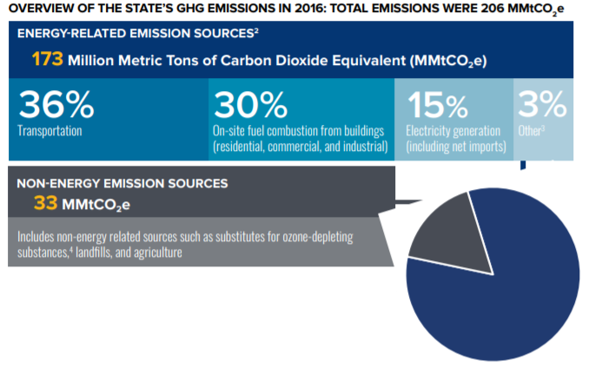
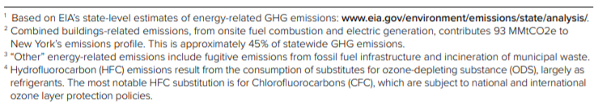
Figure 2: Overview of the State’s GHG Emissions in 2016

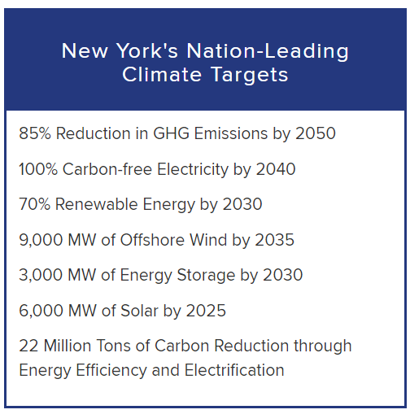
Figure 3: Overview of the CLCPA targets

The Purpose of a Greenhouse Gas Inventory
Many local governments have decided to gain a detailed understanding of how their emissions and their community’s emissions are related to climate change and have committed to reducing GHG emissions at the local level. Local governments exercise direct control over their own operations and can lead by example by reducing energy usage in municipal facilities, using alternative fuels for their fleets, and investing in renewable energy sources. Local governments can also influence community-wide activities that contribute to climate change by improving building codes and standards, providing cleaner transportation options, and educating members of the community about their choices as consumers. Each local government is unique with its own set of opportunities, challenges, and solutions, and therefore climate action needs to be tailored to each community at the local level.

Because local governments typically contribute less than ten percent of the total greenhouse gas emissions generated in a given community, it is recommended that local governments develop both local government operations and community-wide greenhouse gas emissions inventories and reduction strategies. Before concerted management and reduction of greenhouse gas emissions can occur within our local governments and communities, local governments must undertake measurement and analysis of all GHG sources. As mentioned previously, SUNY ESF students are compiling a municipal operations GHG inventory for the town operations on a parallel track to this community inventory being developed. Both inventories include energy use and emissions data for the 2019 year.

It is important to note that this inventory represents an estimate of emissions for the Town of Manlius community for the 2019 year, and that the purpose of this inventory is to gain a general baseline of emissions upon which the town can work from for climate action planning purposes. This inventory includes a number of assumptions and estimations, and the methods used to establish this baseline will not necessarily be the same methods used to measure progress.

There are several major benefits to compiling emissions inventories:

- Fiscal benefits: Developing climate and energy strategies can help reduce energy costs and save taxpayer dollars. Conducting a GHG emissions inventory will explain exactly how energy is being used and identify opportunities to become more efficient.

- Climate leadership: By taking action now to address climate change, local governments and elected officials can be recognized for their leadership on climate and energy issues.

- Community benefits: Measures to reduce GHG emissions and energy consumption typically have many co-benefits. They can improve air quality and public health, stimulate the local economy, create green jobs, and make communities more livable and walkable.

- Regulatory preparedness: Taking action now will help your jurisdiction prepare for any future legislative requirements and position your local government for successful compliance.

Town Profile
The Town of Manlius is located in eastern Onondaga County. The town covers an area of approximately 50 square miles and encompasses the Village of Manlius (approximately 1.8 square mile), the Village of Fayetteville (approximately 1.7 square miles), and the Village of Minoa (approximately 1.3 square miles). The majority of the area is zoned Restricted Agriculture, with Residential Districts scattered throughout. According to the 2019 American Community Survey, the town has a population of about 19,849 residents outside of the three villages, with 7,903 occupied housing units.

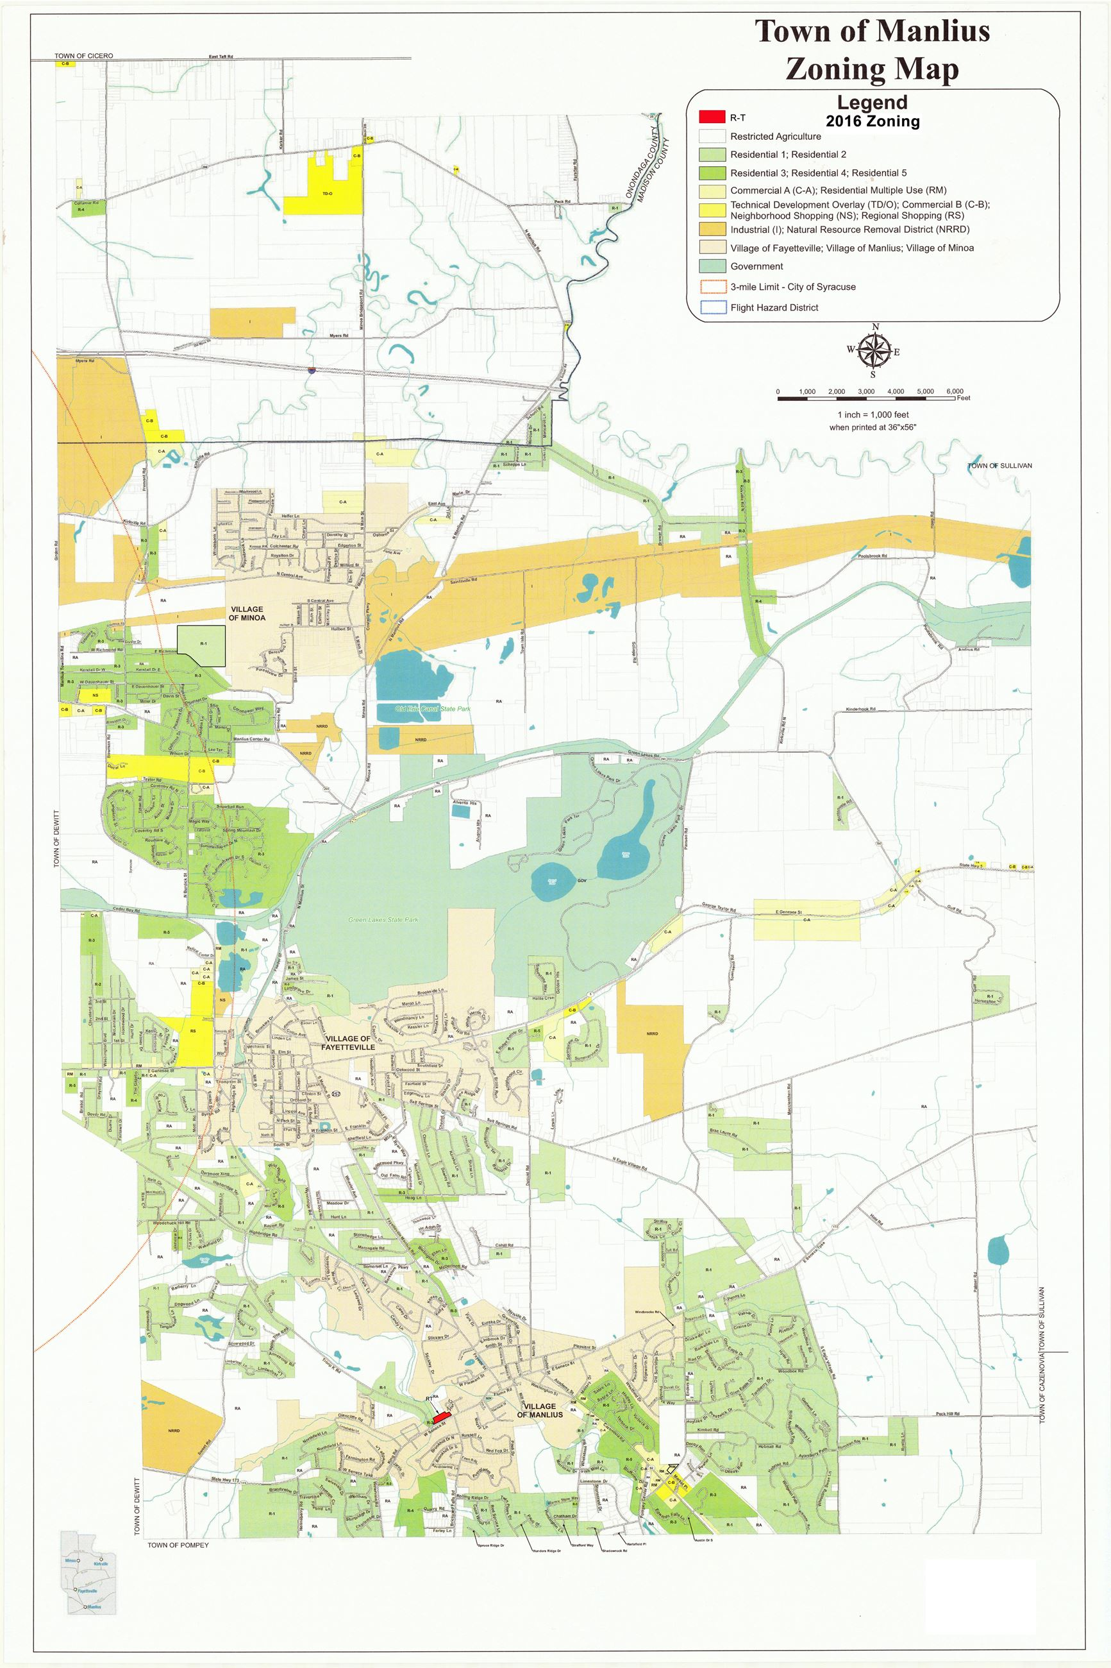

Figure 4: Town of Manlius Zoning Map 2016

II. Data Collection and Analysis
Information related to residential, commercial/industrial, transportation, waste, wastewater, and agriculture were collected for the Manlius community for the 2019 year following the U.S. Community Protocol. Specific data collection methods for each sector are explained within each section of this report.

The ICLEI ClearPath tool was utilized to convert the information into emissions data measured in metric tons of carbon dioxide equivalent (MTCO₂e). The online tool streamlines the process of converting different sources, units, and varieties of emissions into comparable energy use and emissions figures.

Reporting
The three most prevalent greenhouse gases, and therefore the focus of this analysis, are carbon dioxide (CO₂), methane (CH₄) and nitrous oxide (N₂O). The unit used to discuss these gases in aggregate is carbon dioxide equivalent (CO₂e), which is a conversion based on each gas’s Global Warming Potential (GWP), or the impact of 1 unit of each gas in the atmosphere compared to 1 unit of CO₂ (see Table 1). This inventory uses the GWP values published by the IPCC’s 4th Assessment Report, which is consistent with the GWP values used in the municipal operations inventory so as to allow for direct comparison. A discussion of emissions using the IPCC’s 5th Assessment Report is also included later in this report.

Greenhouse Gas (GHG) | Global Warming Potential (GWP)
Carbon Dioxide (CO₂) | 1
Methane (CH₄) | 25
Nitrous Oxide (N₂O) | 298

Table 1: IPCC 4th Assessment Global Warming Potential of Greenhouse Gases

Emissions are reported by sector and source in this inventory. Sectors are included or excluded in the boundaries of GHG inventories based on availability of data, relevance to emissions totals, and scale to which they can be changed. This inventory includes emissions for the residential, commercial/industrial, transportation, waste, wastewater, and agricultural sectors. Commercial and industrial sectors are combined due to availability of data from the Utility Energy Registry (UER), which combines commercial/industrial electricity and natural gas use into what it refers to as the “business” sector. Emissions data is also reported by source, including electricity, natural gas, fuel oil, and propane as sources of emissions within the residential or commercial/industrial sectors, while gasoline and diesel are included as sources of emissions within the transportation sector.

III. Community Emissions Inventory

Overall Results
In 2019, the Town of Manlius’ community emissions totaled 197,079 MTCO₂e. In 2019, the transportation sector contributed to the largest percentage of emissions, accounting for 120,658 MTCO₂e, or 61% of the community’s total emissions. Residential energy use was the next highest emitting sector, producing 51,082 MTCO₂e, or 26% of total community emissions, followed by the commercial/industrial energy use sector, which produced 18,482 MTCO₂e, or 9% of total emissions. The agricultural sector emitted 3,240 MTCO₂e, or 2% of emissions, followed by the waste sector which contributed 2,085 MTCO₂e, or 1% of emissions. The smallest emitting sector was the wastewater sector, which produced 1,532 MTCO₂e, or 1% of total community emissions.

Figure 5: 2019 Community Emissions by Sector

The largest source of community emissions in the Town of Manlius in 2019 was gasoline, accounting for 84,935 MTCO₂e, or 43% of all community emissions. Natural gas was also a large emitting source, producing 52,260 MTCO₂e (26%).

Figure 6: 2019 Community Emissions by Source

Residential Sector

Methods and inputs
Residential electricity and natural gas usage for 2019 was collected using the Utility Energy Registry (UER), which was developed pursuant to the Order Adopting the Utility Energy Registry, issued by the New York State Public Service Commission on April 20, 2018. The UER “standardizes and crowdsources data directly from utilities,” and “was developed by NYSERDA to provide local communities data they need to develop greenhouse gas (GHG) inventories and to track progress towards climate goals.”

Residential propane and fuel oil use were compiled using the 2019 American Community Survey 5-Year Estimates tables for Selected Housing Characteristics which indicate house heating fuels within the Town of Manlius. This information was compared to New York State data for household heating fuel, also from the 2019 American Community Survey 5-Year Estimates tables, and amount/type of fuel consumed within the state (according to the US Energy Information Administration (EIA)’s 2018 Residential Energy Consumption Estimates, which are the most recent estimates available) to calculate estimated heating fuel use within Town of Manlius homes.

Residential energy uses were entered into ClearPath using standard emissions factors for natural gas, propane, and fuel oil. The Environmental Protection Agency (EPA)’s Emissions & Generation Resource Integrated Database (eGRID) factors for NPCC Upstate NY from 2018 were used for electricity emissions calculations (these are the most recent available- see Table 2 below).

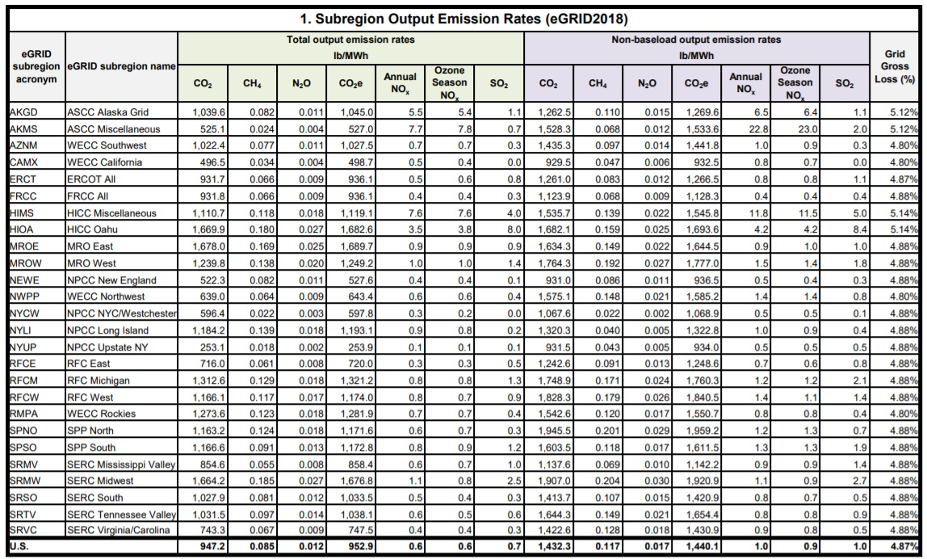

Table 2: eGRID2018 Summary Table: Subregion Emissions

Results
Residential electricity consumption in 2019 was 72,276,375 kWh; residential natural gas consumption was 7,519,282 therms; residential propane consumption was 20,036 MMBtu; and residential fuel oil consumption was 20,454 MMBtu. Residential emissions from electricity in 2019 were 8,332 MTCO₂e; emissions from residential natural gas were 39,984 MTCO₂e; emissions from propane were 1,244 MTCO₂e; and emissions from fuel oil were 1,523 MTCO₂e. Overall residential emissions in 2019 were 51,082 MTCO₂e.

Figure 7: 2019 Residential Emissions by Source

Commercial/Industrial Sector

Methods and inputs
Commercial/industrial electricity and natural gas usage for 2019 were gathered from the National Grid UER data for 2019, under the Business field (which includes non-residential customers).

Commercial/industrial propane and fuel oil use were estimated by assuming the proportion of residential homes using propane and fuel oil within the Town of Manlius is equal to the proportion of commercial square footage within the Town of Manlius using propane and fuel oil.

The proportion of residential homes using propane and fuel oil was determined from the 2019 American Community Survey 5-Year Estimates tables for Selected Housing Characteristics, which indicate house heating fuels within the Town of Manlius, compared to total occupied housing units within the town. These ratios were multiplied by the estimated commercial square footage within the Town of Manlius to come up with the estimated commercial/industrial space within the town that uses fuel oil and propane.

Commercial/industrial square footage in the Town of Manlius was estimated using commercial floor space per worker from the US EIA’s Commercial Buildings Energy Consumption Survey (CBECS) information for 2012 (this was the most recent year with data available), multiplied by the total number of nonfarm workers in the Town of Manlius according to the American Community Survey 2019 5-year tables for Occupation by Sex for the Civilian Employed Population 16 Years and Over (including all employed minus natural resources, construction, and maintenance occupations).

Commercial square footage in the Town of Manlius using fuel oil and propane were then compared to commercial square footage using fuel oil and propane within New York State. Total commercial floor space within New York was calculated using EIA’s Commercial Buildings Energy Consumption Survey (CBECS) for 2012 (this was the most recent year with data available), multiplied by the total number of nonfarm workers as per the American Community Survey 2019 5-year tables for Occupation by Sex for the Civilian Employed Population 16 Years and Over (including all employed minus natural resources, construction, and maintenance occupations) for New York State. Manlius commercial/industrial space using fuel oil and propane were then compared to the statewide proportion of households using fuel oil and propane from the statewide American Community Survey. That ratio was then multiplied by the total fuel use within New York State (from the EIA’s State Energy Data System (SEDS) 2018 report) to come up with the total fuel oil and propane use within the Town of Manlius. These calculations are explained in detail within the CNY RPDB’s data collection and analysis workbooks for this inventory.

Commercial energy uses were entered into ClearPath using the default emissions factors for natural gas, propane, and fuel oil. Similar to the residential electric analysis, the EPA’s eGRID factors from 2018 was used for electricity emissions calculations for the commercial/industrial sector.

Results
Commercial/industrial electricity consumption in 2019 was 45,117,502 kWh; commercial/industrial natural gas consumption was 2,308,699 therms; commercial/industrial propane consumption was 5,804 million British Thermal Units (MMBtu); and commercial/industrial fuel oil consumption was 8,659 MMBtu. Commercial/industrial emissions from electricity in 2019 were 5,201 MTCO₂e; emissions from commercial/industrial natural gas were 12,276 MTCO₂e; emissions from propane were 360 MTCO₂e; and emissions from fuel oil were 645 MTCO₂e. Total emissions from the commercial/industrial sector in 2019 were 18,482 MTCO₂e.

Figure 8: 2019 Commercial/Industrial Emissions by Source

Transportation Sector

Methods and inputs
Transportation emissions were estimated using estimated annual vehicle miles traveled (AVMT), 2019 U.S. National Default emissions factors (updated 2020 – see Table 3 below), and estimates for percentage of vehicle types. Transportation emissions were broken down for diesel and gasoline, assuming a standard 10% ethanol blend in gasoline.

AVMT for 2019 was calculated by multiplying available Annual Average Daily Traffic (AADT) counts from 2019 by road lengths within the Town of Manlius and multiplying total daily VMT by 365 days per year.

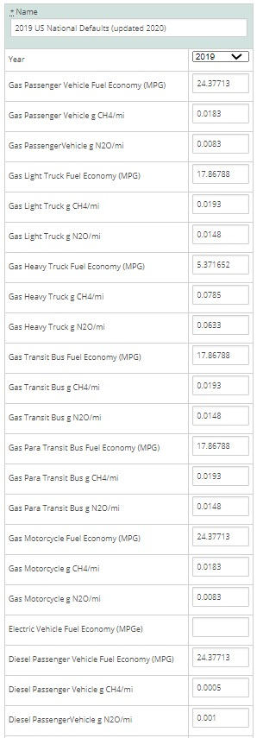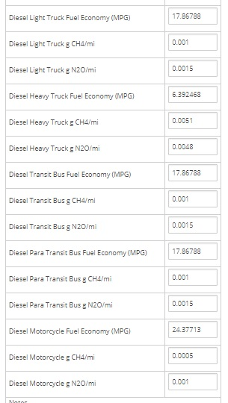

Table 3: 2019 US National Default Transportation Emissions

AADT counts were primarily only available for main arteries; therefore, additional calculations for AADT were needed to estimate AVMT for local/collector roads, as well as some main arteries that do not have AADTs available. The total length of roads in Manlius with traffic counts is 74.392 miles, while 152.558 miles of roads do not have AADT counts available.

According to the Minimum Maintenance Standards Regulation 239/02, a set of guidelines produced by the Association of Municipalities of Ontario to help local communities estimate traffic volume, while conducting an AADT count, it is possible to estimate the traffic volume for dead-ends and cul-de-sacs to avoid resource intensive counts. This is done by multiplying the number of houses on the roadway by a factor of 6 for rural areas.

This method was applied to the Town of Manlius for the roads without AADT counts since most of these roads were local/collector roads. It was determined that there were 7,903 occupied households in the Town of Manlius in 2019 (not inclusive of the two villages), according to the American Community Survey. It was assumed that all homes are on roadways that do not have a count, since most houses are on local/collector roads. By multiplying the number of occupied homes by 6, a combined AADT count of 47,418 was calculated for all 152.558 miles of roads without AADT counts available. In order to calculate VMTs, an average AADT value was needed, and derived by dividing the total AADT by the 152.558 miles of uncounted roadway. This gave an average AADT value of 310.8 for 2019, which was applied to all roadways that did not have a count.

Results
AVMT for roads with AADT counts available in 2019 totaled 234,749,803.47, while AVMT for roads without AADT counts available in 2019 totaled 17,307,570. Total AVMT in 2019 was 252,057,373.

BeginDescr | EndDescrip | RoadwayNam | Calculatio | AADT | RCSTAYearD | Length_Mi | VMT
COUNTY LINE | FYLER RD | BRIDGEPORT KIRK | 2019 | 1,632 | 246090, 2019, CT | 0.0001 | 0.14
MANLIUS TL / SULLIVAN TL | INTER 34 - RT 13 OVER | NYS Thruway | 2019 | 43,379 | 240050, 2019, CT | 0.0037 | 160.64
MANLIUS TL / SULLIVAN TL | INTER 34 - RT 13 OVER | NYS Thruway | 2019 | 43,379 | 240050, 2019, CT | 0.0047 | 201.92
Onon/Mad Co Line | TUSCARORA RD |  | 2019 | 12,169 | 240017, 2019, CT | 0.0003 | 3.17
Onon/Mad Co Line | CR 17 EAST LAKE RD |  | 2019 | 2,581 | 240016, 2019, CT | 0.0001 | 0.24
COUNTY LINE | BRDGPRT KIRKVILLE RD | PECK RD | 2019 | 1,361 | 248001, 2019, CT | 0.0019 | 2.62
SWEET RD | NY 173 | TROOPK | 2019 | 5,141 | 332023, 2019, CT | 1.5286 | 7858.43
POMPEY CTR RD | ORAN-DELPHI RD |  | 2019 | 10,291 | 330053, 2019, CT | 0.6186 | 6366.24
MANLIUS TN LN | FREEMONT RD | KIRKVILLE RD | 2019 | 13,630 | 331145, 2019, CT | 0.5700 | 7769.10
END 5/92 OLAP | WOODCHUCK HILL RD |  | 2019 | 22,100 | 330164, 2019, CT | 0.6245 | 13801.98
NY 5 | MANLIUS V/L | DUGUID ROAD | 2019 | 1,467 | 331006, 2019, CT | 1.7190 | 2521.77
RT 290 MYCENAE | Onon/Mad Co Line |  | 2019 | 12,763 | 330045, 2019, CT | 0.8237 | 10512.92
EAST SENECA ST | VILLAGE LINE | NORTH ST | 2019 | 1,545 | 331212, 2019, CT | 0.0001 | 0.16
MINOA V/L | N MANLIUS RD | EAST AVENUE | 2019 | 847 | 331004, 2019, CT | 0.2769 | 234.53
NY 173 | TROOP K RD | SWEET RD | 2019 | 2,269 | 332031, 2019, CT | 1.3503 | 3063.79
RT 5 FAYETTEVILLE | RT 290 END RT 257 |  | 2019 | 4,322 | 330374, 2019, CT | 1.3406 | 5794.25
RT 481I | MANLIUS TL / SULLIVAN TL | NYS Thruway | 2019 | 43,411 | 330306, 2019, CT | 3.2796 | 142371.58
RT 481I | MANLIUS TL / SULLIVAN TL | NYS Thruway | 2019 | 43,411 | 330306, 2019, CT | 3.2815 | 142453.20
 | FREMONT RD |  | 2019 | 17,525 | 330036, 2019, CT | 0.4161 | 7291.35
KIRKVILLE RD | DEAD END | GIRDEN RD | 2019 | 173 | 331143, 2019, CT | 0.2874 | 49.73
JAMESVILLE RD | THORNTREE HILL DR | WOODCHUCK HILL | 2019 | 4,474 | 332006, 2019, CT | 0.0223 | 99.61
FREMONT RD | SHEPPS COR RD |  | 2019 | 7,464 | 330028, 2019, CT | 1.6800 | 12539.52
SHEPPS COR RD | RT 31 END RT 298 |  | 2019 | 7,761 | 330027, 2019, CT | 0.1734 | 1346.04
CENTRAL AVE | CR 53 KIRKVILLE RD | FREMONT RD | 2019 | 14,364 | 331146, 2019, CT | 0.3700 | 5314.68
WOODCHUCK HILL RD | RT 257 MANLIUS |  | 2019 | 19,195 | 330238, 2019, CT | 1.1645 | 22352.96
END 5/92 OLAP | TOWN OF MANLIUS VILLAGE OF F |  | 2019 | 23,166 | 330106, 2019, CT | 0.9733 | 22548.49
NY 92 | DEWITT T/L | WOODCHUCK HILL | 2019 | 2,858 | 331041, 2019, CT | 0.5261 | 1503.47
BROADFIELD RD | NY 173 | SWEET RD | 2019 | 1,740 | 331023, 2019, CT | 0.3982 | 692.90
JCT RT 481I | FREMONT RD |  | 2019 | 8,991 | 330093, 2019, CT | 0.3420 | 3074.89
E GENESEE ST | CEDAR BAY | LYNDON RD | 2019 | 3,273 | 332035, 2019, CT | 0.0001 | 0.40
FREEMONT RD | VILLAGE LINE | CENTRAL AVE | 2019 | 6,089 | 331147, 2019, CT | 0.6480 | 3945.97
I-481 | NY 298 | E TAFT RD | 2019 | 4,609 | 332025, 2019, CT | 1.5246 | 7026.93
RT 257 | GREEN LK STATE PK RD |  | 2019 | 7,814 | 330188, 2019, CT | 1.5505 | 12115.29
DUGUID RD | RT 290 MYCENAE |  | 2019 | 6,656 | 330187, 2019, CT | 2.6800 | 17838.08
GREEN LK STATE PK RD | RT 5 END RT 290 |  | 2019 | 6,598 | 330186, 2019, CT | 2.5200 | 16626.96
END 92/173 OLAP | Onon/Mad Co Line |  | 2019 | 3,158 | 330185, 2019, CT | 2.5970 | 8201.29
END 92/173 OLAP | POMPEY CTR RD |  | 2019 | 17,280 | 330183, 2019, CT | 0.6459 | 11160.88
NY 92 | NY173 | ENDERS RD | 2019 | 3,588 | 332045, 2019, CT | 0.8562 | 3072.06
SWEET RD | START 92/173 OLAP |  | 2019 | 4,359 | 330181, 2019, CT | 1.3307 | 5800.48
RT 91 JAMESVILLE | SWEET RD |  | 2019 | 5,328 | 330180, 2019, CT | 0.3207 | 1708.56
RT 92 MANLIUS | RT 5 FAYETTEVILLE |  | 2019 | 6,331 | 330179, 2019, CT | 1.1909 | 7539.27
RT 257 | DUGUID RD |  | 2019 | 8,751 | 330178, 2019, CT | 0.5285 | 4625.16
FREMONT RD | RT 257 |  | 2019 | 10,469 | 330176, 2019, CT | 1.6995 | 17792.48
NYS 290 | N BURDICK | BOWMAN RD | 2019 | 2,181 | 332231, 2019, CT | 1.4207 | 3098.61
BOWMAN RD | SALMONSON DR | COVENTRY RD S | 2019 | 221 | 332217, 2019, CT | 0.5399 | 119.32
N BURDICK | DEWITT T/L | CEDAR BAY RD W | 2019 | 5,019 | 332070, 2019, CT | 0.8067 | 4048.90
SCHEPPS RD | CR 115 | KIRKVILLE RD | 2019 | 5,206 | 332066, 2019, CT | 0.8608 | 4481.47
SCHEPPS RD | CR 115 | KIRKVILLE RD | 2019 | 5,206 | 332066, 2019, CT | 0.8608 | 4481.47
BRIARWOOD | BARBERRY | TANGLEWOOD LA | 2019 | 237 | 335117, 2019, CT | 0.3700 | 87.69
PECK HILL | DEAD END | RUSTIC LA | 2019 | 103 | 335116, 2019, CT | 0.2504 | 25.79
W DAVENHAUER S | DEAD END | PATTON AVE | 2019 | 122 | 335115, 2019, CT | 0.0968 | 11.81
NY290 | WILSON | OSBORNE DRIVE | 2019 | 102 | 335114, 2019, CT | 0.1400 | 14.28
I-90 WB (OFF) | TOLL BOOTH | EXIT 34A I9O AT | 2019 | 7,627 | 333811, 2019, CT | 0.2545 | 1941.24
N BURDICK | S SUMMERHAVEN | N SUMMER HAVEN | 2019 | 816 | 335113, 2019, CT | 0.2986 | 243.67
MCDERMOTT | CUL DE SAC | MORLEY LA | 2019 | 13 | 335112, 2019, CT | 0.0466 | 0.61
I-90 INT34A (ON) | I-90 EB (ON) | EXIT 34A I9O AT | 2019 | 8,283 | 333810, 2019, CT | 0.0523 | 433.51
PEWTER LA | CUL DE SAC | HANDHEWN WAY | 2019 | 45 | 335111, 2019, CT | 0.0505 | 2.27
GOLDEN HEIGHTS | DEAD END | HALITE COURSE | 2019 | 181 | 335110, 2019, CT | 0.1688 | 30.55
PENSTOCK WAY | CUL DE SAC | DYCUS CIR | 2019 | 48 | 335109, 2019, CT | 0.0580 | 2.78
FREMONT RD | DEAD END | CRYSLER DRIVE W | 2019 | 96 | 335108, 2019, CT | 0.1000 | 9.60
BRIARWOOD LA | CUL DE SAC | BRIARWOOD CIR | 2019 | 9 | 335107, 2019, CT | 0.0506 | 0.46
MACCLENTHEN RD | DEAD END | BRAE LEURE | 2019 | 82 | 335106, 2019, CT | 0.5600 | 45.92
WHETSTONE | CUL DE SAC | BLARNEY STONE W | 2019 | 124 | 335105, 2019, CT | 0.2499 | 30.99
STONYKILL | ROUMARE RD | AUTUMN RUN | 2019 | 55 | 335104, 2019, CT | 0.1475 | 8.11
TILTON RD | COVENTRY RD N | ACTON ST | 2019 | 83 | 335103, 2019, CT | 0.2660 | 22.08
ENDERS RD | DEAD END | SUGARLAND DR | 2019 | 409 | 335400, 2019, CT | 0.1456 | 59.53
WEST SENECA ST | FARMINGTON RD | STONELEDGE LA | 2019 | 281 | 335228, 2019, CT | 0.0020 | 0.56
GLENCLIFF | VILLAGE LINE | NORTHFIELD LA | 2019 | 187 | 335225, 2019, CT | 0.0176 | 3.30
WEST SENECA ST | FARMINGTON RD | MEADOWRIDGE RD | 2019 | 258 | 335223, 2019, CT | 0.0025 | 0.65
OLD DYKE WAY | WHEELER AV | MEADOW DRIVE | 2019 | 71 | 335399, 2019, CT | 0.2179 | 15.47
HULBERT AVE | MINOA VILL LN | CASTELLO PKWY | 2019 | 3,732 | 336131, 2019, CT | 0.1904 | 710.53
N MANLIUS RD | MINOA BRIDGEPORT RD | EAST MYERS ROAD | 2019 | 404 | 336034, 2019, CT | 1.3090 | 528.83
NY 290 | HULBERT AVE | S MAIN ST | 2019 | 3,637 | 336130, 2019, CT | 0.9472 | 3444.82
KIRKVILLE RD | FLYER RD | N MANLIUS RD | 2019 | 3,157 | 336197, 2019, CT | 0.9300 | 2936.01
CR 115 N MANILUS RD | CO LN | PECK RD | 2019 | 1,719 | 336123, 2019, CT | 0.8159 | 1402.45
CR 115 N MANLUIS RD | COUNTY LN | FYLER RD | 2019 | 5,729 | 336122, 2019, CT | 0.0579 | 331.81
NY 290 | CENTRAL AVE | FREMONT RD | 2019 | 11,231 | 336156, 2019, CT | 0.8500 | 9546.35
FLYER RD | PECK RD | N MANLIUS RD | 2019 | 2,855 | 336121, 2019, CT | 0.8500 | 2426.75
CR 53 KIRKVILLE RD | NY 298 | FREMONT RD | 2019 | 3,243 | 336120, 2019, CT | 2.1200 | 6875.16
KIRKVILLE RD | NY 298 | SCHEPPS COR RD | 2019 | 2,574 | 336119, 2019, CT | 1.9000 | 4890.60
N KIRKVILLE RD | KINDERHOOK RD | POOLS BROOK ROA | 2019 | 318 | 336182, 2019, CT | 2.4300 | 772.73
KIRKVILLE RD (CR0530) | ONONDAGA CL | N KIRKVILLE RD | 2019 | 1,715 | 336118, 2019, CT | 0.4800 | 823.20
CEDAR BAY RD | NY 290 | NORTH BURDICK S | 2019 | 7,906 | 336181, 2019, CT | 1.1763 | 9299.91
FREEMONT RD | SCHEPPS RD | KIRKVILLE RD | 2019 | 0 | 336117, 2019, CT | 1.6400 | 0.00
ROBERTS ST | MANLIUS TN LN | KIRKVILLE RD | 2019 | 13,695 | 336116, 2019, CT | 0.0061 | 83.04
CR 145 GATES RD | CR10 | BROADFIELD RD | 2019 | 319 | 336114, 2019, CT | 0.3044 | 97.11
MANLIUS TN LN | NY 92 | POMPEY CTR RD | 2019 | 4,665 | 336112, 2019, CT | 0.4684 | 2185.00
SALTSPRING RD | END | FIELDSTONE DR | 2019 | 53 | 335433, 2019, CT | 0.0023 | 0.12
NY 92 | POMPEY T/L | WHETSTONE RD | 2019 | 613 | 336095, 2019, CT | 0.8265 | 506.64
MYERS SPUR | SCHEPPS CORNERS RD | MYERS ROAD | 2019 | 450 | 336093, 2019, CT | 0.9859 | 443.67
MINOA VILL LN | KIRKVILLE RD | MINOA RD | 2019 | 3,216 | 338021, 2019, CT | 0.2680 | 862.00
CR 115 | N KIRKVILLE RD (CR0531) | KIRKVILLE RD | 2019 | 2,260 | 338020, 2019, CT | 1.7392 | 3930.52
KIRKVILLE RD | KIRKVILLE RD | KIRKVILLE RD SP | 2019 | 37 | 338064, 2019, CT | 0.1400 | 5.18
NY 298 | E TAFT RD | FREMONT RD | 2019 | 1,624 | 338049, 2019, CT | 0.8854 | 1437.92
NY 92 | VILLAGE LINE S | HIGHBRIDGE ST | 2019 | 6,210 | 338037, 2019, CT | 0.6703 | 4162.30
NY 290 | KIRKVILLE RD (CR0530) | N KIRKVILLE RD | 2019 | 2,946 | 337028, 2019, CT | 1.5400 | 4536.84
TROOP K RD | NY 92 | HIGHBRIDGE ST | 2019 | 8,329 | 338036, 2019, CT | 0.3300 | 2748.57
NY 92 | CR 109 | WOODCHUCK HILL | 2019 | 5,054 | 331243, 2019, CT | 0.2177 | 1100.04
NY 257 | N EAGLE VIL RD | SALT SPRINGS RD | 2019 | 4,930 | 332068, 2019, CT | 1.3987 | 6895.39
NY 5 | CEDAR BAY RD | NORTH BURDICK S | 2019 | 13,458 | 331267, 2019, CT | 1.0077 | 13561.90
 |  |  |  |  |  |  | 643,150.15 | Daily VMT total
 |  |  |  |  |  |  | 365.00 | 365 days
 |  |  |  |  |  |  | 234,749,803.47 | Annual VMT

Table 4: 2019 Town of Manlius Traffic Data for Road Segments with Available AADT

# occupied housing units: | 7,903
Total AADT for roads not accounted for above: | 47,418
Days per year: | 365
Average AADT for roads not accounted for above: | 310.8
Total Annual VMT for manually calculated roads: | 17,307,570

Table 5: 2019 Town of Manlius Traffic Data for Road Segments without Available AADT

Emissions from transportation in the Town of Manlius in 2019 totaled 120,658 MTCO₂e, with 84,935 MTCO₂e from gasoline (10% ethanol) and 35,723 MTCO₂e from diesel.

Figure 9: 2019 Transportation Emissions by Source

Waste Sector

Methods and inputs
Waste emissions from the Town of Manlius were calculated using information provided by Syracuse Haulers, the company that provides waste service to the town. There were 6,008 tons of waste disposed of from the Town of Manlius in 2019, all of which were ultimately disposed of at the OCRRA waste to energy facility.

Results
Waste emissions in 2019 totaled 2,085 MTCO₂e.

Wastewater Sector

Methods and inputs
According to Ann Oot, Town Manager, wastewater from the town is treated at the Meadowbrook-Limestone facility on Route 290 in Manlius which is owned and operated by Onondaga County – WEP. Therefore, both emissions from this wastewater facility and from septic systems are included in the Town of Manlius’ community inventory.

Process emissions from the Meadowbrook-Limestone facility were calculated using the Process N2O Emissions from Wastewater Treatment and the Process N2O From Effluent Discharge to Rivers and Estuaries calculators in ClearPath. The total population served by the facility is 36,469, and the Industrial Commercial Discharge Multiplier of 1.25 from ICLEI protocols was used in the calculations.

Fugitive emissions from septic systems within the Town of Manlius were calculated using the Population Based method in ClearPath. The population served by septic systems within the town was estimated by subtracting the number of accounts connected to the sewer in 2019 (information provided by Ann Oot, Town Manager) from the total number of households within the Town of Manlius, and then multiplying the number of households served by septic systems by the average household size of owner-occupied units within the town (from the American Community Survey 2019 5-year table for Selected Housing Characteristics).

Households connected to sewer (2019): | 5,419
Total households (2019): | 7,903
Households using septic (2019): | 2,484
Average household size of owner-occupied unit in town: | 2.41
Population using septic in (2019): | 5,998

Table 6: 2019 Estimation for Town of Manlius Population using Septic Systems

Results
Emissions from the wastewater treatment facility are estimated to be 881 MTCO₂e, and fugitive emissions from septic systems in the Town of Manlius totaled 651 MTCO₂e in 2019. Overall wastewater emissions are estimated to be 1,532 MTCO₂e.

Figure 10: 2019 Wastewater Emissions

Agriculture Sector

Methods and inputs
Agricultural emissions from enteric fermentation were estimated using ICLEI’s Community Protocol, Appendix G: Agricultural and Livestock Emission Activities and Sources. Onondaga County data from the 2017 Agricultural Census was pared down to town-level data by comparing the ratio of town land in agriculture to county land in agriculture and multiplying that figure by livestock counts. Estimated livestock counts for the town were then multiplied by each animal type’s emissions factor (kg CH₄/head/year as provided by ICLEI), then by 1/1000 to convert kg to metric tons. Metric tons of CH₄ from all animal sources was then input into ClearPath to calculate metric tons of carbon dioxide equivalent produced by enteric fermentation from all animal types within the Town of Manlius.

 | Land in Agriculture (acres) | Data Source
Onondaga County | 160,717 | 2017 Ag Census: https://www.nass.usda.gov/Publications/AgCensus/2017/Full_Report/Volume_1,_Chapter_2_County_Level/New_York/
Town of Manlius | 5,602 | GIS parcel data
Ratio of agricultural land in town: | 3.49%
Table 7: County and Town land in Agriculture, 2019

Livestock Population | County | Town (estimated)
beef cows | 1,458 | 51
dairy cows | 25,553 | 891
hogs and pigs | 83 | 3
sheep and lambs | 415 | 14

Table 8: County and Town Livestock Population, 2019

 | Emissions Factor (kg CH4/hear/year) | CH4=Animal Population x EF x (1/1000)
beef cows | 94 | 4.78
dairy cows | 140 | 124.70
hogs and pigs | 2 | 0.00
sheep and lambs | 8 | 0.12
 | Total MT CH₄ in Town of Manlius, 2019: | 129.59
Table 9: Methane Associated with Livestock Enteric Fermentation in Town of Manlius, 2019

Results
The estimated emissions from agricultural enteric fermentation in the Town of Manlius totaled 3,240 MTCO₂e in 2019.

Discussion
There is some margin of error in the calculations for emissions from agricultural enteric fermentation in the Town of Manlius because town-specific livestock counts were not available. Since livestock figures were estimated for the town based off of county data, counts could be off, resulting in either more or less emissions from this sector than reality.

While there are other sources of emissions from agriculture besides enteric fermentation, including from manure management and fertilizer application, data on these sources is largely unavailable and methodologies are limited.

IV. Community Emissions Forecast

Methods and inputs
A community emissions forecast is included here to provide a sense of what emissions might look like in 2030 under a business-as-usual scenario. The forecast was compiled using ClearPath guidance. Compound Average Growth Rates were used to forecast emissions in all sectors, using the inputs noted below.

To forecast emissions from the residential and commercial/industrial sectors, State energy use trends as described in the 2015 New York State Energy Plan and mandates of the Climate Leadership and Community Protection Act (i.e. 70% electricity from renewables by 2030) were used.

To forecast emissions from the transportation sector, State energy use trends as described in the 2015 New York State Energy Plan and Federal rules on vehicle fuel mileage standards were used.

To forecast emissions from the waste sector, population growth rates for the Town of Manlius from the American Community Survey from 2010 vs. 2019 were used, assuming population would continue to grow at a similar rate through 2030 and waste production would increase proportionally to population growth.

To forecast emissions from the wastewater sector, population growth rates for the Town of Manlius from the American Community Survey from 2010 vs. 2019 were used, assuming population would continue to grow at a similar rate through 2030 and wastewater emissions would increase proportionally to population growth.

To forecast emissions from agriculture, county dairy cow counts from the 1992 and 2017 Agricultural Census “Cattle and Calves - Inventory and Sales” tables were used, assuming dairy cow populations in the Town of Manlius would continue to grow at a similar rate through 2030. Dairy cow counts were used because they represent approximately 96% of emissions from agricultural enteric fermentation in the Town of Manlius and have a higher emissions factor than the other livestock types.

Results

Assuming a business-as-usual scenario, emissions in the Town of Manlius in 2030 are expected to decrease from 197,079 MTCO₂e in 2019 to 161,986 MTCO₂e in 2030, a decrease of about 18%. Emissions are expected to decrease in the residential, commercial/industrial, transportation and wastewater sectors, and increase in the waste and agricultural sectors. Each sector’s forecast is explained further below.

Figure 11: Town of Manlius Community 2030 Emissions Forecast

Discussion

Emissions from the residential sector are expected to decrease from 51,082 MTCO₂e in 2019 to 45,089 MTCO₂e by 2030.

Figure 12: Forecasted Residential Emissions in the Town of Manlius for 2030

Since the Climate Leadership and Community Protection Act has set a goal of 70% electricity coming from renewables by 2030, emissions from residential electricity use are expected to drop significantly. Residential propane and fuel oil use are projected to decrease as well, with natural gas use staying about the same, according to the 2015 New York State Energy Plan.

Emissions from the commercial/industrial sector are expected to decrease overall, from 18,482 MTCO₂e in 2019 to 15,558 MTCO₂e by 2030.

Figure 13: Forecasted Commercial/Industrial Emissions in the Town of Manlius for 2030
Since the Climate Leadership and Community Protection Act has set a goal of 70% electricity coming from renewables by 2030, emissions from commercial/industrial electricity use are expected to drop significantly. Commercial/industrial fuel oil use is projected to decrease as well, with propane use staying about the same and natural gas use increasing over time, according to the 2015 New York State Energy Plan.

Emissions from the transportation sector are expected to decrease overall as well, from 120,658 MTCO₂e in 2019 to 93,864 MTCO₂e by 2030.

Figure 14: Forecasted Transportation Emissions in the Town of Manlius for 2030

According to the 2015 New York State Energy Plan, gasoline and vehicle miles traveled are expected to decrease over time, with diesel use and vehicle miles traveled increasing. However, the carbon intensity of the vehicle miles traveled for all fuel types is expected to decrease as federal transportation policies require vehicle fuel mileage standards to improve over time, so emissions from all fuel sources are expected to decrease.

Emissions from the waste sector are expected to increase, from 2,085 MTCO₂e in 2019 to 2,106 MTCO₂e by 2030. This forecast is directly related to estimated population growth rate in the town.

Emissions from the wastewater sector are expected to increase, from 1,532 MTCO₂e in 2019 to 1,547 MTCO₂e in 2030. This forecast is directly related to estimated population growth rate in the town.

Emissions from agricultural enteric fermentation in the Town of Manlius are expected to increase from 3,240 MTCO₂e in 2019 to 3,821 MTCO₂e by 2030. This forecast assumes emissions from agricultural enteric fermentation will continue to increase at a similar rate as the increase in county dairy cow population from 1992 to 2017.

V. Municipal Operations Emissions Forecast

Methods and inputs
A municipal operations emissions forecast is included here to provide a sense of what emissions might look like in 2030 for municipal operations under a business-as-usual scenario. The forecast was compiled using ICLEI’s protocol for forecasting and entering data into the ClearPath tool online. Data from the municipal inventory compiled by SUNY ESF students and CNYRPDB was used as a baseline for this forecast. Compound Average Growth Rates were used to forecast emissions in all sectors using the inputs noted below.

To forecast emissions from the municipal buildings and facilities sector, population growth rates from 2010 to 2019 as well as mandates of the Climate Leadership and Community Protection Act (i.e. 70% electricity from renewables by 2030) were used. It is assumed that as population of the town increases, energy used by municipal operations at facilities increases in a proportional manner.

To forecast emissions from the municipal vehicle fleet, population growth rates as well as Federal rules on vehicle fuel mileage standards were used. It is assumed that as population of the town increases, energy used by the municipal vehicle fleet increases in a proportional manner.

To forecast emissions from municipal streetlights, population growth rates as well as mandates of the Climate Leadership and Community Protection Act (i.e. 70% electricity from renewables by 2030) were used. It is assumed that as population of the town increases, energy used by municipal operations increases in a proportional manner.

Results
Assuming a business-as-usual scenario, emissions in the Town of Manlius in 2030 from all municipal sectors are expected to decrease, with total emissions decreasing from 914 MTCO₂e in 2019 to 735 MTCO₂e in 2030, a decrease of about 20%. Each sector’s forecast is explained further below.

Figure 15: Town of Manlius Municipal Operations 2030 Emissions Forecast

Discussion
Municipal natural gas use is expected to remain relatively constant in accordance with the town population growth trend (which has increased only very slightly since 2010), but since the Climate Leadership and Community Protection Act requires the state to achieve 70% renewable electricity by 2030, emissions from municipal operations electricity use are expected to drop fairly significantly from 34 MTCO₂e to 10 MTCO₂e. Overall emissions from municipal buildings and facilities are therefore expected to decrease from 125 MTCO₂e in 2019 to 101 MTCO₂e by 2030.

Emissions from the municipal vehicle are expected to decrease as well, because despite an estimated similar amount of vehicle miles traveled in accordance with the town’s population growth trend, the carbon intensity of the vehicle miles traveled is expected to decrease as federal transportation policies require vehicle fuel mileage standards to improve over time.

Finally, emissions from streetlights are expected to decrease in accordance with CLCPA goals of achieving 70% renewable electricity by 2030.

VI. GWP: IPCC 4th Assessment vs 5th Assessment

The information above utilizes the IPCC’s 4th assessment report figures for global warming potential (GWP) to be consistent with the municipal operations inventory calculations, as explained previously. The IPCC 4th assessment report assumes a GWP of 25 for methane over a 100-year period, meaning that the impact of 1 unit of methane in the atmosphere creates 25 times more warming potential than 1 unit of CO₂ over a 100-year time period. However, methane typically remains in the atmosphere for closer to 12 years as opposed to CO₂ which can remain in the atmosphere for over 100 years, meaning that methane’s impact while it remains in the atmosphere is much stronger than that of CO₂. Therefore, the IPCC 5th assessment report includes both a 100 year and 20-year GWP for methane of 28 and 84, respectively.

Also, the IPCC 5th assessment report’s 20-year GWP for nitrous oxide is 264 as compared to 298 from the IPCC 4th assessment report, 100-year GWP.

This section of the report includes a discussion of what emissions look like for the Town of Manlius community assuming the IPCC 5th assessment report’s 20-year GWP factors for methane and nitrous oxide instead of the 4th assessment report’s 100-year GWP factors.

Figure 16 below compares total community emissions for the Town of Manlius assuming the IPCC 4th assessment GWP and the IPCC 5th assessment 20-year GWP.

Figure 16: 2019 Town of Manlius Community Emissions Scenarios

As illustrated, there is not much difference between the two scenarios for residential, commercial/industrial, transportation, or waste sectors, but there is a more noticeable increase in emissions for wastewater and a significant increase in agricultural emissions using the IPCC 5th assessment 20-year GWPs. Therefore, it is important to consider the methodology used in creating this and future inventory updates, as well as when comparing data from this inventory to inventories from other communities.

VII. Conclusion
The greenhouse gas inventory is the first milestone in climate action planning, to be followed by developing a reduction goal and then creation of a climate action plan.

The results of this study indicate that the largest percentage of community emissions came from the transportation sector for 2019. Transportation emissions should be targeted in the town’s future Climate Action Plan so that energy use from this sector can be reduced, therefore lowering both energy costs and GHG emissions.

As a Climate Smart Community, the Town of Manlius has partnered with state and local agencies to combat climate change and pledge to reduce greenhouse gas emissions. Conducting a baseline emissions inventory is an important step in climate action planning, mitigation, and adaptation. This community inventory will provide a benchmark for planning purposes with the goal of setting an emissions reduction target and developing a Climate Action Plan.

VIII. Bibliography

Beverine, Kevin and Walz, Nicole. (2021, March-April). Emails.

Center for Climate and Energy Solutions. (2020). Federal Vehicle Standards. Retrieved from https://www.c2es.org/content/regulating-transportation-sector-carbon-emissions/.

ICLEI. (2020). ClearPath. Retrieved from https://clearpath.icleiusa.org/.

IPCC. (2014). Fifth Assessment Report. Retrieved from https://www.ipcc.ch/report/ar5/syr/.

IPCC Working Group I. (2007). The Physical Science Basis. Retrieved from https://wg1.ipcc.ch/publications/wg1-ar4/faq/wg1_faq-1.3.html.

Level of Service Policy for Municipal Highways in the United Townships of Head, Clara & Maria. (2008). Retrieved from http://www.townshipsofheadclaramaria.ca/download.php?dl=YToyOntzOjI6ImlkIjtzOjI6 Ijg1IjtzOjM6ImtleSI7aTo0O30=.

Oot, Ann. (2021, March-April). Emails.

NYSERDA. (2014). Climate Change in New York State: Updating the 2011 ClimAID Climate Risk Information. Retrieved from https://www.nyserda.ny.gov/About/Publications/Research%20and%20Development%20 Technical%20Reports/Environmental%20Research%20and%20Development%20Techni cal%20Reports/Response%20to%20Climate%20Change%20in%20New%20York.

NYSERDA. (2019). New York Greenhouse Gas Inventory Fact Sheet. Retrieved from https://www.nyserda.ny.gov/About/Publications/EA-Reports-and-Studies/Energy- Statistics.

NYSERDA. (2020). Community Energy Use Data. Retrieved from https://www.nyserda.ny.gov/All-Programs/Programs/Clean-Energy- Communities/Community-Energy-Use-Data.

US EIA. (2019). State Energy Data System (SEDS): 1960-2018. Retrieved from https://www.eia.gov/state/seds/seds-data-complete.php#Consumption.

US EIA. (2016). Commercial Buildings Energy Consumption Survey (CBECS). Retrieved from https://www.eia.gov/consumption/commercial/data/2012/#b1-b2.

US EPA. (2020). Emissions & Generation Resource Integrated Database (eGRID). Retrieved from https://www.epa.gov/energy/emissions-generation-resource-integrated-database- egrid.

The U.S. Community Operations Protocol was developed by ICLEI-Local Governments for Sustainability in order to provide “detailed, cutting-edge guidance on completing a GHG emissions inventory at the community scale in the United States — including emissions from businesses, residents, and transportation,” according to ICLEI’s website.
ClearPath is a proprietary tool developed by ICLEI-Local Governments for Sustainability to assist local governments with conducting greenhouse gas emissions inventories and with the development of local climate action plans.
IPCC. 2014. Fifth Assessment Report. https://www.ipcc.ch/report/ar5/syr/
IPCC Working Group. https://wg1.ipcc.ch/publications/wg1-ar4/faq/wg1_faq-1.3.html
NYSERDA. 2014. Climate Change in New York State: Updating the 2011 ClimAID Climate Risk Information. https://www.nyserda.ny.gov/About/Publications/Research%20and%20Development%20Technical%20Reports/Environmental%20Research%20and%20Development%20Technical%20Reports/Response%20to%20Climate%20Change%20in%20New%20York
NYSERDA. 2014. Climate Change in New York State: Updating the 2011 ClimAID Climate Risk Information. https://www.nyserda.ny.gov/About/Publications/Research%20and%20Development%20Technical%20Reports/Environmental%20Research%20and%20Development%20Technical%20Reports/Response%20to%20Climate%20Change%20in%20New%20York; and National Climate Assessment. 2014. Climate Change Impacts in the United States. https://nca2014.globalchange.gov/.
NYSERDA. Greenhouse Gas Inventory Fact Sheet. https://www.nyserda.ny.gov/About/Publications/EA-Reports-and-Studies/Energy-Statistics.
ICLEI. 2012. U.S. Community Protocol for Accounting and Reporting of Greenhouse Gas Emissions.
The ESF student group used the EPA’s Local Government GHG Inventory Tool, which is set up using IPCC 4th assessment GWPs. The CNY RPDB is an ICLEI member and can therefore use their ClearPath tool, but ClearPath cannot be shared with others, so a free tool had to be used for the ESF group’s analysis.
NYSERDA. Utility Energy Registry. https://utilityregistry.org/app/index.html#/
US EIA. State Energy Data System (SEDS): 1960-2018. https://www.eia.gov/state/seds/seds-data-complete.php#Consumption
The ClearPath tool provides standard emissions factors that were developed by ICLEI and are described in the Local Government Operations Protocol, Appendix G.
US EPA. Emissions & Generation Resource Integrated Database (eGRID). https://www.epa.gov/energy/emissions-generation-resource-integrated-database-egrid.
US EIA. Commercial Buildings Energy Consumption Survey (CBECS). https://www.eia.gov/consumption/commercial/data/2012/#b1-b2
US EIA. Commercial Buildings Energy Consumption Survey (CBECS). https://www.eia.gov/consumption/commercial/data/2012/#b1-b2
US EIA. State Energy Data System (SEDS): 1960-2018. https://www.eia.gov/state/seds/seds-data-complete.php#Consumption.
The ClearPath tool provides standard emissions factors that were developed by ICLEI and are described in the Local Government Operations Protocol, Appendix G.
US EPA. Emissions & Generation Resource Integrated Database (eGRID). https://www.epa.gov/energy/emissions-generation-resource-integrated-database-egrid.
As per Eli Yewdall at ICLEI, “The default vehicle factor sets are derived from EIA data for fuel economy, and EPA emissions factors for CH4 and N2O. Because EPA publishes factors by model year, we had to convert those to represent the average mix of new and old vehicles on the road in a particular year; we did this using data from the US National GHG inventory.”
As provided by Eli Yewdall at ICLEI: Gasoline passenger vehicles: 68.6% Deisel passenger vehicles: 0.3% Gasoline light trucks: 19.7% Deisel light trucks: 0.8% Gasoline heavy trucks: 1.4% Deisel heavy trucks: 8.5%
The gasoline entry in ClearPath was entered as ethanol with 10% biofuel to account for the typical 10% ethanol blend.
AADT and road segment length GIS data provided by the NYSDOT Highway Data Services Bureau. These traffic counts include all traffic within the town, including pass-through traffic where the origin and destination of trips occur outside of the town's boundaries. These trips will be more difficult to address in climate action planning than the trips that begin and/or end within the town.
http://www.townshipsofheadclaramaria.ca/download.php?dl=YToyOntzOjI6ImlkIjtzOjI6Ijg1IjtzOjM6ImtleSI7aTo0O30=
Obtained from Nicole Walz, Controller for Syracuse Haulers and Kevin Beverine, Sales Manager for Syracuse Haulers
As per instructions from Eli Yewdall of ICLEI.
According to https://eaglenewsonline.com/new/government/2018/08/22/violations-cited-at-meadowbrook-limestone-wastewater-plant-could-cost-municipalities-millions/.
This forecast uses the March 2020 Safer Affordable Fuel Efficient (SAFE) Vehicles Rule, which projects combined passenger and light duty vehicle fuel efficiency to be 40.4 mpg by 2026, according to https://www.c2es.org/content/regulating-transportation-sector-carbon-emissions/ accessed 5/6/21.
This forecast uses the March 2020 Safer Affordable Fuel Efficient (SAFE) Vehicles Rule, which projects combined passenger and light duty vehicle fuel efficiency to be 40.4 mpg by 2026, according to https://www.c2es.org/content/regulating-transportation-sector-carbon-emissions/ accessed 5/10/21.
This would imply additional streetlights are added, which might occur with increased development as population continues to grow.
IPCC. Climate Change 2014 Synthesis Report. https://ar5-syr.ipcc.ch/ipcc/ipcc/resources/pdf/IPCC_SynthesisReport.pdf

